**Prototypes**

1-4 Login

This prototype is a simply mock-up of how the SONAR system’s login page will appear for all users. Users will simply enter their university email (as that will be the standard username for ALL users) along with the password unique to this system.

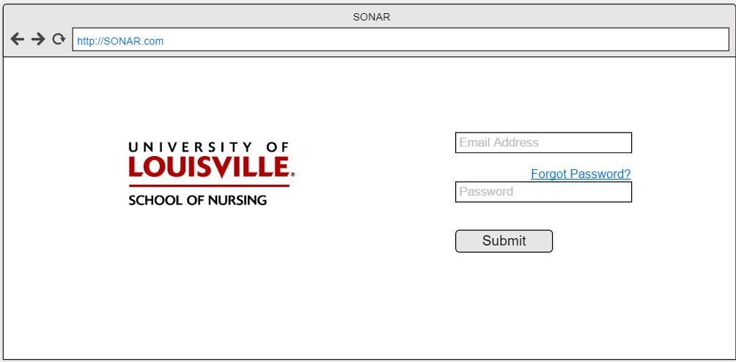

5) Submit Grades

The Professor will submit the grades of each student in each class they teach in a given semester. After successfully logging on to the system, Professors will be able to select the class from a list of classes assigned to them for the current semester, and then manually go through and select the grade of each student. Once this has been completed for a class, the professor will submit the grades. If the professor needs to clear the data entered for some reason, they will have the option to do so.

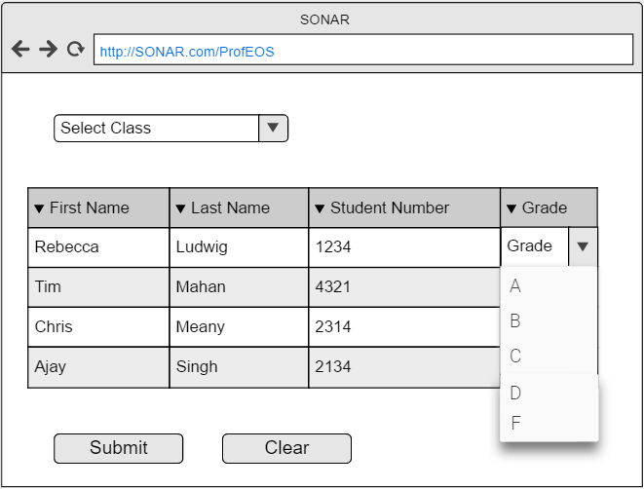

6-7 Queries

The user will run many searches (queries) against the database in order to gain information about not just individual students, but groups of students that participate in the programs offered by the School of Nursing. These searches will be used to generate reports about students, and with these reports advisors will be able to reach out to students who may have decided to not enroll in a particular semester without graduating, or reach out to students that may be on academic probation or failed a course. This will also allow Advisors to track the progress of individual students for advising appointments, with an easy-to-view report generated from a simple query.

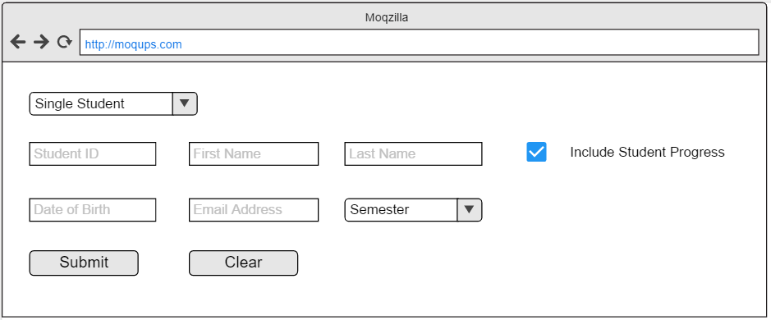

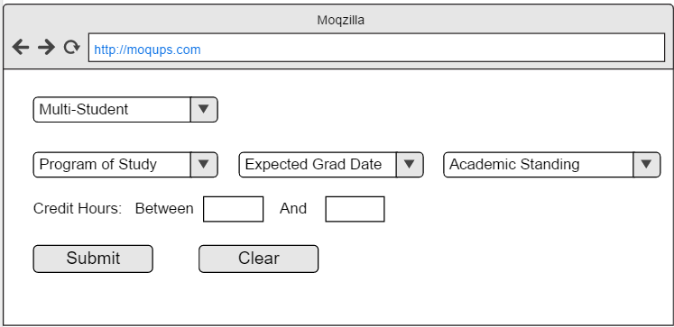

8) Document Upload

Students will have the ability to submit documentation for the review of advisors. The system will provide student users with an easy to use page that simply allows them to submit PDFs, PNGs, and JPEGs to the system so that Advisors may review and approve, not edit the documentation. When the Student selects the Document type, it lets the Advisor know what they’re looking at for approval. When the Document is selected, students can select Clear to remove it, or Submit to send it to the Advisors.

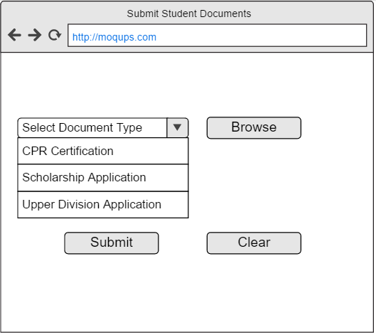

9) Import from CSV

If the need should ever arise a need for data to be imported into the database, the system administrator will have the ability to do so. This allows the system to have more robust functionality, while limiting this privilege to a group that also has the ability to restore the system from a backup should anything go wrong. These excel files (in csv format) can be used to populate the database with information it previously did not contain in a quick, efficient manner. All an Administrator would need to do is Arrange the CSV file columns according to how the Import Student Data link specifies, browse to the file, and hit submit.

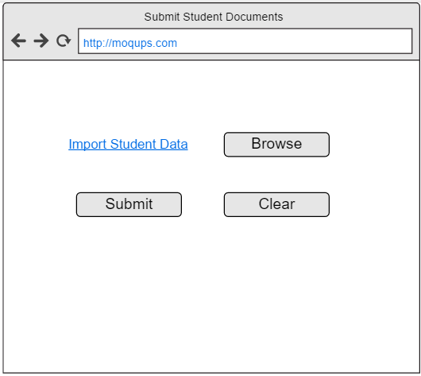

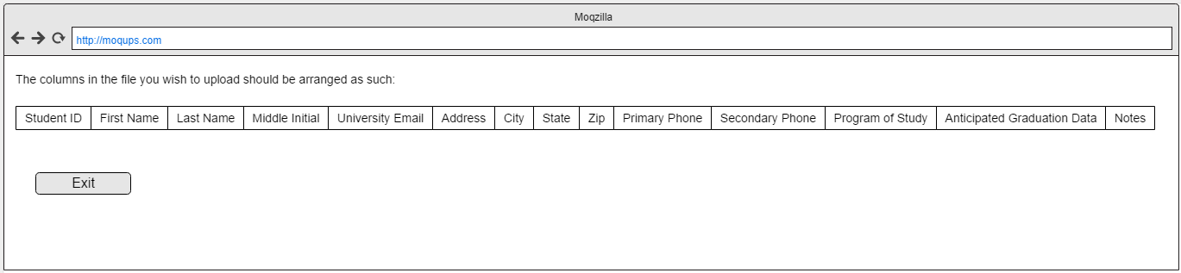

10-11 Reports

Some users such as Advisors and Committee Members would benefit greatly from having the ability to run reports and export those reports to files that they can manipulate on their computers individually, without making any changes to the data stored on the system. To provide this functionality, we’ll have premade reports for advisors and committee members to select from, as well as the division of student should they wish to be so specific. They will then be able to export the data to excel file types or in PDF format to meet their manipulation/viewing needs.

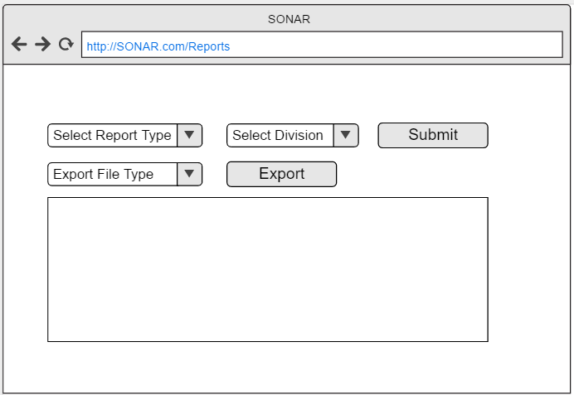

12) Automatic Reporting

Some reports can be generated and delivered automatically. On this page, users will be able to sign up for weekly, monthly, or semester reports. These will be the built in reports that are available on the reports page for users to export. All an Advisor would need to do is check the box next to the report they wish to receive on regular intervals. Once this is complete, they only need hit Save and the changes will take effect.

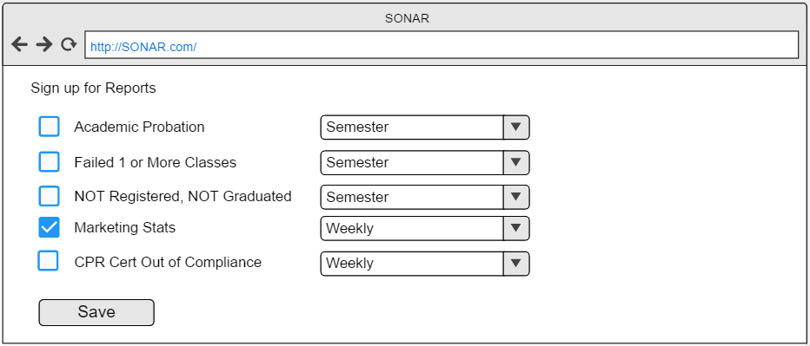

13) Reset password via email

This prototype will allow any user to reset their password. They will select reset password button and enter their email address. An email with a link will be sent to them to allow them to enter their old password followed by entering a new password twice to confirm that it’s the same and meets the standards for the program.

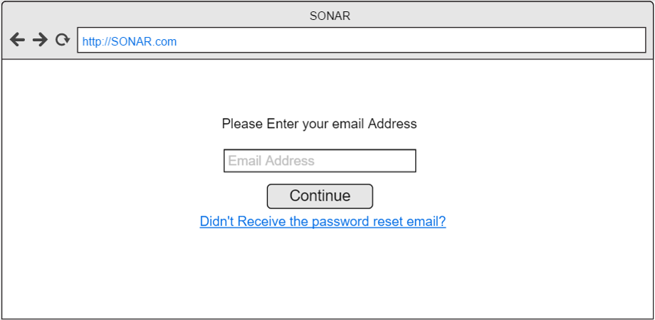

14) Generate automatic email templates

This will allow professors, advisors and committee members to choose a pre written template to send as an email to save them time. They will log in with their username and password then select the email tab. They will be brought to a blank email with pre-loaded email templates they can click on to be automatically dropped into a blank email. This will cut down on the time spent to type emails.

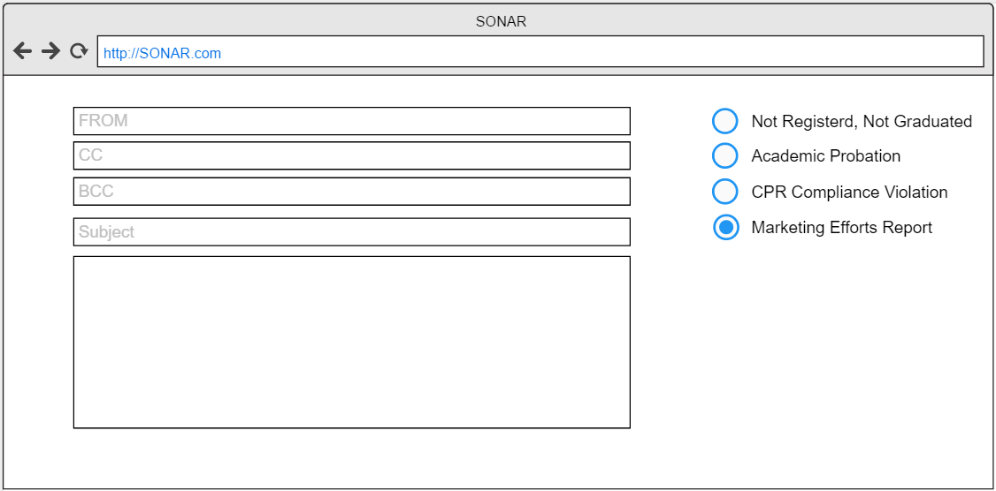

15 Track Students progress

This prototype will allow an advisor to track a student’s progress through the program by running a simple query or report.

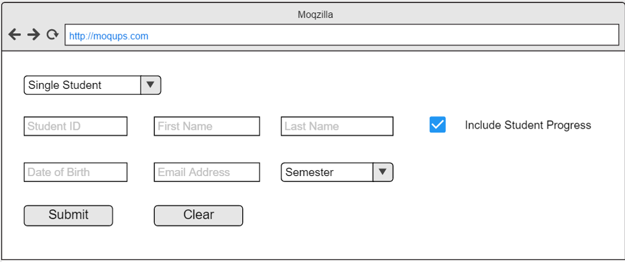

16) Track graduation progress of student

Here, advisors will be able to view a student’s completed classes and classes that need to be taken that are required to graduate. They will enter their credentials and select the student tab. From here they will search the student they want and be able to look at what classes they have finished and still need to finish.

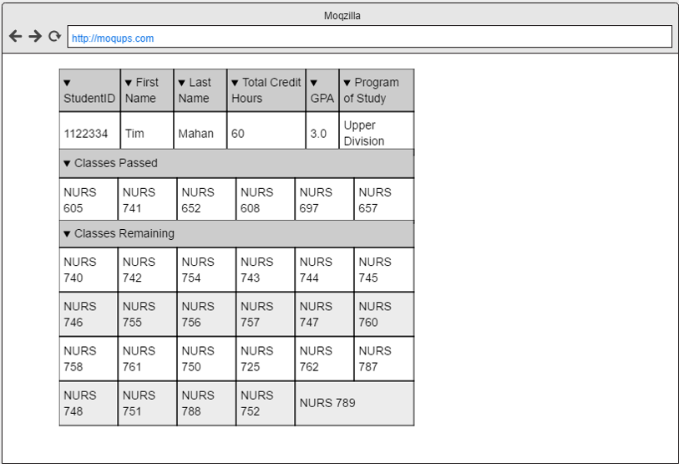

25. Submission of application to school of nursing.

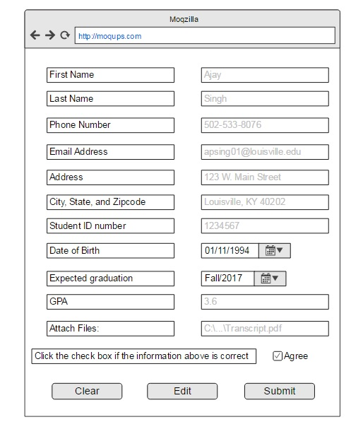

26. Track Received scholarships

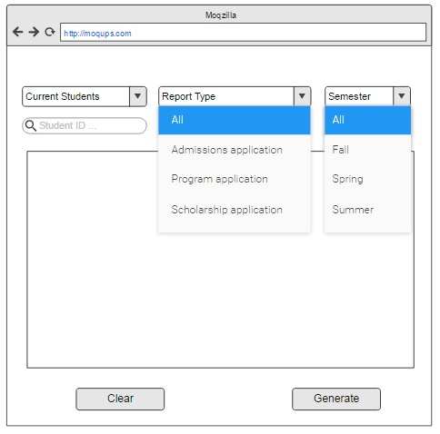

27. submit scholarships



29. Track Marketing Efforts

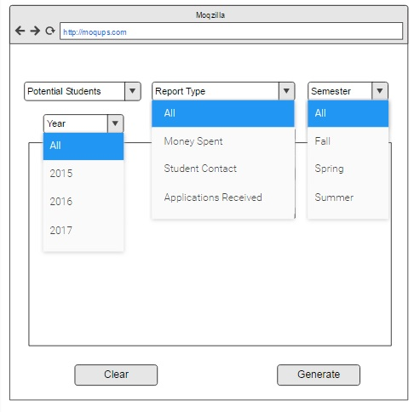

30. View reports for admissions decisions



31. Submission of application for program of study



32. Add to database storage

**System admin would physically add storage to system server**

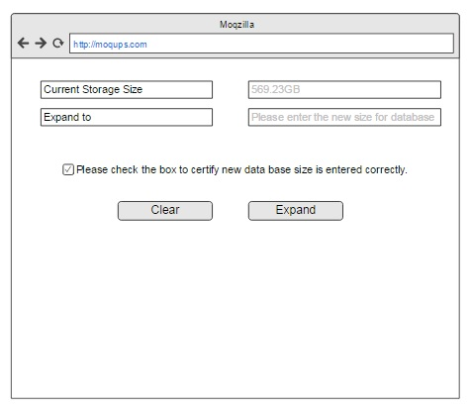

33. Add Graduated students to alumni list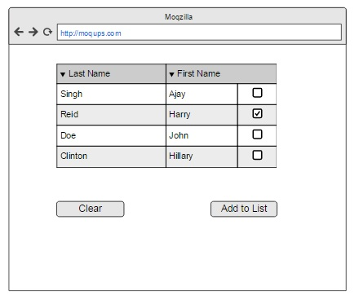

34. Generate email list



35. Edit contact information for alumni

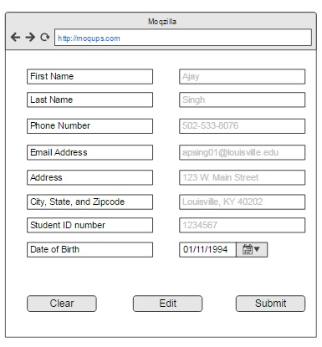

1. Generate email list to ask alumni for donations



Edit Upper Division Student: 38

Advisor will input/edit following information to update student in the database.

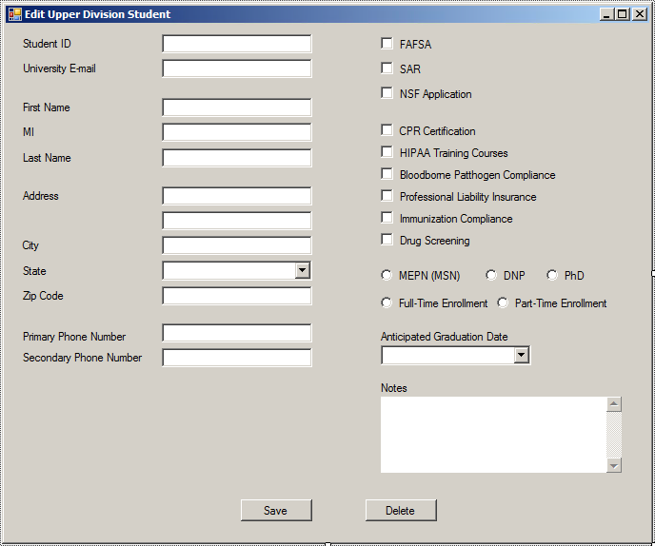

Delete Upper Division Student: 39

Advisor will input their user name and password to delete student from database.

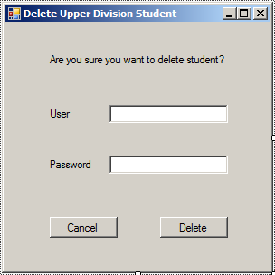

Create Lower Division Student: 40

Advisor will input following information to create student in the database.

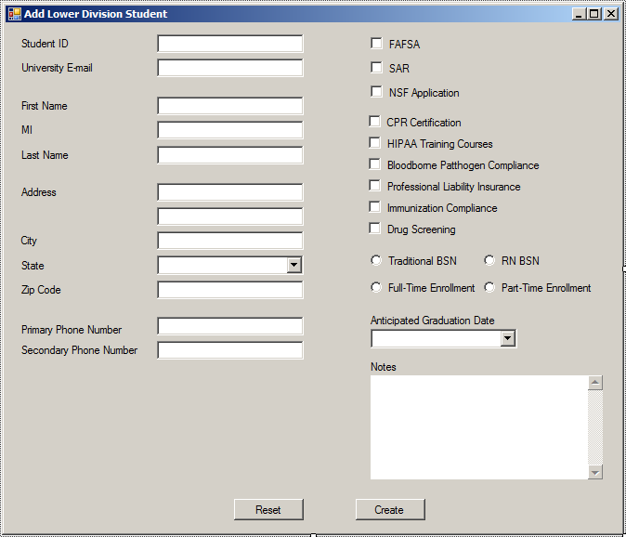

Edit Lower Division Student: 41

Advisor will input/edit following information to update student in the database.

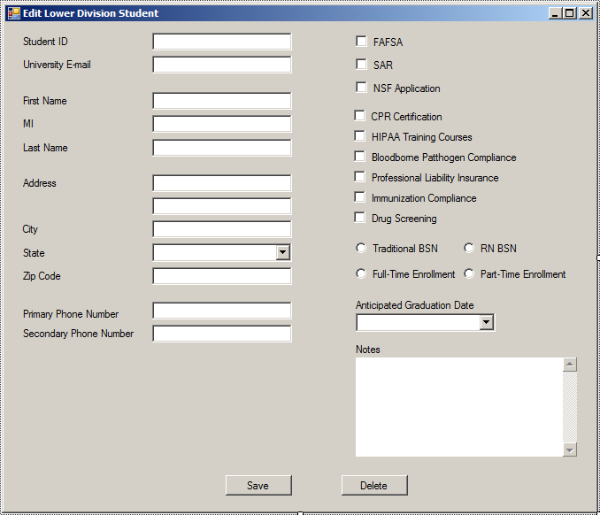

Delete Lower Division Student: 42

Advisor will input their user name and password to delete student from database.

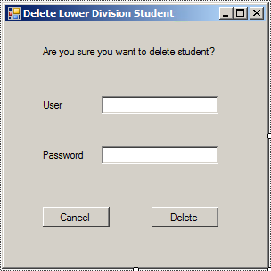

Create Perspective Student: 43

Advisor will input following information to create student in the database.

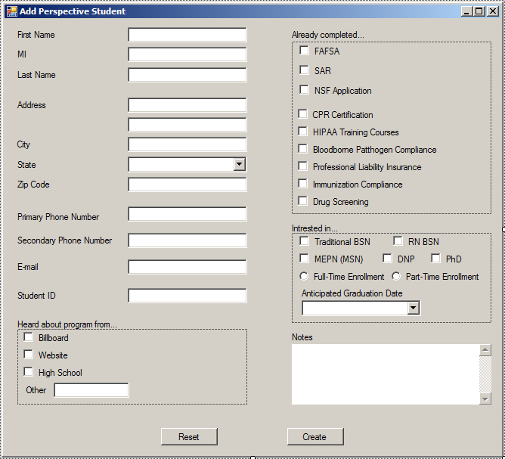

Edit Perspective Student: 44

Advisor will input/edit following information to update student in the database.

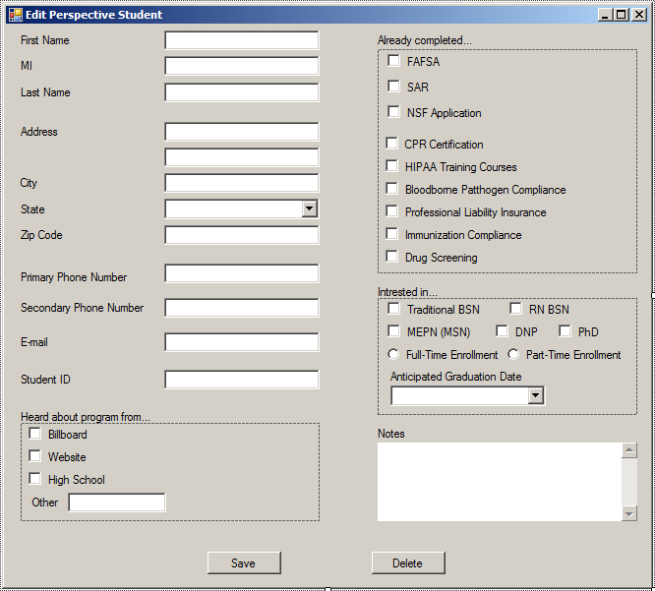

Delete Perspective Student: 45

Advisor will input their user name and password to delete student from database.

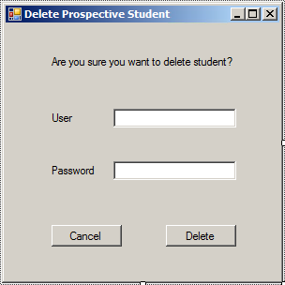

Create Graduate: 46

Advisor will input following information to create student in the database.

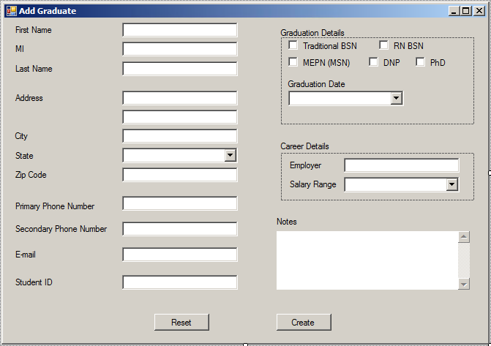

Edit Graduate: 47

Advisor will input/edit following information to update student in the database.

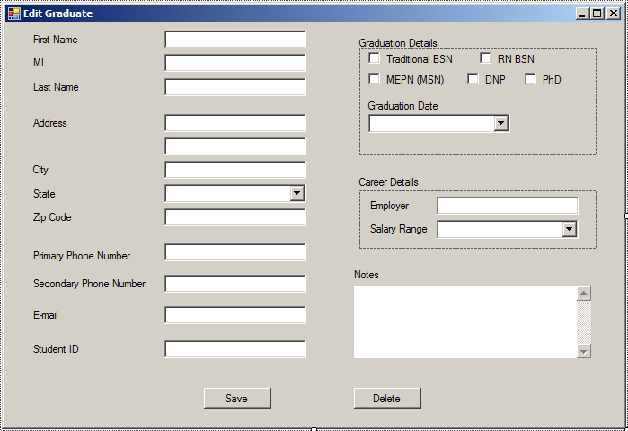

Delete Graduate: 48

Advisor will input their user name and password to delete student from database.

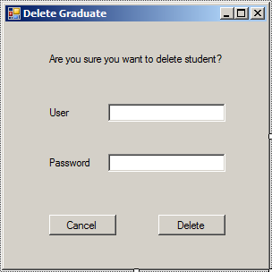

49) Create Admin

When the system is designed, there will be an Admin account created for the initial setup purposes. In order to ensure the administrative role can change hands, and to provide support for multiple administrator accounts (should the school ever need it) the SONAR system will need a page for creating admin users. Below is the flow describing how to complete this task.



50) Create Professor

Professor accounts will need be created in order to allow the professors using the system to upload grades to it.



51) Create Advisor

Advisor accounts will need to be created in order to grant SON advisors access to the system and the ability to create, update, and delete students. As well as track student progress and pull reports.



52) Create Committee Member

Advisor accounts will need to be created in order to grant SON advisors access to the system and the ability to create, update, and delete students. As well as track student progress and pull reports. The following describes how Advisors are to be created.



53) Update Admin

As information changes, Admins will need the ability to update their information in order to stay current. This also allows passwords to be manually changed as a fail-safe to the email resets should the admin need their password changed.



54) Update Professor

As information changes, Admins will need the ability to update their information in order to stay current. This also allows passwords to be manually changed as a fail-safe to the email resets should the admin need their password changed.



55) Update Advisor

As information changes, Admins will need the ability to update their information in order to stay current. This also allows passwords to be manually changed as a fail-safe to the email resets should the admin need their password changed.



56) Update Committee Member

As information changes, Admins will need the ability to update their information in order to stay current. This also allows passwords to be manually changed as a fail-safe to the email resets should the admin need their password changed.



57) Delete Admin

It is not expected the once an admin is created, they will always be a part of the School of Nursing. In case an admin needs to have their access turned off, there will be an option that will ‘delete’ the admin from the system. This will effectively turn off the administrator’s access, and their login will no longer function.



58) Delete Professor

It is not expected the once an admin is created, they will always be a part of the School of Nursing. In case an admin needs to have their access turned off, there will be an option that will ‘delete’ the admin from the system. This will effectively turn off the administrator’s access, and their login will no longer function.



59) Delete Advisor

It is not expected the once an admin is created, they will always be a part of the School of Nursing. In case an admin needs to have their access turned off, there will be an option that will ‘delete’ the admin from the system. This will effectively turn off the administrator’s access, and their login will no longer function.



60) Delete Committee Member

It is not expected the once an admin is created, they will always be a part of the School of Nursing. In case an admin needs to have their access turned off, there will be an option that will ‘delete’ the admin from the system. This will effectively turn off the administrator’s access, and their login will no longer function.



61) Student Submit Documents

Students will periodically need to upload documents to the system for Advisors to review. The flow below describes how students will upload documents for Advisors to review.



62) Create Prospective Student

Prospective Students interested in enrolling in the school of nursing will need a way to find out more information about the school, and need a way to schedule visits with the school in order to get a feel for the program. This describes how a prospective student would create an account.

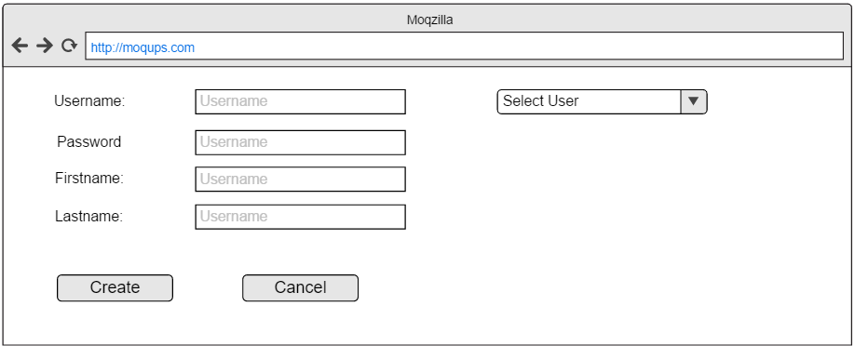

63) Update Prospective Student

Prospective Students who have created accounts may need to change their information after the account has been created.



64) Delete Prospective Student

To keep Prospective Student accounts from taking up more space than necessary on the SONAR system, advisors will have the ability to delete them from the system after a certain period of inactivity in a mass delete.



65) Sign Up for Visits

66) Create Donor

Donors interested in enrolling in the school of nursing will need a way to find out more information about the school, and need a way to schedule visits with the school in order to get a feel for the program. This describes how a Donor would create an account.



67) Update Donor

Donors who have created accounts may need to change their information after the account has been created.



68) Delete Donor

To keep Donor accounts from taking up more space than necessary on the SONAR system, advisors will have the ability to delete them from the system after a certain period of inactivity in a mass delete.



**Requirements**

1. Login Screen
2. Eligibility management system will allow professors to submit pass/fail status for each student.
3. The database will meet the needs of the advisors for monitoring students.
4. System will let the SON management to run queries on database for decision making.
5. The database will allow advisors to create new queries.
6. System will have the ability to import CSV files from other programs.
7. The system will be able to generate reports for the advisors.
8. System will allow admissions committee to run reports to facilitate decision making.
9. The system will allow for automatic reporting to advisors.
10. The system will have the ability to export data into CSVs .
11. The system will allow advisors to update student records.
12. The system will have the ability for advisors to enter student information manually.
13. The system will allow the system administrator to create new system users.
14. Password reset through email.
15. The system will send automatically generated email alerts to students
16. The system will generate email templates for advisors to send to students.
17. The system will allow advisors to track student progress.
18. The system will allow student for submit their applications to the school of nursing.
19. The system will let inform advisors when students have received scholarships.
20. The system will allow students to submit applications for scholarships.
21. The system will provide advisors the ability to track marketing efforts.
22. The system will allow students to fill out an application to the school of nursing online.
23. The system will expansion capabilities, allowing for system admin to increase database storage.
24. The system will be able to add graduated students to the alumni list.
25. The system will generate emails to send to the alumni for updating contact information for the advisors.
26. The system will allow advisors to manually update alumni contact information from received email.
27. The system will generate an email list of alumni to ask for donations.
28. The Administrators will be able to backup the system database
29. The administrators will be able to restore the system database
30. The system will be secured per University regulations.

**Data Dictionaries**

Data dictionaries are simply used to list the fields (columns) a table will have as well as the information regarding each field. In the following dictionaries, we include the field name, a brief description of what the field represents, the size of the field (for calculating storage requirements), and finally whether a field is the unique identifier (primary key, or PK) in the table and/or whether the field is a unique identifier (foreign key, or FK) in another table.

Admissions Application

|  |  |  |  |  |
| --- | --- | --- | --- | --- |
| Attribute Type | Definition | Type of Attribute | Size | PK/FK |
| Application Number | Unique identifier for admissions application submitted | int | 4 | Pk |
| StudentID | Identifier to identify individual students saved in the database. | uint | 4 | FK |
| First Name | Common Name for the user | varchar | 10 |  |
| MI | Middle initial of user. Can be used to identify users who might have the same first and last name. | varchar | 1 |  |
| Last Name | Surname of the user | varchar | 10 |  |
| Email | Primary email that can be used for sending out notifications | varchar | 30 |  |
| Address | Physical address of the user for mailing purposes. | varchar | 30 |  |
| City | City in which the donor resides. | varchar | 20 |  |
| State | 2 letter abbreviation for the state that user resides in. | varchar | 2 |  |
| Zipcode | Zip code for the physical address of the user | uint | 4 |  |
| Phone Number | Primary phone number where student can be reached. | uint | 4 |  |
| GPA | Grade point average for the student that will be used in the decision making process. | decimal | 16 |  |
| ACT Score | ACT score for the student | short | 2 |  |
| SAT Score | SAT score for student | short | 2 |  |
| Notes | Field to enter details on anything else not listed in the preceeding attributes. | varchar | 500 |  |

|  |  |  |  |  |
| --- | --- | --- | --- | --- |
| Scholarship Application | |  |  |  |
| Attribute Type | Definition | Type of Attribute | Size | PK/FK |
| ScholarshipAppID | Identifier for each application submitted by the student | int | 4 | PK |
| StudentID | Identifier to identify individual students saved in the database. | uint | 4 | FK |
| First Name | Common Name for the user | varchar | 10 |  |
| MI | Middle initial of user. Can be used to identify users who might have the same first and last name. | varchar | 1 |  |
| Last Name | Surname of the user | varchar | 10 |  |
| Email | Primary email that can be used for sending out notifications | varchar | 30 |  |
| Address | Physical address of the user for mailing purposes. | varchar | 30 |  |
| City | City in which the donor resides. | varchar | 20 |  |
| State | 2 letter abbreviation for the state that user resides in. | varchar | 2 |  |
| Zipcode | Zip code for the physical address of the user | uint | 4 |  |
| Phone Number | Primary phone number where student can be reached. | uint | 4 |  |
| GPA | Grade point average for the student that will be used in the decision-making process. | decimal | 16 |  |
| Expected Graduation | Expected graduation date for the student | date | 4 |  |
| Notes | Field to enter details on anything else not listed in the preceding attributes. | varchar | 500 |  |

|  |  |  |  |  |
| --- | --- | --- | --- | --- |
| Marketing type |  |  |  |  |
|  |  |  |  |  |
| Attribute Type | Definition | Type of Attribute | Size | PK/FK |
| MarketingTypeID | Unique number to identify each marketing type | Short | 2 | PK |
| TypeName | Descriptive name of each marketing type. | varchar | 15 |  |

|  |  |  |  |  |
| --- | --- | --- | --- | --- |
| Student Type |  |  |  |  |
|  |  |  |  |  |
| Attribute Type | Definition | Type of Attribute | Size | PK/FK |
| Student Type ID | Unique number to identify each student type | Short | 2 | PK |
| Student type name | Name of the student type | varchar | 15 |  |
| Description | Brief description of the Student type | varchar | 100 |  |

|  |  |  |  |  |
| --- | --- | --- | --- | --- |
| Courses |  |  |  |  |
|  |  |  |  |  |
| Attribute Type | Definition | Type of Attribute | Size | PK/FK |
| CourseID | Unique number to identify each course | Short | 2 | PK |
| Course Name | Descriptive Name of the course | varchar | 15 |  |
| Department | Name of the department the course will be listed under | varchar | 15 |  |

|  |  |  |  |  |
| --- | --- | --- | --- | --- |
| Email template Type | |  |  |  |
|  |  |  |  |  |
| Attribute Type | Definition | Type of Attribute | Size | PK/FK |
| EmailTemplateID | Unique number to identify each email template | Short | 2 | PK |
| Email Template Namee | Name of the email template | varchar | 15 |  |
| Description | Brief description of the email template and possible use scenarios. | varchar | 100 |  |

Alumni Member

|  |  |  |  |  |
| --- | --- | --- | --- | --- |
| Attribute Type | Definition | Type of Attribute | Size | PK/FK |
| Username  Password  Email Address  Firstname  Lastname  Phone number  Street Address  City  State  Zip Code  Place of Work  Current Position  StudentID | This is the identifier used to log users in to the system  This is the key used to log users in to the system  Used to contact he Donor in the future  The common name of the user  Surname of the user  Telephone/cellphone contact of the user  The physical address of the users residence  City in which the donor  State in which the donor currently resides  Zip code where the donor currently resides  Helps University keep track of where their student go to work after graduating  Title of the current position held by the alumni  Identifier to uniquely identify student in the system | Varchar  Varchar  Varchar  Varchar  Varchar  Varchar  Varchar  Varchar  Char  Char  Varchar  Varchar  Int | 20  20  30  20  25  15  30  15  2  5  20  15  4 | PK  FK |

Committee Member

|  |  |  |  |  |
| --- | --- | --- | --- | --- |
| Attribute Type | Definition | Type of Attribute | Size | PK/FK |
| Username  Password  EmployeeID  Email Address  Firstname  Middle Initial  Lastname  Primary Phone number  Secondary Phone number  Street Address  City  State  Zip Code  CreatedByID | This is the identifier used to log users in to the system  This is the key used to log users in to the system  Identifier for each employee  Used to contact he Member in the future  The common name of the user  Middle name intial for the committee member  Surname of the user  Telephone/cellphone contact of the user  Telephone/cellphone contact of the user  The physical address of the users residence  City in which the member  State in which the member currently resides  Zip code where the member currently resides  Information about the admin responsible for creating the user | Varchar  Varchar  int  Varchar  Varchar  Char  Varchar  Varchar  varchar  Varchar  Varchar  Char  Char  Varchar | 20  20  4  30  20  1  25  10  10  30  15  2  5  15 | PK  FK |

Donor Class

|  |  |  |  |  |
| --- | --- | --- | --- | --- |
| Attribute Type | Definition | Type of Attribute | Size | PK/FK |
| Username  Password  Email Address  Firstname  Lastname  Phone number  Street Address  City  State  Zip Code | This is the identifier used to log users in to the system  This is the key used to log users in to the system  Used to contact he Donor in the future  The common name of the user  Surname of the user  Telephone/cellphone contact of the user  The physical address of the users residence  City in which the donor  State in which the donor currently resides  Zip code where the donor currently resides | Varchar  Varchar  Varchar  Varchar  Varchar  Varchar  Varchar  Varchar  Char  Char | 20  20  30  20  25  15  30  15  2  5 | PK |

Professor

|  |  |  |  |  |
| --- | --- | --- | --- | --- |
| Attribute Type | Definition | Type of Attribute | Size | PK/FK |
| Username  Password  EmployeeID  Email Address  Firstname  Middle Initial  Lastname  Primary Phone number  Secondary Phone number  Street Address  City  State  Zip Code  CreatedByID | This is the identifier used to log users in to the system  This is the key used to log users in to the system  Identifier for each employee  Used to contact he professor in the future  The common name of the user  Middle name intial for the professor  Surname of the user  Telephone/cellphone contact of the user  Telephone/cellphone contact of the user  The physical address of the users residence  City in which the professor resides  State in which the professor currently resides  Zip code where the professor currently resides  Information about the admin responsible for creating the user | Varchar  Varchar  int  Varchar  Varchar  Char  Varchar  Varchar  varchar  Varchar  Varchar  Char  Char  Varchar | 20  20  4  30  20  1  25  10  10  30  15  2  5  15 | PK  FK |

Prospective Students

|  |  |  |  |  |
| --- | --- | --- | --- | --- |
| Attribute Type | Definition | Type of Attribute | Size | PK/FK |
| Username  Password  Email Address  Firstname  Lastname  Phone number  Street Address  City  State  Zip Code  MarketingTypeID | This is the identifier used to log users in to the system  This is the key used to log users in to the system  Used to contact he Student in the future  The common name of the user  Surname of the user  Telephone/cellphone contact of the user  The physical address of the users residence  City in which the student  State in which the student currently resides  Zip code where the student currently resides  Form of marketing responsible for bringing in prospective student | Varchar  Varchar  Varchar  Varchar  Varchar  Varchar  Varchar  Varchar  Char  Char  Varchar | 20  20  30  20  25  15  30  15  2  5  10 | PK  FK |

Semester

|  |  |  |  |  |
| --- | --- | --- | --- | --- |
| Attribute Type | Definition | Type of Attribute | Size | PK/FK |
| SemesterName  Year  Season | This identifies which semester we’re talking about, it will be denoted by a scheme similar to F16 for Fall 2016, or SU17 for Summer 2017  Year the Semester takes place  Season the semester will take place in. | Varchar  Char  Varchar | 4  4  6 | PK |

Certs Check List

|  |  |  |  |  |
| --- | --- | --- | --- | --- |
| Attribute Type | Definition | Type of Attribute | Size | PK/FK |
| CertID | Unique Identifer for specific instances of certifications tracked in the database | Int | 4 | PK |
| CertExpiration | Date the Certification Expires | Date/time |  |  |
| StudentID (username) | Unique identifier for tying students to the certifications they upload |  |  | FK |
| CertTypeID | Unique Identifier that indicates the type of certificate a student has uploaded. |  |  | FK |

Advisor

|  |  |  |  |  |
| --- | --- | --- | --- | --- |
| Attribute Type | Definition | Type of Attribute | Size | PK/FK |
| UserName | This is the identifier used to log users in to the system | Varchar | 20 | PK |
| Password | Used to authenticate users when they log into the system | Varchar | 20 |  |
| Firstname | The common name of the user | Varchar | 20 |  |
| Lastname | Surname of the user | Varchar | 20 |  |
| EmployeeID | Identifier for each employee | Int | 4 |  |
| Email | Used to log users in and contact them when necessary | Varchar | 30 |  |
| MiddleInitial | Middle name intiial for the advisor | Char | 1 |  |
| Address | The physical address of the users residence | Varchar | 30 |  |
| City | City in which the student | Varchar | 15 |  |
| State | State in which the student currently resides | Char | 2 |  |
| Zip | Zip code where the student currently resides | Uint | 4 |  |
| PrimaryPhone | Telephone/cellphone contact of the user | Varchar | 15 |  |
| SecondaryPhone | Secondary telephone/cellphone contact of the user | Varchar | 15 |  |
| CreatedByID | Administrator that created the advisor | Varchar | 30 | FK |

FinancialAidCheckList

|  |  |  |  |  |
| --- | --- | --- | --- | --- |
| Attribute Type | Definition | Type of Attribute | Size (Bytes) | PK/FK |
| AidID  AidName  SchoolYear  StudentID | Identifier of the the specific type of aid  Descriptive name of financial aid  Year that aid is offered  Unique identifier given by university | Char  Varchar  Char  Char | 8  36  8  14 | PK  FK |

Prospective Student Visits

|  |  |  |  |  |
| --- | --- | --- | --- | --- |
| Attribute Type | Definition | Type of Attribute | Size (Bytes) | PK/FK |
| VisitID  VisitDate  VisitTime  ProspectiveStudentUsename | 6 digit code of that will uniquely identify date  Date that the visit will take place  Time that the visit will take place  User name of the prospective student that will be vistiting | Char  Date  Time  Varchar | 12  3  5  36 | PK  FK |

Classes Enrollment

|  |  |  |  |  |
| --- | --- | --- | --- | --- |
| Attribute Type | Definition | Type of Attribute | Size (Bytes) | PK/FK |
| ClassID  CourseID  CreditHours  Section  StudentID  ProfessorID  Buidling  RoomNumber  StartTime  SemesterName | 4 character ID that is used on the ‘Schedule of Classes’ in ULINK  Code that is used to describe course type, ex: CIS300  Number of hours that the course is worth  Number of the section as used in ULINK and Blackboard  University ID given to student  ID assigned to professor  Building the class takes place  Room number where class takes place  Time class starts  The semester that the class will take place, ex: Fal2017 | Char  Varchar  Int  Char  Char  Char  Varchar  Varchar  Time  Varchar | 8  14  4  8  14  14  45  15  8  14 | PK  FK  FK  FK  FK |

Administrator

|  |  |  |  |  |
| --- | --- | --- | --- | --- |
| Attribute Type | Definition | Type of Attribute | Size (Bytes) | PK/FK |
| CreatedByID  UserName  Password  FirstName  MiddleInitial  LastName  EmployeeID  Email  Address  City  State  Zip  PrimaryPhone  SecondaryPhone | ID created to uniquely identify each administrator  Unique identifier created so each admin can log in  Unique password created so each admin can log in  Admin’s first name  Admin’s middle initial  Admin’s last name  Admin’s UofL employee ID  Admin’s email address  Admin’s address  Admin’s city  Admin’s state  Admin’s zip code  Admin’s phone number  Admin’s secondary phone number | Char  Varchar  Varchar  Varchar  Char  Varchar  Char  Varchar  Varchar  Varchar  Char  Char  Char  Char | 12  36  36  36  2  36  14  90  90  45  4  10  20  20 | PK  FK |

CertType

|  |  |  |  |  |
| --- | --- | --- | --- | --- |
| Attribute Type | Definition | Type of Attribute | Size (Bytes) | PK/FK |
| CertTypeID  CertTypeName | Identifies category that certification falls under  Name of the type of certification | Char  Varchar | 4  30 | PK |

Students

|  |  |  |  |  |
| --- | --- | --- | --- | --- |
| Attribute Type | Definition | Type of Attribute | Size | PK/FK |
| Username  Password  Email Address  Firstname  Lastname  Phone number  Street Address  City  State  Zip Code  Student Type  Advisor | This is the identifier used to log users in to the system  This is the key used to log users in to the system  Used to contact he Student in the future  The common name of the user  Surname of the user  Telephone/cellphone contact of the user  The physical address of the users residence  City in which the student  State in which the student currently resides  Zip code where the student currently resides  Options like Upper division, lower division, etc. that help determine the program of study  Assigns student to a particular advisor | Varchar  Varchar  Varchar  Varchar  Varchar  Varchar  Varchar  Varchar  Char  Char  Varchar  Varchar | 20  20  30  20  25  15  30  15  2  5  20 | PK  FK  FK |

**Class Diagram**

This is a visual representation of all the classes our system will include. A class is essentially the blueprint for an object (objects would be things like students, professors, admissions applications and so on). This blueprint lists every attribute an object can have, and is used directly to create objects when the system is running. The classes within a class diagram list the class name at the top, followed by the attributes in the next section, and in the last section each class lists the methods (actions) available to each object of a particular class. The following is the class diagram we have put together for the SONAR system:



**ERD**

An Entity Relationship Diagram represent all the tables that will be present within the database of our system. Each table in the diagram contains the table name, as well as the attributes for each class. The difference between an ERD and a Class Diagram is that an ERD does not list the actions an object of a certain class will be able to take, but rather the keys (primary and foreign) within each table of the database. A primary key (denoted with PK) is the unique identifier for a specific table. A foreign key (denoted with FK) is a unique identifier (primary key) in another table. By giving each table a uniquely identifiable attribute, and placing the same attribute in other tables, we create relationships among the tables. The relationships created with these keys can vary. If you look at a table, and follow a line coming out of it (representing the relationship with another table) to the connecting table, you will see one of several things:

* 
* This represent a zero to many relationship, think of it this way, a professor may teach zero to many students in a semester depending on what they are doing.
* 
* This represent a 1 and only 1 relationship, think of it this way, a student can be one, and only one, kind of student (an example would be a lower division student, a student cannot be both an upper division student AND a lower division student at the same time.)

The following is our ERD for the SONAR system.



**WND**

The Window Navigation Diagram is a simple layout of the navigation options possible for a user of the system. Our diagram shows forms, which would be actual web pages (see the prototypes section for examples) that accept input, and the act on it. The outputs are the results of users such as advisors using the forms within the system. The following is a simple Window Navigation Diagram for the different kinds of users of out SONAR system:



**Gantt Chart Schedule**

The following is a Gantt chart. It is simply a visual representation of the tasks the team will need to complete in the coming iteration of the project. It provides a name for each task. Each task listed will have a corresponding section in the report we deliver at the end of this iteration. The chart also lists the team member responsible for completing a task, any task marked with “All Members” simply means that the tasks has been divided amongst the group members to complete in parallel to each other. The Gantt chart also lists the anticipated start and end date for each task. Finally, the arrows drawn from one project to another indicate dependencies, these dependencies are what guided our decisions in the order of completion with certain tasks.



SONAR

Use Cases for SONAR

Version <1.0>

Revision History

|  |  |  |  |
| --- | --- | --- | --- |
| **Date** | **Version** | **Description** | **Author** |
| 16/Oct/16 | 1.0 | First writing of use case. | Tim Mahan |
|  |  |  |  |
|  |  |  |  |
|  |  |  |  |

Table of Contents

1. Use-Case Name 2

1.1 Brief Description 2

2. Flow of Events 2

2.1 Basic Flow 2

2.2 Alternative Flows 2

2.2.1 < First Alternative Flow > 2

2.2.2 < Second Alternative Flow > 2

3. Special Requirements 2

3.1 < First Special Requirement > 2

4. Pre-conditions 2

4.1 < Pre-condition One > 2

5. Post-conditions 2

5.1 < Post-condition One > 2

Login for Advisors

# Use Case Name

Login for Advisors

## Brief Description

This use case describes how an Advisor or other staff member will log into our SONAR system. It starts at logging into the school’s virtual environment from a remote location, and ends with an advisor successfully logging into the system. It also discusses any alternatives there may be to the ideal system flow. These alternative flows include what happens when the virtual client fails, when users fail to login to the horizon system, and when advisors will login to the system while on campus.

# Flow of Events

## Basic Flow

* The advisor will open the VMWare Horizon client located on their desktop, attempt to login to the virtual environment with their University credentials, and open the virtual environment available to the school of nursing staff if the login is successful.
* Next, the advisor will open the SONAR web link located on their desktop. This will take the advisor to the login page, where they will type in their university email as their username, and the password which was previously generated for the advisor.
* When the advisor has entered their valid username and password combination, they will be redirected to the appropriate web page for advisors.

## Alternative Flows

### Horizon Client Fails

The advisor will open the VMWare Horizon client located on their desktop, attempt to login to the virtual environment with their University credentials, and open the virtual environment available to the school of nursing staff if the login is successful.

If an advisor does not successfully log into the schools virtual environment, they will need to reenter their password and try again. If a login cannot be successfully had, they will need to reach out to University IT for assistance.

### Incorrect Login Credentials

The advisor will open the VMWare Horizon client located on their desktop, attempt to login to the virtual environment with their University credentials, and open the virtual environment available to the school of nursing staff if the login is successful.

Next, the advisor will open the SONAR web link located on their desktop. This will take the advisor to the login page, where they will type in their university email as their username, and the password which was previously generated for the advisor.

If the login to SONAR was unsuccessful, the advisor will need to initiate either a password reset, or call the system administrator to unlock their account.

### Remote Login

The Advisor will already be on campus, and will be able to open the login page to our SONAR system directly from their own laptop. Provided they are connected to the school’s network and correctly enter their SONAR credentials, they will be able to login to the system and open the advisors homepage.

# Special Requirements

## Connectivity

Must be connected to School of Nursing network or connected through virtual Lab.

## Server Software

Server must run Windows Server 2012 or newer, as well as run SQL server 2016.

## FERPA

Due to FERPA restrictions, we cannot store student grades to the cloud.

# Pre-conditions

## Server On

Server must be turned on.

## SQL Server Running

SQL server software (database) must be running.

## Web Server Running

Web server software (for web pages) must be running.

# Post-conditions

## Logged In

The system will now be logged into by an advisor, now the system will be ready to update, create, and delete student information

## Ready for Reports

The system will now be ready to generate reports.

# Extension Points

## Invalid SONAR credentials

If the user types in invalid credentials, the system will not log them on. Users will be asked to provided valid login credentials should the credentials entered fail

## Invalid U of L credentials

If the user does not type in valid credentials, the Horizon software used by the university will ask for valid credentials to log remote users into the schools virtual lab.

## Unstable Network Connections

If the user is logging into the schools virtual environment, they must have a stable internet connection. If this is not possible, the user will not be able to log into the schools virtual environment, and consequently, will not be able to log into the SONAR system.

## Server Not Running

If the server that hosts the SONAR system is not turned on, the user will have to contact the SONAR system administrator.

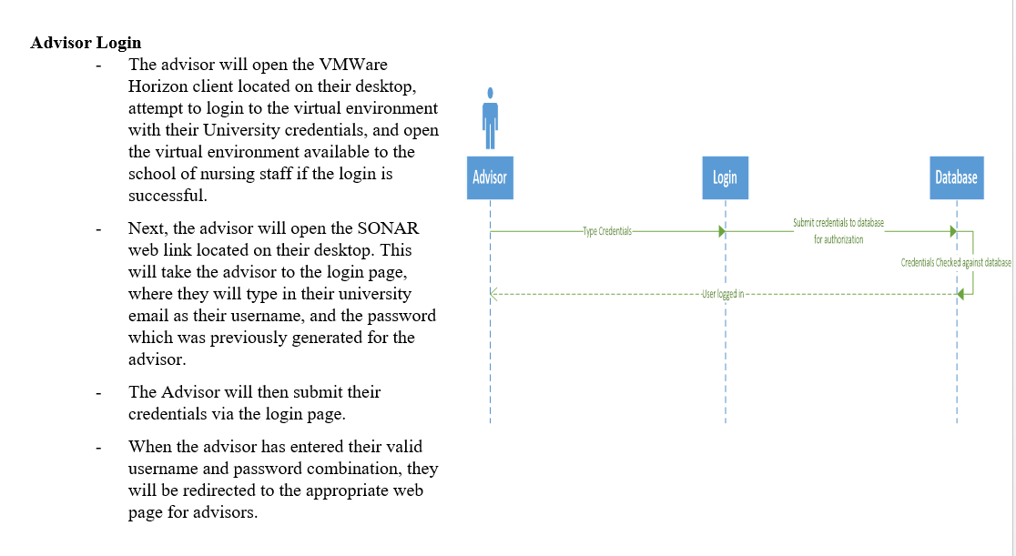

Login for Administrator

# Use-Case Name

Login for Administrators

## Brief Description

This use case describes how the Administrator will log into our SONAR system. It starts with the Administrator opening either the school virtual lab, or by opening the program from their laptop when they’re at the school and ends with the administrator being logged in, ready to complete the tasks they’ve been requested to complete. These alternative flows include what happens when the virtual client fails, when users fail to login to the horizon system, and when advisors will login to the system while on campus.

# Flow of Events

## Basic Flow

* The Administrator will open the VMWare Horizon client located on their desktop, attempt to login to the virtual environment with their University credentials, and open the virtual environment available to the school of nursing staff if the login is successful.
* Next, the Administrator will open the SONAR web link located on their desktop. This will take the Administrator to the login page, where they will type in their university email as their username, and the password which was previously generated for the Administrator.
* When the Administrator has entered their valid username and password combination, they will be redirected to the appropriate web page for the administration of the system.

## Alternative Flows

### Horizon Client Fails

The Administrator will open the VMWare Horizon client located on their desktop, attempt to login to the virtual environment with their University credentials, and open the virtual environment available to the SONAR administrator if the login is successful.

If the Administrator does not successfully log into the schools virtual environment, they will need to reenter their password and try again. If a login cannot be successfully had, they will need to reach out to University IT for assistance.

### Incorrect Login Credentials

The Administrator will open the VMWare Horizon client located on their desktop, attempt to login to the virtual environment with their University credentials, and open the virtual environment available to the school of nursing staff if the login is successful.

Next, the Administrator will open the SONAR web link located on their desktop. This will take the Administrator to the login page, where they will type in their university email as their username, and the password which was previously generated for the advisor.

If the login to SONAR was unsuccessful, the system administrator will need to initiate a password reset via email.

### Remote Login

The Administrator will already be on campus, and will be able to open the login page to our SONAR system directly from their own laptop. Provided they are connected to the school’s network and correctly enter their SONAR credentials, they will be able to login to the system and open the administrator homepage.

# Special Requirements

## Connectivity

Must be connected to School of Nursing network or connected through virtual Lab.

## Server Software

Server must run Windows Server 2012 or newer, as well as run SQL server 2016.

## FERPA

Due to FERPA restrictions, we cannot store student grades to the cloud.

# Pre-conditions

## Server On

Server must be turned on.

## SQL Server Running

SQL server software (database) must be running.

## Web Server Running

Web server software (for web pages) must be running.

# Post-conditions

## Logged In

The system will now be logged into by an advisor, now the system will be ready to update, create, and delete student information

## Ready for Reports

The system will now be ready to generate reports.

# Extension Points

## Invalid SONAR credentials

If the user types in invalid credentials, the system will not log them on. Users will be asked to provided valid login credentials should the credentials entered fail

## Invalid U of L credentials

If the user does not type in valid credentials, the Horizon software used by the university will ask for valid credentials to log remote users into the schools virtual lab.

## Unstable Network Connections

If the user is logging into the schools virtual environment, they must have a stable internet connection. If this is not possible, the user will not be able to log into the schools virtual environment, and consequently, will not be able to log into the SONAR system.

## Server Not Running

If the server that hosts the SONAR system is not turned on, the user will have to contact the SONAR system administrator.

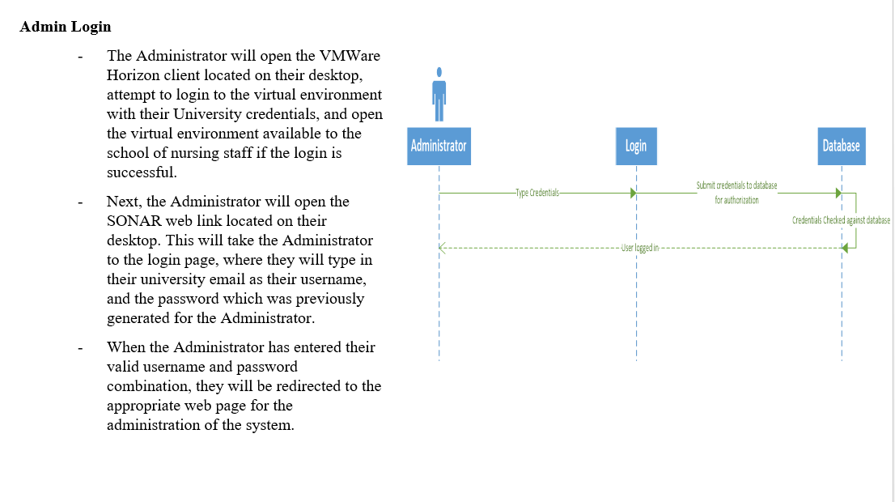

Login for Students

# Use Case Name

Login for Students

## Brief Description

This use case describes how a Student or other staff member will log into our SONAR system. It starts at logging into the school’s virtual environment from a remote location, and ends with a Student successfully logging into the system. It also discusses any alternatives there may be to the ideal system flow. These alternative flows include what happens when the virtual client fails, when users fail to login to the horizon system, and when Students will login to the system while on campus.

# Flow of Events

## Basic Flow

* The Student will open the VMWare Horizon client located on their desktop, attempt to login to the virtual environment with their University credentials, and open the virtual environment available to the school of nursing staff if the login is successful.
* Next, the Student will open the SONAR web link located on their desktop. This will take the Student to the login page, where they will type in their university email as their username, and the password which was previously generated for the Student.
* When the Student has entered their valid username and password combination, they will be redirected to the appropriate web page for Students.

## Alternative Flows

### Horizon Client Fails

The Student will open the VMWare Horizon client located on their desktop, attempt to login to the virtual environment with their University credentials, and open the virtual environment available to the school of nursing staff if the login is successful.

If a Student does not successfully log into the schools virtual environment, they will need to reenter their password and try again. If a login cannot be successfully had, they will need to reach out to University IT for assistance.

### Incorrect Login Credentials

The Student will open the VMWare Horizon client located on their desktop, attempt to login to the virtual environment with their University credentials, and open the virtual environment available to the school of nursing staff if the login is successful.

Next, the Student will open the SONAR web link located on their desktop. This will take the Student to the login page, where they will type in their university email as their username, and the password which was previously generated for the Student.

If the login to SONAR was unsuccessful, the Student will need to initiate either a password reset, or call the system administrator to unlock their account.

### Remote Login

The Student will already be on campus, and will be able to open the login page to our SONAR system directly from their own laptop. Provided they are connected to the school’s network and correctly enter their SONAR credentials, they will be able to login to the system and open the Students homepage.

# Special Requirements

## Connectivity

Must be connected to School of Nursing network or connected through virtual Lab.

## Server Software

Server must run Windows Server 2012 or newer, as well as run SQL server 2016.

## FERPA

Due to FERPA restrictions, we cannot store student grades to the cloud.

# Pre-conditions

## Server On

Server must be turned on.

## SQL Server Running

SQL server software (database) must be running.

## Web Server Running

Web server software (for web pages) must be running.

# Post-conditions

## Logged In

The system will now be logged into by a Student, now the system will be ready to update, create, and delete student information

## Ready for Reports

The system will now be ready to generate reports.

# Extension Points

## Invalid SONAR credentials

If the user types in invalid credentials, the system will not log them on. Users will be asked to provided valid login credentials should the credentials entered fail

## Invalid U of L credentials

If the user does not type in valid credentials, the Horizon software used by the university will ask for valid credentials to log remote users into the schools virtual lab.

## Unstable Network Connections

If the user is logging into the schools virtual environment, they must have a stable internet connection. If this is not possible, the user will not be able to log into the schools virtual environment, and consequently, will not be able to log into the SONAR system.

## Server Not Running

If the server that hosts the SONAR system is not turned on, the user will have to contact the SONAR system administrator.

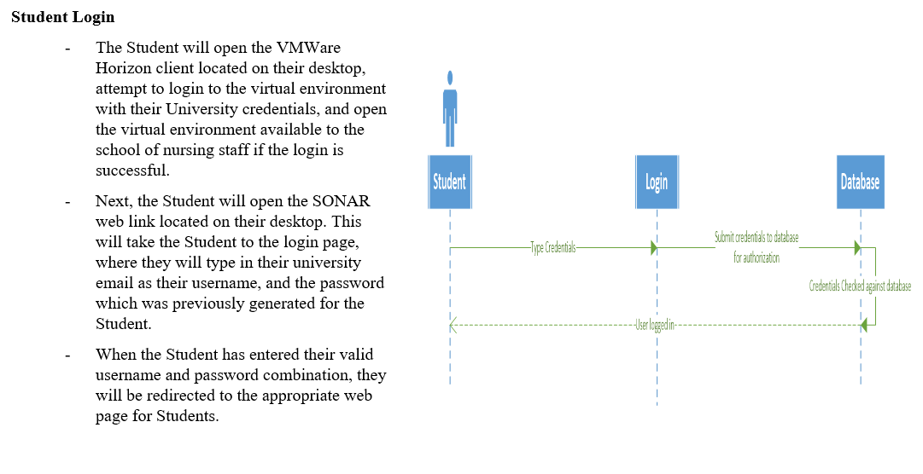

Login for Professor

# Use-Case Name

Login for Professors

## Brief Description

This use case describes how a Professor or other staff member will log into our SONAR system. It starts at logging into the school’s virtual environment from a remote location, and ends with a Professor successfully logging into the system. It also discusses any alternatives there may be to the ideal system flow. These alternative flows include what happens when the virtual client fails, when users fail to login to the horizon system, and when advisors will login to the system while on campus.

# Flow of Events

## Basic Flow

* The Professor will open the VMWare Horizon client located on their desktop, attempt to login to the virtual environment with their University credentials, and open the virtual environment available to the school of nursing staff if the login is successful.
* Next, the Professor will open the SONAR web link located on their desktop. This will take the Professor to the login page, where they will type in their university email as their username, and the password which was previously generated for the Professor.
* When the Professor has entered their valid username and password combination, they will be redirected to the Professors homepage, where they will be able to upload student grades.

## Alternative Flows

### Horizon Client Fails

The Professor will open the VMWare Horizon client located on their desktop, attempt to login to the virtual environment with their University credentials, and open the virtual environment available to the SONAR Professor if the login is successful.

If the Professor does not successfully log into the schools virtual environment, they will need to reenter their password and try again. If a login cannot be successfully had, they will need to reach out to University IT for assistance.

### Incorrect Login Credentials

The Professor will open the VMWare Horizon client located on their desktop, attempt to login to the virtual environment with their University credentials, and open the virtual environment available to the school of nursing staff if the login is successful.

Next, the Professor will open the SONAR web link located on their desktop. This will take the Professor to the login page, where they will type in their university email as their username, and the password which was previously generated for the Professor.

If the login to SONAR was unsuccessful, the system Professor will need to initiate a password reset via email or contact the system administrator to reset their password.

### Remote Login

The Professor will already be on campus, and will be able to open the login page to our SONAR system directly from their own laptop. Provided they are connected to the school’s network and correctly enter their SONAR credentials, they will be able to login to the system and open the Professor homepage.

# Special Requirements

## Connectivity

Must be connected to School of Nursing network or connected through virtual Lab.

## Server Software

Server must run Windows Server 2012 or newer, as well as run SQL server 2016.

## FERPA

Due to FERPA restrictions, we cannot store student grades to the cloud.

# Pre-conditions

## Server On

Server must be turned on.

## SQL Server Running

SQL server software (database) must be running.

## Web Server Running

Web server software (for web pages) must be running.

# Post-conditions

## Logged In

The system will now be logged into by an advisor, now the system will be ready to update, create, and delete student information

## Ready for Reports

The system will now be ready to generate reports.

# Extension Points

## Invalid SONAR credentials

If the user types in invalid credentials, the system will not log them on. Users will be asked to provided valid login credentials should the credentials entered fail

## Invalid U of L credentials

If the user does not type in valid credentials, the Horizon software used by the university will ask for valid credentials to log remote users into the schools virtual lab.

## Unstable Network Connections

If the user is logging into the schools virtual environment, they must have a stable internet connection. If this is not possible, the user will not be able to log into the schools virtual environment, and consequently, will not be able to log into the SONAR system.

## Server Not Running

If the server that hosts the SONAR system is not turned on, the user will have to contact the SONAR system administrator.

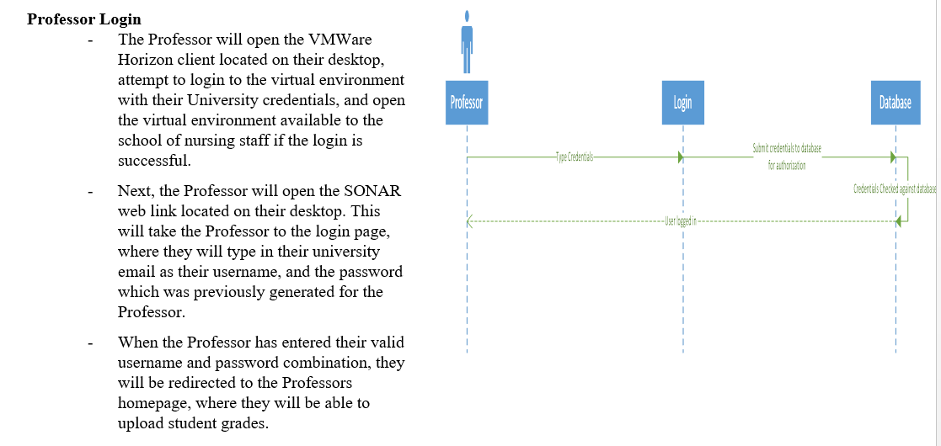

Login for Admission Committee Members

# Use Case Name

Login for Admission Committee Members

## Brief Description

This use case describes how a Committee Members or other staff member will log into our SONAR system. It starts at logging into the school’s virtual environment from a remote location, and ends with a Committee Members successfully logging into the system. It also discusses any alternatives there may be to the ideal system flow. These alternative flows include what happens when the virtual client fails, when users fail to login to the horizon system, and when advisors will login to the system while on campus.

# Flow of Events

## Basic Flow

* The Committee Members will open the VMWare Horizon client located on their desktop, attempt to login to the virtual environment with their University credentials, and open the virtual environment available to the school of nursing staff if the login is successful.
* Next, the Committee Members will open the SONAR web link located on their desktop. This will take the Committee Members to the login page, where they will type in their university email as their username, and the password which was previously generated for the Committee Members.
* When the Committee Members has entered their valid username and password combination, they will be redirected to the appropriate web page for Admission Committee Members.

## Alternative Flows

### Horizon Client Fails

The Committee Members will open the VMWare Horizon client located on their desktop, attempt to login to the virtual environment with their University credentials, and open the virtual environment available to the school of nursing staff if the login is successful.

If a Committee Members does not successfully log into the schools virtual environment, they will need to reenter their password and try again. If a login cannot be successfully had, they will need to reach out to University IT for assistance.

### Incorrect Login Credentials

The Committee Members will open the VMWare Horizon client located on their desktop, attempt to login to the virtual environment with their University credentials, and open the virtual environment available to the school of nursing staff if the login is successful.

Next, the Committee Members will open the SONAR web link located on their desktop. This will take the Committee Members to the login page, where they will type in their university email as their username, and the password which was previously generated for the Committee Members.

If the login to SONAR was unsuccessful, the Committee Members will need to initiate either a password reset, or call the system administrator to unlock their account.

### Remote Login

The Committee Members will already be on campus, and will be able to open the login page to our SONAR system directly from their own laptop. Provided they are connected to the school’s network and correctly enter their SONAR credentials, they will be able to login to the system and open the Admission Committee Members homepage.

# Special Requirements

## Connectivity

Must be connected to School of Nursing network or connected through virtual Lab.

## Server Software

Server must run Windows Server 2012 or newer, as well as run SQL server 2016.

## FERPA

Due to FERPA restrictions, we cannot store student grades to the cloud.

# Pre-conditions

## Server On

Server must be turned on.

## SQL Server Running

SQL server software (database) must be running.

## Web Server Running

Web server software (for web pages) must be running.

# Post-conditions

## Logged In

The system will now be logged into by an advisor, now the system will be ready to update, create, and delete student information

## Ready for Reports

The system will now be ready to generate reports.

# Extension Points

## Invalid SONAR credentials

If the user types in invalid credentials, the system will not log them on. Users will be asked to provided valid login credentials should the credentials entered fail

## Invalid U of L credentials

If the user does not type in valid credentials, the Horizon software used by the university will ask for valid credentials to log remote users into the schools virtual lab.

## Unstable Network Connections

If the user is logging into the schools virtual environment, they must have a stable internet connection. If this is not possible, the user will not be able to log into the schools virtual environment, and consequently, will not be able to log into the SONAR system.

## Server Not Running

If the server that hosts the SONAR system is not turned on, the user will have to contact the SONAR system administrator.

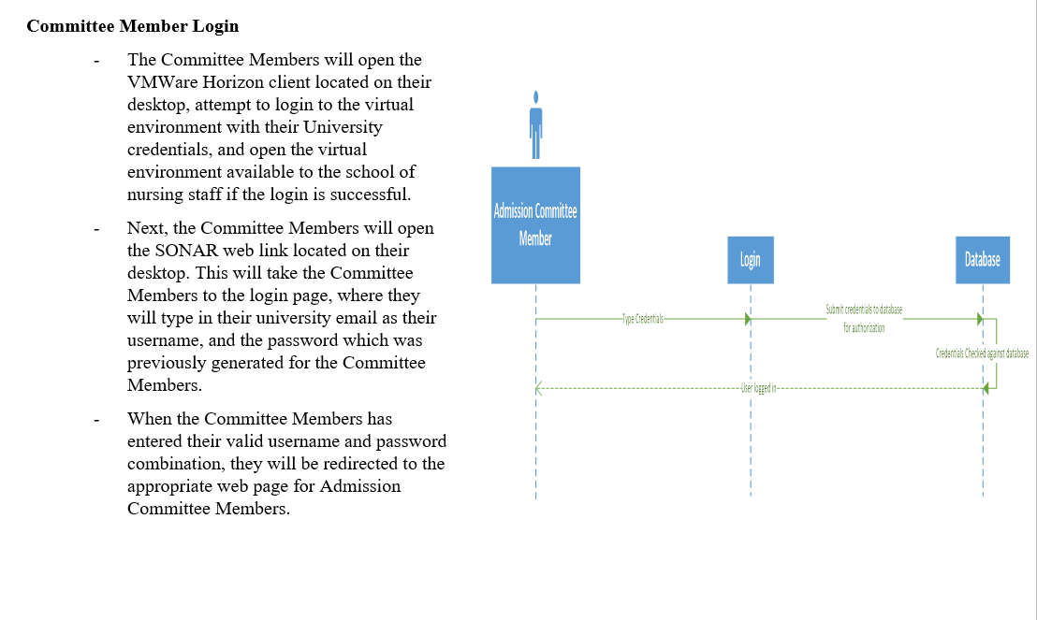

Submit Grades

# Use-Case Name

Submit Grades

## Brief Description

The Professor will submit the grades of each student in each class they teach in a given semester. This happens after a successful logon has been completed, and once the professor has finished entering the grades, they will submit the completed form and the grades for each student in the class will be written to the database. This use case includes an alternative flow where the professor may need to clear out all grades previously entered, as well as extension points for the feature this user case will become.

# Flow of Events

## Basic Flow

* The Professor will first successfully complete a login to the system via the login page. Once this is complete, there will be a drop down arrow that contains a list of each class they’ve taught during the past semester. The professor will select one class at a time.
* When a class has been selected, a form will appear on the webpage beneath the dropdown box with a list of student names, student ID’s, and a dropdown box next to each student. This will allow the Professor to simply click each dropdown box and select the grade earned.
* Beneath the form there will be two buttons. One will the clear the form and the other will record all the student’s grades to the database. When a Professor submits the grades, they will be recorded, and the Professor will be redirected to the page where they first selected the class they wish to submit grades for.

## Alternative Flows

### Incorrect Grades

The Professor will have selected a class, but started entering the grades of another class. When this occurs, the Professor will select the “Clear” button located beneath the form to erase any information they’d entered so far.

# Special Requirements

## Connectivity

Must be connected to School of Nursing network or connected through virtual Lab.

# Pre-conditions

## Logged In

The Professor will need to have already successfully logged into the SONAR system.

# Post-conditions

## Successful Submission

The Professor will have submitted the grades for one class for one semester.

# Extension Points

## Incorrect Class

A Professor will have the opportunity to change a student’s grades before submitting, after the Submit button has been clicked, a Professor will need to contact the system administrator to edit the student’s record.

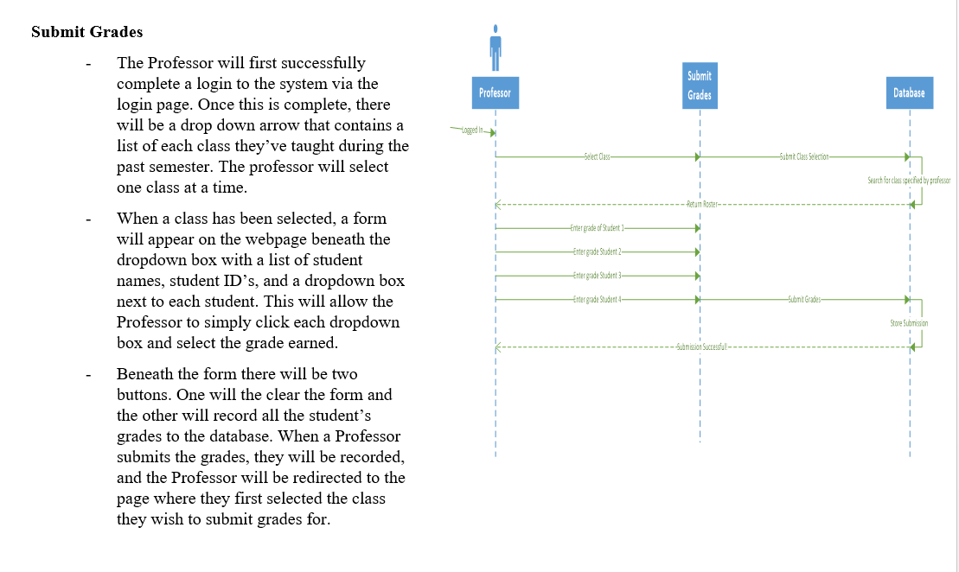

Query for Advising

# Use-Case Name

Query for Advising

## Brief Description

The Advisor will run many searches (queries) against the database in order to gain information about not just individual students, but groups of students that participate in the programs offered by the School of Nursing. These searches will be used to generate reports about students, and with these reports advisors will be able to reach out to students who may have decided to not enroll in a particular semester without graduating, or reach out to students that may be on academic probation or failed a course. This use case also details an alternative flow where an advisor doesn’t complete the report form before trying to generate the report.

# Flow of Events

## Basic Flow

* The Advisor will have successfully logged into the system by this point, and select the Queries tab visible on their home page.
* Once the Queries tab has been selected, the Advisor will need to select they type of query they wish to run. When they have selected the Multiple Student Query option, the Advisor will be presented with three drop down boxes.
* First, they will see the Student Type dropdown box, where they can select the type of student (lower division, upper division, graduate student, potential student, and Alumni) they wish to search for. The next dropdown box will have the attributes they wish to display (a dropdown box with check boxes next to each attribute the Advisor wishes to display). Finally, they will select the semester they wish to search through.
* Once all of the attributes have been selected, the Advisor will hit the Submit button to run the query. The results will be displayed in the available white space below the selection options.

## Alternative Flows

### Incomplete Form

The Advisor will not fill in all three of the required fields and the report will not be generated. Instead of being met with an error, the advisor will be informed what was missing and asked to fill in that part of the form.

Once the missing piece of the form has been filled out, the advisor will be allowed to generate and export the report if they so choose.

# Special Requirements

## Connectivity

Must be connected to School of Nursing network or connected through virtual Lab.

# Pre-conditions

## Logged In

The Advisor must be successfully logged into the system.

# Post-conditions

## Completed Query

The Committee Member will have generated the results of a query they selected. These results will be displayed on the web page for the Committee Member to review.

# Extension Points

## Missing Input

If a field has not been filled out, an error message will appear asking the Advisor to fill in that particular part of the form. For instance, if the semester option isn’t selected, the Advisor will receive a specific error asking them to select a semester.

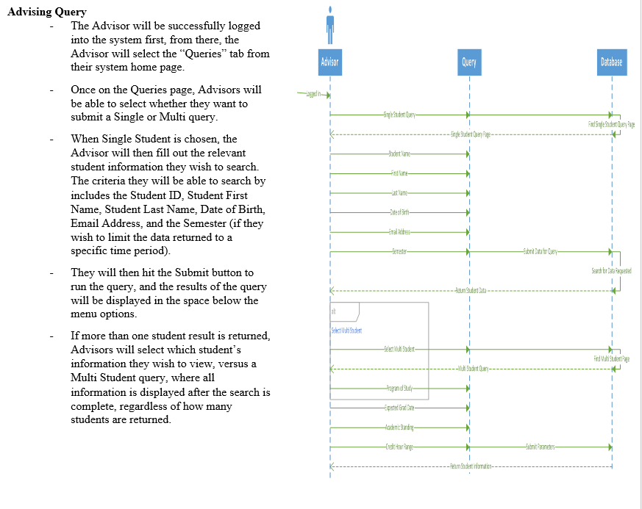

Query for Admission Committee

# Use-Case Name

Query for Admission Committee

## Brief Description

The Admission Committee Member will run many searches (queries) against the database in order to gain information about not just individual students, but groups of students that participate in the programs offered by the School of Nursing. These searches will be used to generate reports about students, and with these reports Committee Members will be able to reach out to students who may have decided to not enroll in a particular semester without graduating, or reach out to students that may be on academic probation or failed a course. This use case also details an alternative flow where a Committee Member doesn’t complete the report form before trying to generate the report.

# Flow of Events

## Basic Flow

* The Committee Member will be successfully logged into the system first, from there, the Committee Member will select the “Queries” tab from their system home page.
* Once on the Queries page, the Committee Member will be provided with drop down lists to choose the division level they wish to view, as well as the type of information they wish to view, and the semester they wish to view (in case they need to go back and look at historical data). To name a few options, the Committee Member could select the Lower Division Students in the first dropdown box, the students who failed one or more classes, and then the semester in which they wish to run the query.
* They will then hit the Submit button to run the query, and the results of the query will be displayed in the space below the menu options.

## Alternative Flows

### Incomplete Form

The Committee Member will not fill in all three of the required fields and the report will not be generated. Instead of being met with an error, the Committee Member will be informed what was missing and asked to select that option from the dropdown menus.

Once the missing piece of the form has been filled out, the Committee Member will be allowed to run the query and view the results.

# Special Requirements

## Connectivity

Must be connected to School of Nursing network or connected through virtual Lab.

# Pre-conditions

## Logged In

The Committee Member must be successfully logged into the system.

# Post-conditions

## Completed Query

The Committee Member will have generated the results of a query they selected. These results will be displayed on the web page for the Committee Member to review.

# Extension Points

## Invalid Input

If a field has not been filled out, an error message will appear asking the Committee Member to fill in that particular part of the form. For instance, if the semester option isn’t selected, the Committee Member will receive a specific error asking them to select a semester.

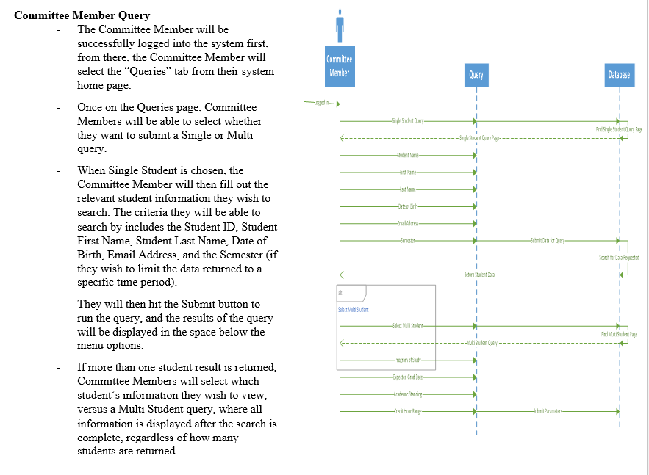

Upload Student Document

# Use-Case Name

Upload Student Document

## Brief Description

Students will have the ability to submit documentation for the review of advisors. The system will provide student users with an easy to use page that simply allows them to submit PDFs, PNGs, and JPEGs to the system so that Advisors may review and approve, not edit the documentation.

# Flow of Events

## Basic Flow

* Students will sign on to the system with their username and password, then browse to the Upload Documents page.
* Next, students will select the type of document they wish to submit (simply so Advisors will know what document they’re going to review before opening) and then hit the Browse button, which will open a small file browser that will allow students to pick which document they wish to submit.
* Once the document has been selected, students will be able to submit the document, which alerts the student’s advisor when the advisor next logs on to the system.

## Alternative Flows

### Student Selects Wrong File

Should a student go through the process of browsing through documents and accidentally select a document other than what they need to submit, the clear button will allow the student to remove the attached document and start the browsing process over again.

# Special Requirements

## Connectivity

Must be connected to School of Nursing network or connected through virtual Lab.

# Pre-conditions

## Logged On

The student MUST be logged on to the system in order to use this feature.

# Post-conditions

## Successful Submission

The student’s document will have successfully been submitted to the system for review by advisors.

# Extension Points

## Large File

If a file size is greater than 5 MB will not be accepted by the system. In case of this, students will receive an error asking them to submit a smaller file

## Wrong File Type

If the student submits anything other than a PDF, JPEG, or PNG, they will receive an error asking them to submit the document as one of the above mentioned file types.

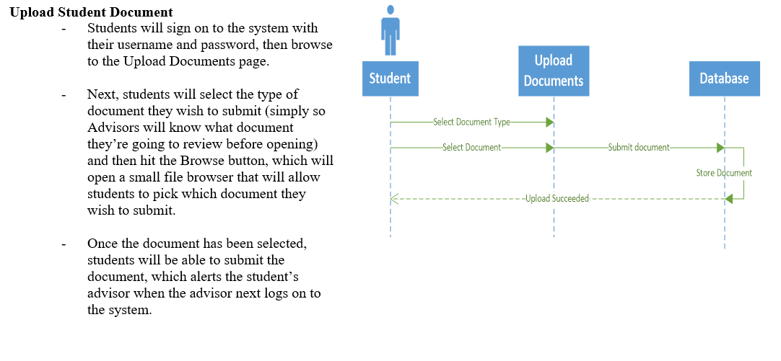

Import Data from Excel

# Use-Case Name

Import Data from Excel

## Brief Description

If the need should ever arise a need for data to be imported into the database, the system administrator will have the ability to do so. This allows the system to have more robust functionality, while limiting this privilege to a group that also has the ability to restore the system from a backup should anything go wrong. These excel files (in csv format) can be used to populate the database with information it previously did not contain in a quick, efficient manner.

# Flow of Events

## Basic Flow

* The Administrator will be successfully logged into the system at this point, and will have just arrived at their system home page. From here they will select the Database Maintenance tab from the main menu offered to the System Administrator.
* Once the Admin has been redirected to the Database Maintenance page, they will see another menu that will allow them to perform a number of functions, these will include importing a CSV (type of Excel file) to the database, export a backup of the database, and edit the database directly.
* The Admin will select the Import option on the menu of the Database Management page. This will open a dialog with a dropdown box that asks the Admin what type of data (lower division student, upper division student, alumni, etc.) they wish to import. When that selection has been made, an example CSV file will be shown. This will be how the columns in the CSV file must be ordered.
* Once the file that will be uploaded is properly formatted, the Admin will click the Upload button and search for the file they wish to upload. Once it has been selected, they will click the Open button and finish the upload. When the upload is complete, they will be taken back to the Database Management page with a pop-up with the message: “Import Complete”.

## Alternative Flows

### Wrong File type

If the Admin selects the wrong file type, which would be an excel file that has not been saved as a CSV, the system will reject it, and ask the Admin to please select a different file with the CSV file type. Another dialog box will open and allow the user to select another file with the correct file type.

# Special Requirements

## Connectivity

Must be connected to School of Nursing network or connected through virtual Lab.

# Pre-conditions

## User Type

The use of the system must be and Advisor

## File Type

The Admin must upload a CSV file

## File Format

The file to be uploaded must have its columns named and arranged as specified by the dialog box displayed by the system when the data type is selected.

# Post-conditions

## Successful Database Update

The Admin will have successfully uploaded a CSV file to the system. The new data (whether it be lower division students, upper division students, alumni information, etc.) will now be searchable by the other users for generating reports, or simply looking up a particular individual’s information.

# Extension Points

## Invalid Input

Non-CSV file type (such as other Excel file types, word documents, or PowerPoint files) file is uploaded, causing an error message to display that asks for a CSV file type.

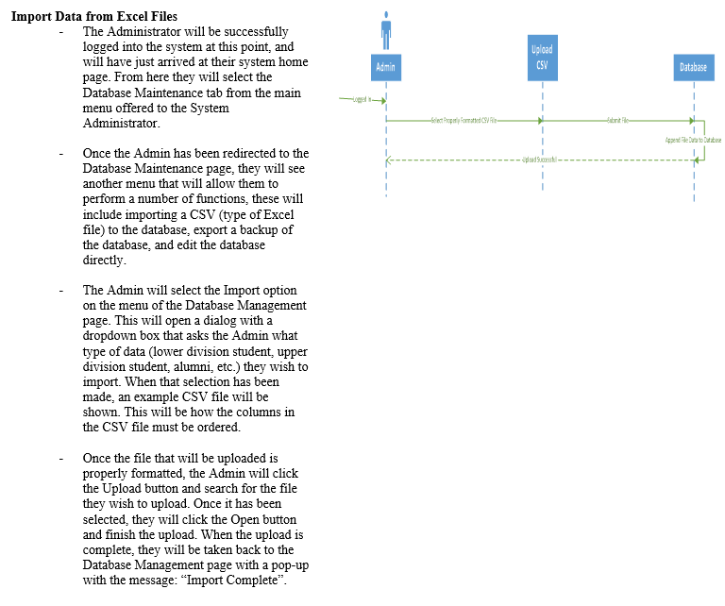

Generate Reports

# Use-Case Name

Generate Reports

## Brief Description

The Advisor will run many searches (queries) against the database in order to gain information about not just individual students, but groups of students that participate in the programs offered by the School of Nursing. These searches will be used to generate reports about students, and with these reports advisors will be able to reach out to students who may have decided to not enroll in a particular semester without graduating, or reach out to students that may be on academic probation or failed a course.

# Flow of Events

## Basic Flow

* The Advisor will have successfully logged into the system by this point, and select the reports tab visible on their home page.
* Once the reports tab has been selected, the Advisor will select the report they wish to run, as well as the date range (start and end dates) of the report so that not all data in the system will be returned. Once the report type and date range have been selected, the Advisor will hit the “Submit” button, which will generate the report and display it in the white space below.
* There will also be an option to export the report to an Excel file for further manipulation if the Advisor so desires.

## Alternative Flows

### Incomplete Fields

The Advisor will not fill in all three of the required fields and the report will not be generated. Instead of being met with an error, the advisor will be informed what was missing and asked to fill in that part of the form.

Once the missing piece of the form has been filled out, the advisor will be allowed to generate and export the report if they so choose.

### Report from Queries

An Advisor may also decide to create a report from the queries they run. In order to do this, the Advisor will start at the homepage and browse to the Queries page, select the kind of students they wish to query, select the attributes they wish to view, and the semester they want search. The Advisor will click the Submit button and run the query.

When the query has finished running, and Export button will appear next to the Submit button, the export button will create a CSV file and export it from the system, and to the Advisors Downloads folder on their local machine if they’re at the school, or their virtual lab Downloads folder if they connect remotely.

# Special Requirements

## Connectivity

Must be connected to School of Nursing network or connected through virtual Lab.

# Pre-conditions

## Logged in

The Advisor must be logged into SONAR before running or exporting reports.

# Post-conditions

## Report Generated

The Advisor will have generated a report of their choosing. From here they can simply view the report or export it for further manipulation.

# Extension Points

## Invalid Query

If the users query fails, they will not be able to export the results. If a query should fail, the user should follow the error message instructions on how to acquire the results they need.

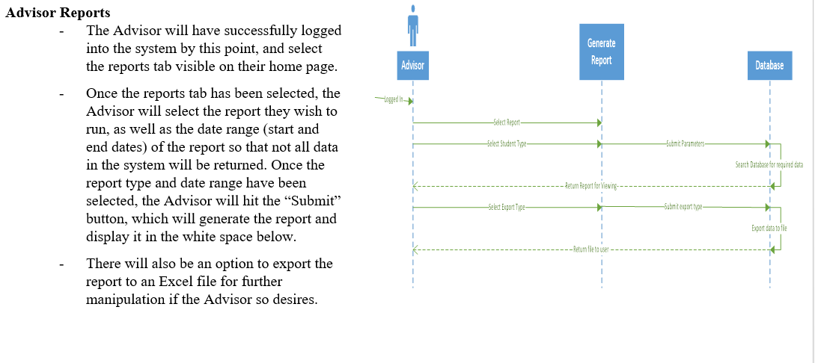

Generate Reports for Decision Making

# Use-Case Name

Generate Reports for Committee Members

## Brief Description

The Committee Member will run many searches (queries) against the database in order to gain information about not just individual students, but groups of students that participate in the programs offered by the School of Nursing. These searches will be used to generate reports about students, and with these reports Committee Members will be able to reach out to students who may have decided to not enroll in a particular semester without graduating, or reach out to students that may be on academic probation or failed a course.

# Flow of Events

## Basic Flow

* The Committee Member will have successfully logged into the system by this point, and select the reports tab visible on their home page.
* Once the reports tab has been selected, the Committee Member will select the report they wish to run, as well as the date range (start and end dates) of the report so that not all data in the system will be returned. Once the report type and date range have been selected, the Committee Member will hit the “Submit” button, which will generate the report and display it in the white space below.
* There will also be an option to export the report to an Excel file for further manipulation if the Committee Member so desires.

## Alternative Flows

### Incomplete Fields

The Committee Member will not fill in all three of the required fields and the report will not be generated. Instead of being met with an error, the Committee Member will be informed what was missing and asked to fill in that part of the form.

Once the missing piece of the form has been filled out, the Committee Member will be allowed to generate and export the report if they so choose.

### Report from Queries

A Committee Member may also decide to create a report from the queries they run. In order to do this, the Committee Member will start at the homepage and browse to the Queries page, select the kind of students they wish to query, select the attributes they wish to view, and the semester they want search. The Committee Member will click the Submit button and run the query.

When the query has finished running, and Export button will appear next to the Submit button, the export button will create a CSV file and export it from the system, and to the Committee Members Downloads folder on their local machine if they’re at the school, or their virtual lab Downloads folder if they connect remotely.

# Special Requirements

## Connectivity

Must be connected to School of Nursing network or connected through virtual Lab.

# Pre-conditions

## Logged in

The Committee Member must be logged into SONAR before running or exporting reports.

# Post-conditions

## Report Generated

The Committee Member will have generated a report of their choosing. From here they can simply view the report or export it for further manipulation.

# Extension Points

## Invalid Query

If the users query fails, they will not be able to export the results. If a query should fail, the user should follow the error message instructions on how to acquire the results they need.

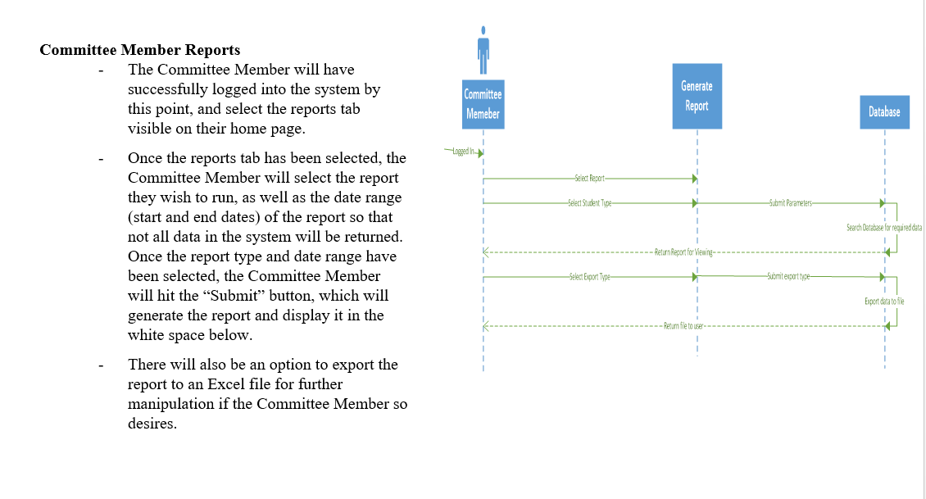

Automatic Reporting

# Use-Case Name

Setup Automatic Reporting

## Brief Description

Some reports can be generated and delivered automatically. On this page, users will be able to sign up for weekly, monthly, or semester reports. These will be the built in reports that are available on the reports page for users to export.

# Flow of Events

## Basic Flow

* The Advisor will log into the SONAR system and start from the homepage. From here, Advisors will browse to the Automatic Reporting page by clicking the Automatic Reporting link listed in the Homepage main menu.
* Once on the Automatic Reporting page, Advisors will have a table which contains all available automatic reports listed. From here, advisors will be able to click a checkbox to the left of each report.
* To the right of each report will be three radio buttons (meaning only one choice can be selected). The first button will fall into a column with the header “Weekly”, the next will fall into a column with the header “Monthly”, and the last button will fall into a column with the header “Semester”.
* When the Weekly box is checked, that report will be emailed weekly on Monday at 8AM, when Monthly is selected, that report will be emailed to the advisor once a month on the first day of the month. When the Semester box is checked, the report will be emailed out on the Monday one week before classes start each semester.
* When the Advisor is finished making changes to the reports they wish to receive, they will have a Save button located above the table on the right side. The Save button will store all changes made, and start the process of emailing reports to the Advisors on the basis in which they specify.

## Alternative Flows

### Forgotten Save

If a user forgets to save and makes a move to browse away from the current page, a dialog box will pop up asking if a user wants to continue on to another page. If they click the Yes button, their changes will be lost and the browser will continue on to the next page the user requested. If the Advisor hits No, the browser will remain on the Automatic Reporting page until the user has saved their changes. Once the changes have been saved, the user will be able to navigate away without any further alerts from the system.

# Special Requirements

## Connectivity

System must be turned on and connected to the school’s network

## Login Type

Currently, the user must be an advisor.

# Pre-conditions

## Logged In

Advisors must be logged into the system to initiate the Automatic reporting process.

# Post-conditions

## Delivered Report

A report will be emailed out to the advisor however often they specified.

# Extension Points

## Forgotten Save

If a user does not save changes before navigating away from the page, their progress will be lost and they will have to start the process over if they wish to make changes to how which automatic reports are delivered and when.

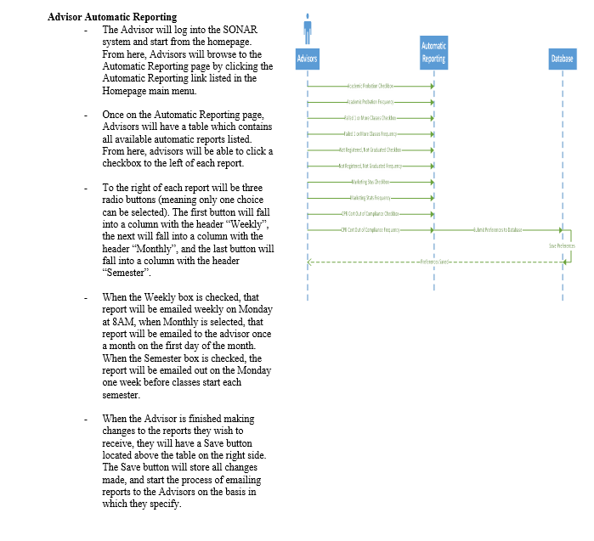

# Export to CSV

## Brief Description

The purpose of this is to allow for the advisor to export information from the database into an excel sheet to use as needed.

# Flow of Events

## Basic Flow

-Main character – Advisor

-Allows advisor to export data from database to an excel sheet

-Allows the advisor the manipulate data in an excel sheet without altering the data in the database

- Allows the advisor to print the students information

## Alternative Flows

Alternative flows are actions that will occur if the information does not export correctly.

### **Information does not transfer correctly**

There is a small chance that if the system is not put together correctly, when an advisor attempts to export the data, the information may be corrupt or not transfer smoothly

# Special Requirements

Special requirements are requirements that must be met before the advisor is able to export the data.

## System Requirements

* Access to Windows Server 2012
* Access SQL 2016
* Due to FERPA restrictions we must store student information and grades on secure University of Louisville servers
* Access to Microsoft excel

# Pre-conditions

## Pre conditions are conditions that must be met for the advisor to be able to successfully export the data.

## Administrator access to the database

In order for the advisor to be able to export data, they must first obtain administrator rights to the system that allows for them to have access to the data.

# Post-conditions

Post conditions are what the final result will be after hitting export

## Exported data

If everything works as it should, after the advisor hits the export data button, the data will automatically open an excel sheet with all of the data properly transferred over.

# Extension Points

If the system is not set up properly, then there is a chance the data will be corrupt.

## Corrupt Data

The system needs to be double checked prior to implementation to insure that when the advisor tries to export the data, the data will transfer correctly and smoothly.

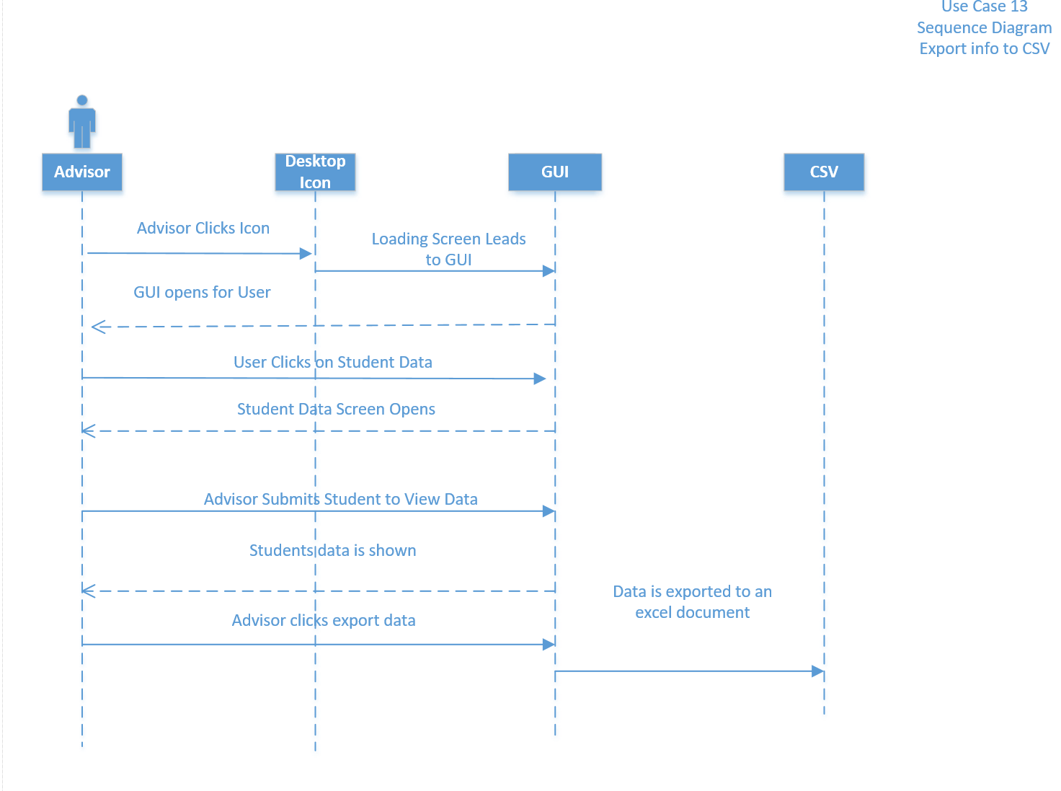

Sonar

Update Student Records

Version <1.0>Revision History

|  |  |  |  |
| --- | --- | --- | --- |
| **Date** | **Version** | **Description** | **Author** |
| 19/Oct/16 | 1.0 | Use Case: Update Student Records | Christopher Meany |
|  |  |  |  |
|  |  |  |  |
|  |  |  |  |

Table of Contents

1. Update student records 4

1.1 Brief Description 4

2. Flow of Events 4

2.1 Basic Flow 4

2.2 Alternative Flows 4

2.2.1 Required fields incomplete 4

2.2.2 Cancel form 4

3. Special Requirements 4

3.1 System Requirements 4

4. Pre-conditions 4

4.1 User access to database 4

5. Post-conditions 4

5.1 Student record is updated 4

6. Extension Points 4

6.1 Input is in invalid form 5

# Update Student Records

## Brief Description

Update a student record will allow for the advisor to login with admin rights and be able to update a student’s records.

# Flow of Events

## Basic Flow

* Actor- Advisor
* Advisor will initially log in with username and password
* Upon logging in they will select update a student
* They will then select the student by their name or student id
* They will update the student and hit confirm
* They will be prompted with an are you sure which they must select yes or no
* If they select yes they will have to re-enter their username and credentials to save

## Alternative Flows

The advisor will be prompted with an incorrect format or error message if information has been put in incorrectly.

### Information in incorrect format

The advisor will receive and error message to fix information that is entered incorrectly or left blank.

### Cancel

If the advisor no longer wishes to update a student’s information they will have the option to cancel the update.

# Special Requirements

These are requirements that must be met to allow the advisor to update the student.

## System Requirements

* Access to Windows Server 2012
* Access SQL 2016
* Due to FERPA restrictions we must store student information and grades on secure University of Louisville servers

# Pre-conditions

Conditions that must be met to allow the advisor to update records

## Access to the system

#### The advisor must have administrator rights to be able to login and change student information.

# Post-conditions

These are the conditions following the updating of the student records

## Student records updated

Once the advisor submits the new information, the student’s records will be updated.

# Extension Points

If any field is incorrectly filled in, they will receive an error message.

## Invalid Input

-Incorrect format

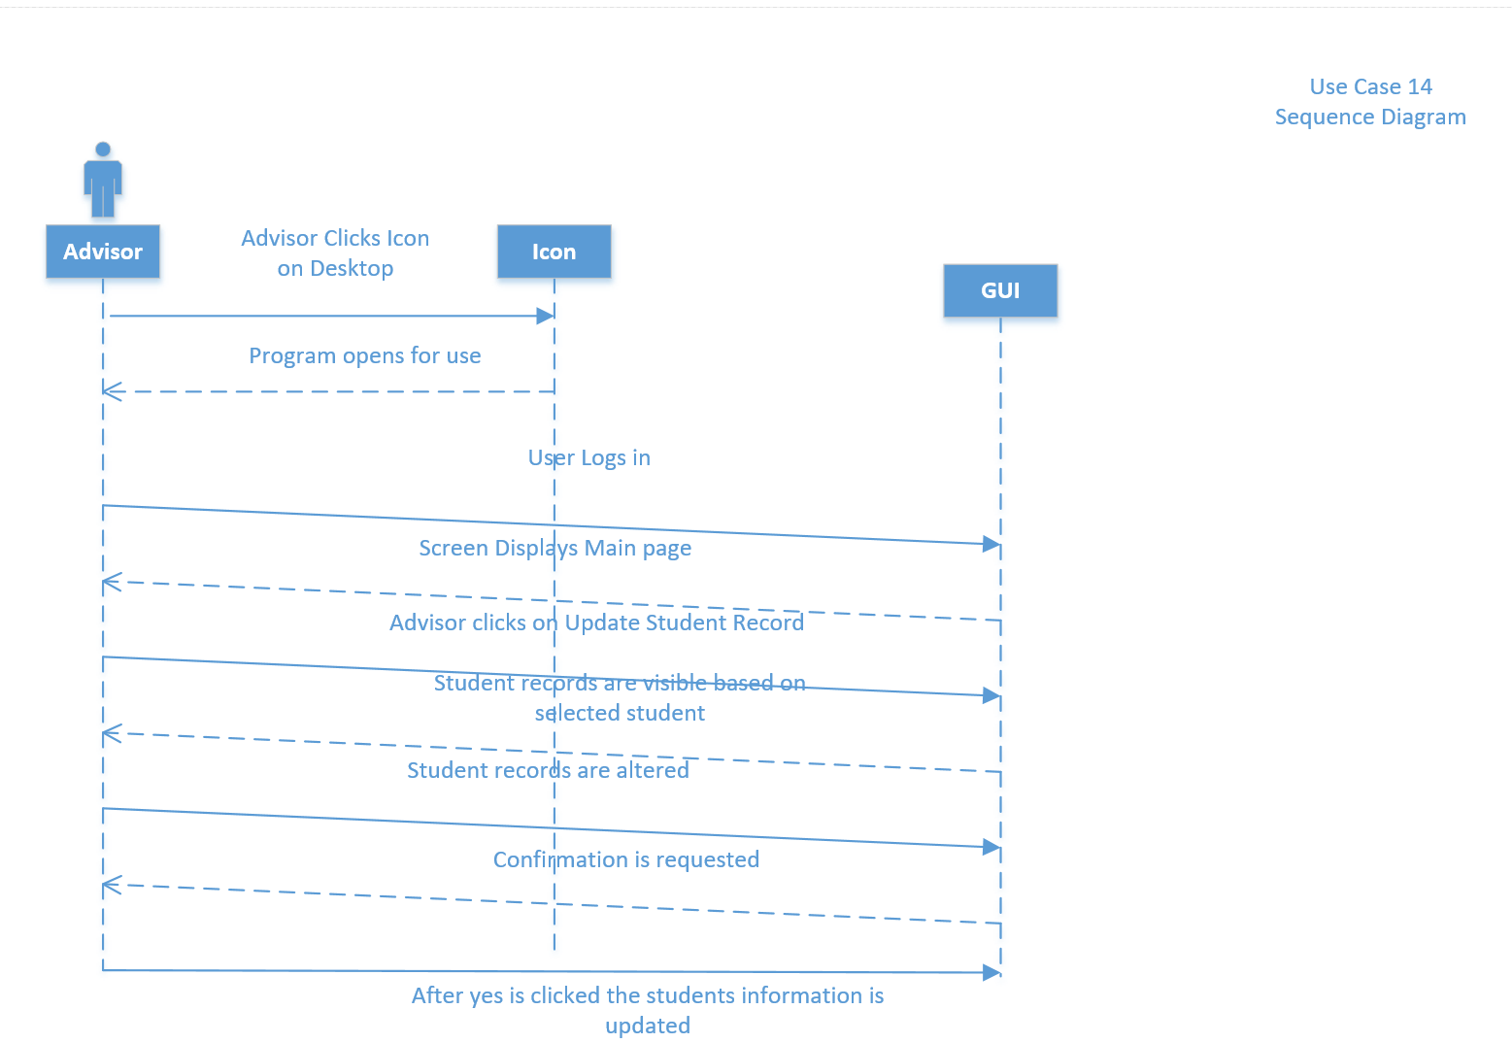

Sonar

Add Students to System Manually

Version <1.0>



Revision History

|  |  |  |  |
| --- | --- | --- | --- |
| **Date** | **Version** | **Description** | **Author** |
| 19/Oct/16 | 1.0 | Use Case: | Christopher Meany |
|  |  |  |  |
|  |  |  |  |
|  |  |  |  |

Table of Contents

1. Add students to system manually 4

1.1 Brief Description 4

2. Flow of Events 4

2.1 Basic Flow 4

2.2 Alternative Flows 4

2.2.1 Required fields incomplete 4

2.2.2 Cancel form 4

3. Special Requirements 4

3.1 System Requirements 4

4. Pre-conditions 4

4.1 Advisor has access to database 4

5. Post-conditions 4

5.1 Student is manually added 4

6. Extension Points 4

6.1 Input is in invalid format 5

# Use-Case Name

## Brief Description

Adding a student manually allows the advisor to create a student and manually add their information

# Flow of Events

## Basic Flow

* Actor- Advisor
* Advisor will log in with username and password
* Advisor will click create student
* Then they will enter the information required about the new student
* After entering the information they will hit submit and be prompted with an are you sure
* They will hit yes to create the student or no to back up and continue editing
* Before the student is fully added, the advisor will have to re-enter their credentials to add the student

## Alternative Flows

Alternative flows are actions that will occur if the advisor incorrectly enters the information.

### **Required fields are incomplete**

* If all of the required fields are not correctly put into the web form then they will receive an error message prompting them to complete the form.

#### **Cancel Form**

If the advisor decides not to submit the form to add the student manually, they can cancel the form.

# Special Requirements

These are the requirements that must be met before the advisor can manually update the student.

## System Requirements

* Access to Windows Server 2012
* Access to SQL 2016
* Due to FERPA restrictions we must store student information and grades on the secured University of Louisville servers.

# Pre-conditions

* These are conditions that must be met to manually add the student.

## Access to the system

The advisor must have administrator rights to login and manually add the student to the system.

# Post-conditions

This is what will happen after the form has been submitted

## Student manually added

Once the form has been manually filled in, the advisor may hit the submit button and the student will have been manually added.

# Extension Points

If a field is incorrectly filled out or left blank, the advisor will receive an error message.

## Invalid Input

* Incorrect format
* Invalid characters
* Incomplete required fields

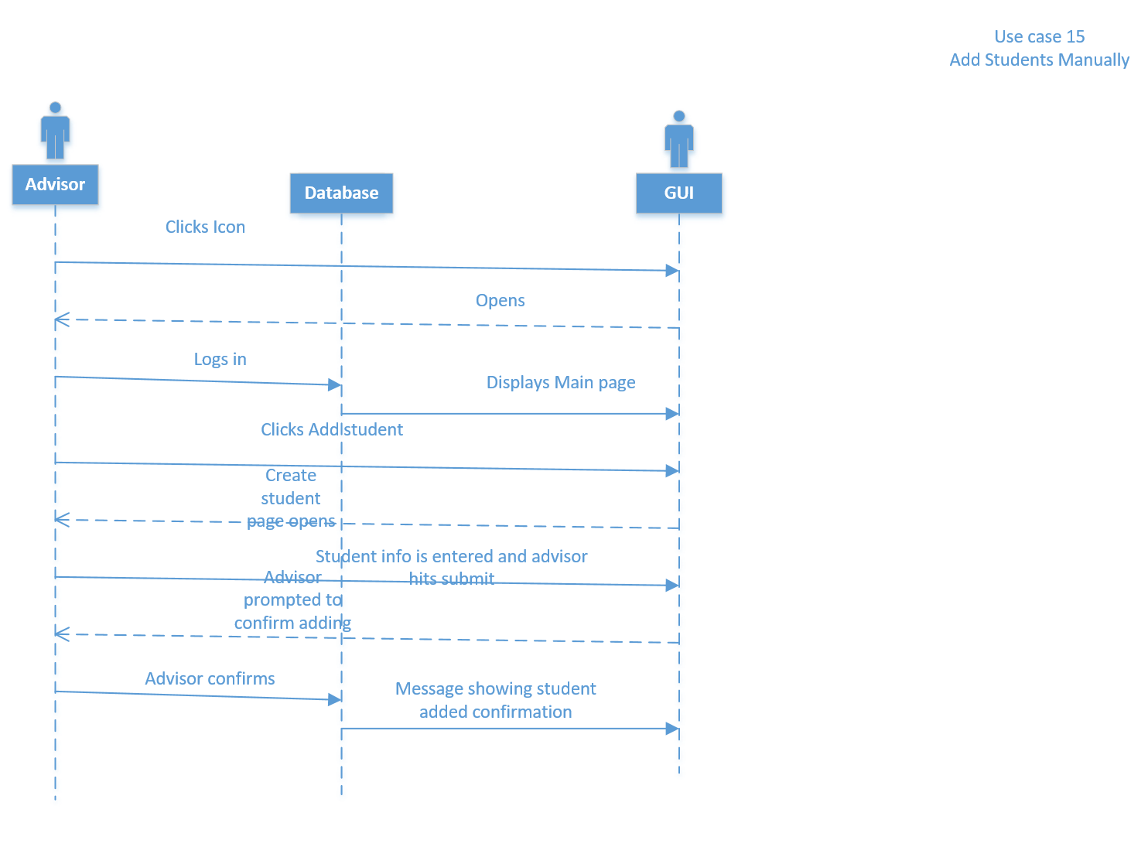

Sonar

Create New System Users

Version <1.0>

Revision History

|  |  |  |  |
| --- | --- | --- | --- |
| **Date** | **Version** | **Description** | **Author** |
| 19/Oct/16 | 1.0 | Use Case: Create new system users | Christopher Meany |
|  |  |  |  |
|  |  |  |  |
|  |  |  |  |

Table of Contents

1. Create new system users 4

1.1 Brief Description 4

2. Flow of Events 4

2.1 Basic Flow 4

2.2 Alternative Flows 4

2.2.1 Required fields incomplete 4

2.2.2 Cancel new user form 4

3. Special Requirements 4

3.1 System Requirements 4

4. Pre-conditions 4

4.1 System creator has admin rights 4

5. Post-conditions 4

5.1 New user is created 4

6. Extension Points 5

6.1 Input is in invalid form or incomplete 5

# Create new system users

## Brief Description

This use case allows for the system creator to create users within the system to use the system

# Flow of Events

## Basic Flow

* Actor – Database Administrator
* Allows the database administrator to create new users such as advisors or teachers
* The database administrator will be able to assign administrator rights to the advisors and teachers to allow them to update records and update student’s information.

## Alternative Flows

Alternative flows are actions that will occur if the database administrator incorrectly inputs a user.

### **Required fields are not complete**

If the required fields are not complete or entered incorrectly, then the database administrator will receive and error message.

### **Cancel form**

If the database administrator wishes to cancel adding a user, then they can hit a cancel button and delete the user they were creating.

# Special Requirements

These are the requirements that must be met to allow the creation of a new user

## System Requirements

* Access to Windows Server 2012
* Access SQL 2016
* Due to FERPA restrictions we must store student information and grades on secure University of Louisville servers

# Pre-conditions

These are the conditions that must be met to allow the database administrator to create a new user

## Administrator rights

The database administrator must have rights to the system that allows for them to create other users.

# Post-conditions

These are the conditions that follow creating a user

## Creating a new user

After the forms have been correctly filled out and submitted, then the new user will have access to the database system.

# Extension Points

If any field is incorrectly filled out or left blank the database administrator will receive and error message

## Incorrectly filled out

If the web form is not correctly filled out or has incorrect format, the administrator will receive an error message.

## Required fields left blank

If the administrator leaves any fields blank, they will receive an error message upon hitting the submit button.

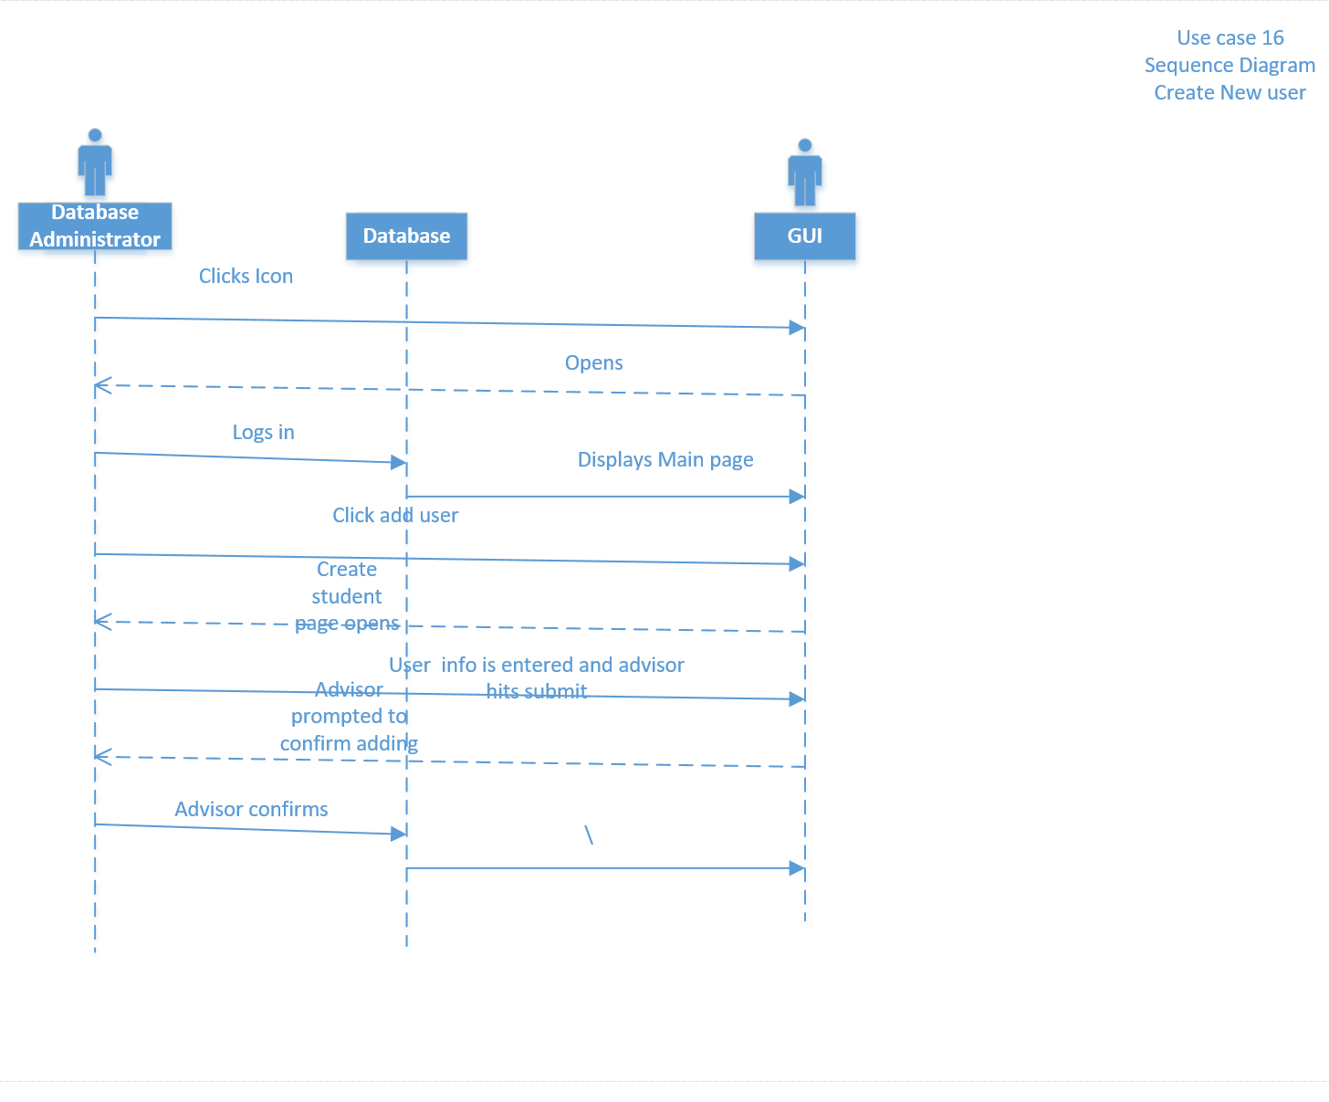

Sonar

Reset User Password Via Email

Version <1.0>

Revision History

|  |  |  |  |
| --- | --- | --- | --- |
| **Date** | **Version** | **Description** | **Author** |
| 19/Oct/16 | 1.0 | Use Case: Reset user password via email | Christopher Meany |
|  |  |  |  |
|  |  |  |  |
|  |  |  |  |

Table of Contents

1. Reset user password via email 2

1.1 Brief Description 2

2. Flow of Events 2

2.1 Basic Flow 2

2.2 Alternative Flows 2

2.2.1 New password is not strong enough 2

2.2.2 New passwords do not match 2

3. Special Requirements 2

3.1 System requirements 2

4. Pre-conditions 2

4.1 User login access to database 2

5. Post-conditions 2

5.1 User password reset successfully 2

6. Extension Points 2

6.1 Passwords do not match 2

6.2 Passwords are not correct format

# Reset user password via email

## Brief Description

The actor in this case is the advisor’s that need to reset their passwords via email. They will submit a request if they need to change their password and they will receive and email with a link to allow them to properly change their login password.

# Flow of Events

## Basic Flow

* Actor – Basic user
* User will navigate to log in screen and select change password button
* They will enter their username and then type their old password followed by their new password twice before hitting submit.
* If the new password meets the requirements set for a password, and is entered correctly twice, then the password will be reset successfully.

The actor in this case is the advisor that needs to reset their password through a link they receive through an email. Once their link is completed and they have matched their new password twice, their password will be reset.

## Alternative Flows

Alternative flows are actions that will occur if the advisor fails to reset their password

### Password is incorrect format

If the advisors new password is not compatible with the format required, they will receive an error message.

### Passwords do not match

The advisor must enter their new password two times to confirm that they have entered the password correctly. If the two times they enter the passwords do not match, they will receive an error message.

# Special Requirements

These are requirements that must be met to run the database and allow them to request to reset their password.

## System Requirements

* Access to Windows Server 2012
* Access SQL 2016
* Due to FERPA restrictions we must store student information and grades on secure University of Louisville servers

# Pre-conditions

These are conditions that must be met to allow the user to reset their password.

## Access to the system

* The user must have rights to the system and a created profile to be able to request to reset their password.

# Post-conditions

The post conditions will be that the user successfully resets their password

## Password reset successfully

Once the email link has been clicked and the password reset information has been successfully filled out, their password will be reset.

# Extension Points

If the password reset information is not filled out correctly, then they will receive and error message.

## Passwords do not match

If the new password is not entered the same twice, they will receive an error message.

## Passwords do not meet required format

If the passwords do not meet the systems format, they will receive and error message

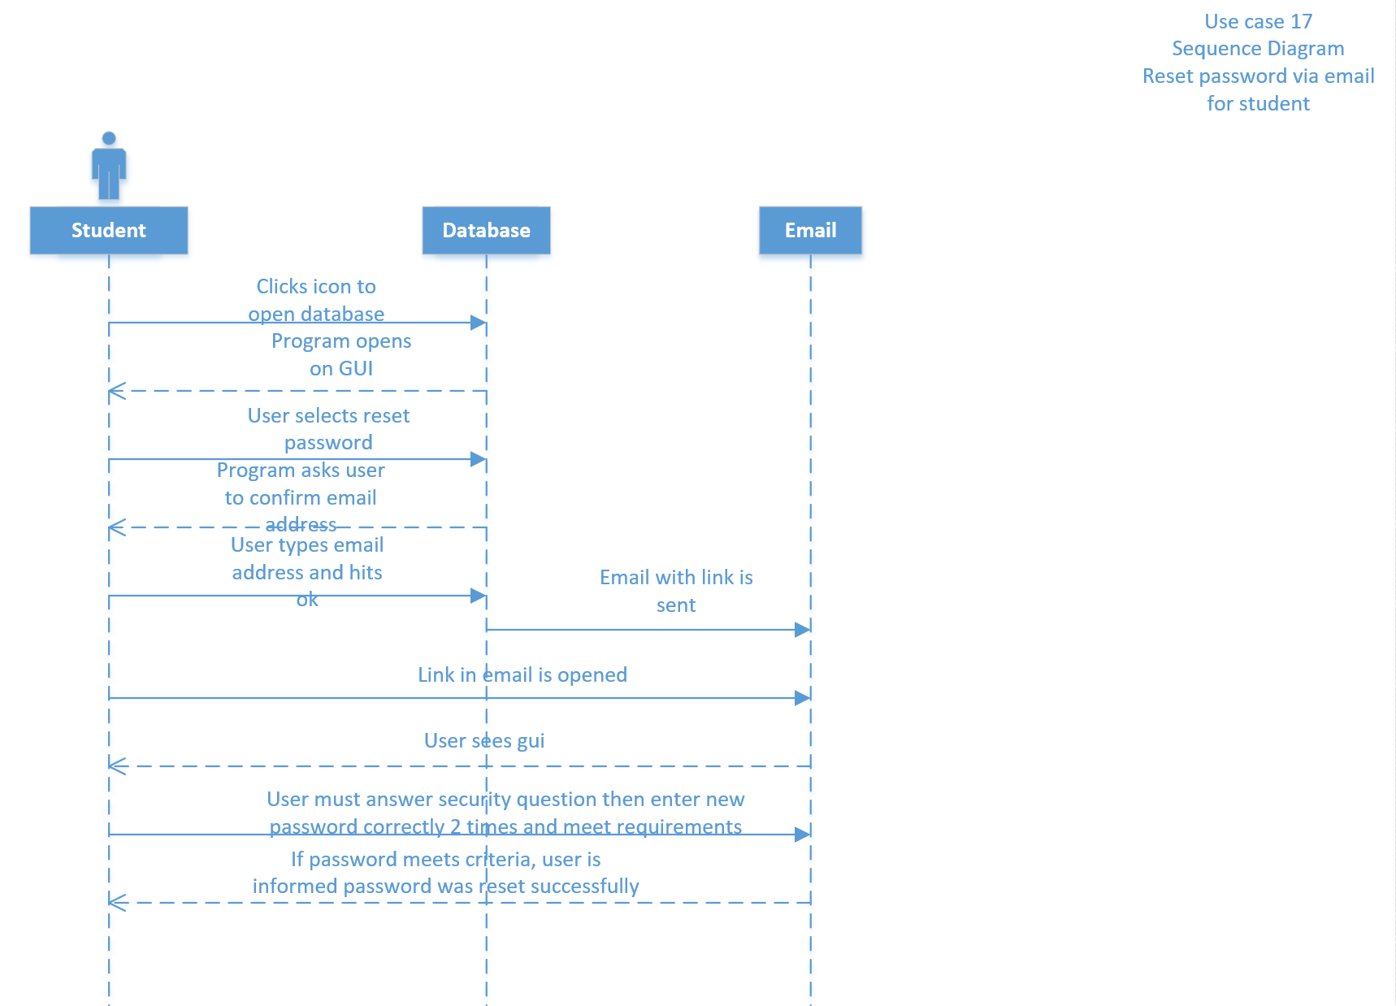

Sonar

Reset System Admin Password Via Email

Version <1.0>

Revision History

|  |  |  |  |
| --- | --- | --- | --- |
| **Date** | **Version** | **Description** | **Author** |
| 19/Oct/16 | 1.0 | Use Case: Reset system admin password via email | Christopher Meany |
|  |  |  |  |
|  |  |  |  |
|  |  |  |  |

Table of Contents

1. Reset System Admin Password Via Email 4

1.1 Brief Description 4

2. Flow of Events 4

2.1 Basic Flow 4

2.2 Alternative Flows 4

2.2.1 New password entered in incorrect format 4

2.2.2 New passwords do not match 4

3. Special Requirements 4

3.1 System Requirements 4

4. Pre-conditions 4

4.1 System admin must have administrator rights 4

5. Post-conditions 5

5.1 Password is successfully changed 5

6. Extension Points 5

6.1 Password format is incorrect 5

Use Case Specification: Database Administrator Change Password Via Email

# System Administrator changes password via email

## Brief Description

When the system administrator needs to change his or her password, they will submit a request to receive a link that will allow for them to change their password through their registered email.

# Flow of Events

## Basic Flow

* Actor – Database Administrator
* System Administrator will navigate to log in screen and select forgot password button
* System administrator will then enter their email and hit submit
* The system administrator will then open the link in their email and enter their username and answer security questions.
* Following the security questions they will have to enter a new password that meets the requirements successfully two times and hit submit.
* If the password was accepted, then they will be notified it was successfully changed.
* If the passwords do not match or do not meet the requirements, then they will be notified to retry.

## Alternative Flows

Alternative flows are actions that will occur if the administrator fails to properly change their password.

### **Password does not meet the required standards**

If the password does not meet the standards set for an appropriate password, then the system administrator will receive and error message prompting them to retype a new password.

### **Passwords do not match**

The user will have to type in a new password two times and make sure that they match or they will receive an error message prompting them to retype the new password.

# Special Requirements

These are requirements that must be filled to allow the system administrator to be able to login and change their password

## System Requirements

* Access to Windows Server 2012
* Access SQL 2016
* Due to FERPA restrictions we must store student information and grades on secure University of Louisville servers
* Must have system administrator rights to the database to authorize them to make this change.

# Pre-conditions

These are conditions that must be met to allow for the system admin to change their password.

## Access to the system with administrator rights

* System administrator must have administrator rights.
* System administrator must be able to have access to the University of Louisville’s new system for the school of nursing.

# Post-conditions

Post conditions are what will take place after the user successfully changes their password.

## Password Reset

After the system administrator successfully submits a new password that meets the requirements necessary for this system, they will have a new password.

# Extension Points

If the system administrator does not properly fill out the new password they will be given an error message to let them know to retry.

## Passwords do not match

The system administrator will have to fill out a form where they enter a new password twice. If the two passwords do not match, they will receive and error message that will tell them to reenter their new passwords twice.

## Password does not meet required format

If the password does not meet the format required by the software, they will be given an error message to let them know to try a new password.

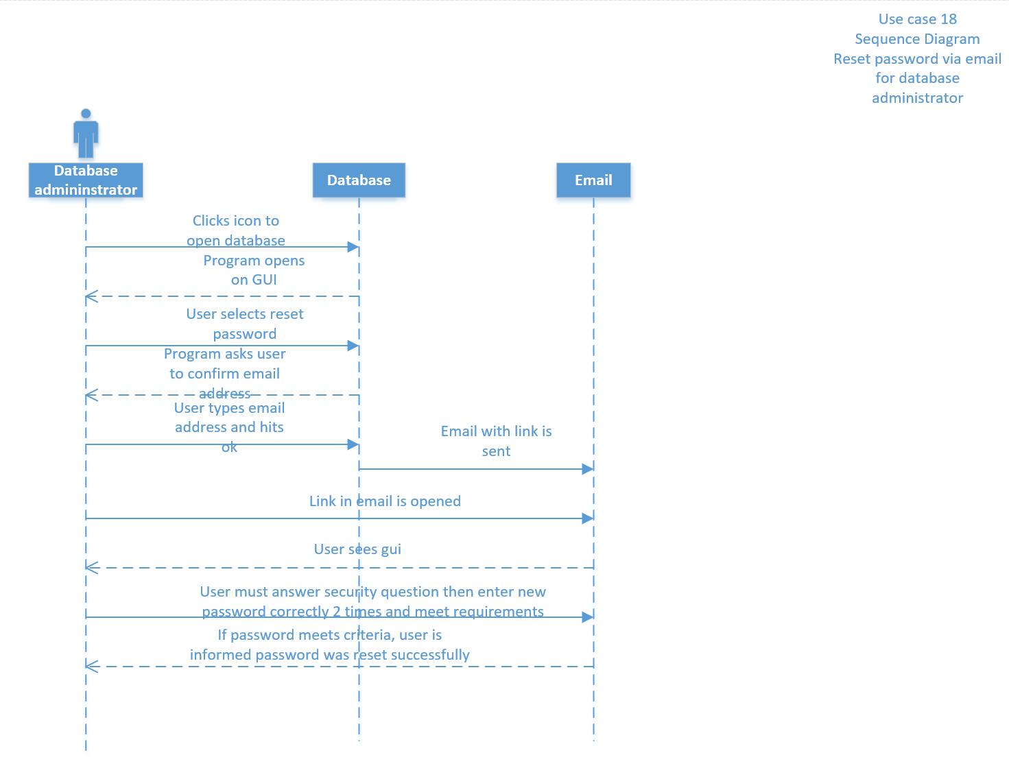

Sonar

Reset Professor Password Via Email

Version <1.0>

Revision History

|  |  |  |  |
| --- | --- | --- | --- |
| **Date** | **Version** | **Description** | **Author** |
| 19/Oct/16 | 1.0 | Use Case: Reset Professor password via email | Christopher Meany |
|  |  |  |  |
|  |  |  |  |
|  |  |  |  |

Table of Contents

1. Reset Professor Password Via Email 4

1.1 Brief Description 4

2. Flow of Events 4

2.1 Basic Flow 4

2.2 Alternative Flows 4

2.2.1 New password entered in incorrect format 4

2.2.2 New passwords do not match 4

3. Special Requirements 4

3.1 System Requirements 4

4. Pre-conditions 4

4.1 Professor must have administrator rights 4

5. Post-conditions 4

5.1 Password is successfully changed 4

6. Extension Points 5

6.1 Passwords do not match 5

6.2 Passwords format is incorrect 5Use Case Specification: Professor Changes Password Via Email

# Professor changes password via email

## Brief Description

When the professor needs to change his or her password, they will submit a request to receive a link that will allow for them to change their password through their registered email.

# Flow of Events

## Basic Flow

* Actor – professor
* Professor will navigate to log in screen and select change password button
* They will enter their username and then type their old password followed by their new password twice before hitting submit.
* If the new password meets the requirements set for a password, and is entered correctly twice, then the password will be reset successfully.

## Alternative Flows

Alternative flows are actions that will occur if the professor fails to properly change their password.

### **Password does not meet the required standards**

If the password does not meet the standards set for an appropriate password, then the professor will receive and error message prompting them to retype a new password.

### **Passwords do not match**

The user will have to type in a new password two times and make sure that they match or they will receive an error message prompting them to retype the new password.

# Special Requirements

These are requirements that must be filled to allow the professor to be able to login and change their password

## System Requirements

* Access to Windows Server 2012
* Access SQL 2016
* Due to FERPA restrictions we must store student information and grades on secure University of Louisville servers
* Must have administrator rights to the database to authorize them to make this change.

# Pre-conditions

These are conditions that must be met to allow for the system admin to change their password.

## Access to the system with administrator rights

* Professor must have administrator rights and login credentials.
* Professor must be able to have access to the University of Louisville’s new system for the school of nursing.

# Post-conditions

Post conditions are what will take place after the user successfully changes their password.

## Password Reset

After the professor successfully submits a new password that meets the requirements necessary for this system, they will have a new password.

# Extension Points

If professor does not properly fill out the new password they will be given an error message to let them know to retry.

## Passwords do not match

The professor will have to fill out a form where they enter a new password twice. If the two passwords do not match, they will receive and error message that will tell them to reenter their new passwords twice.

## Password does not meet required format

If the password does not meet the format required by the software, they will be given an error message to let them know to try a new password.

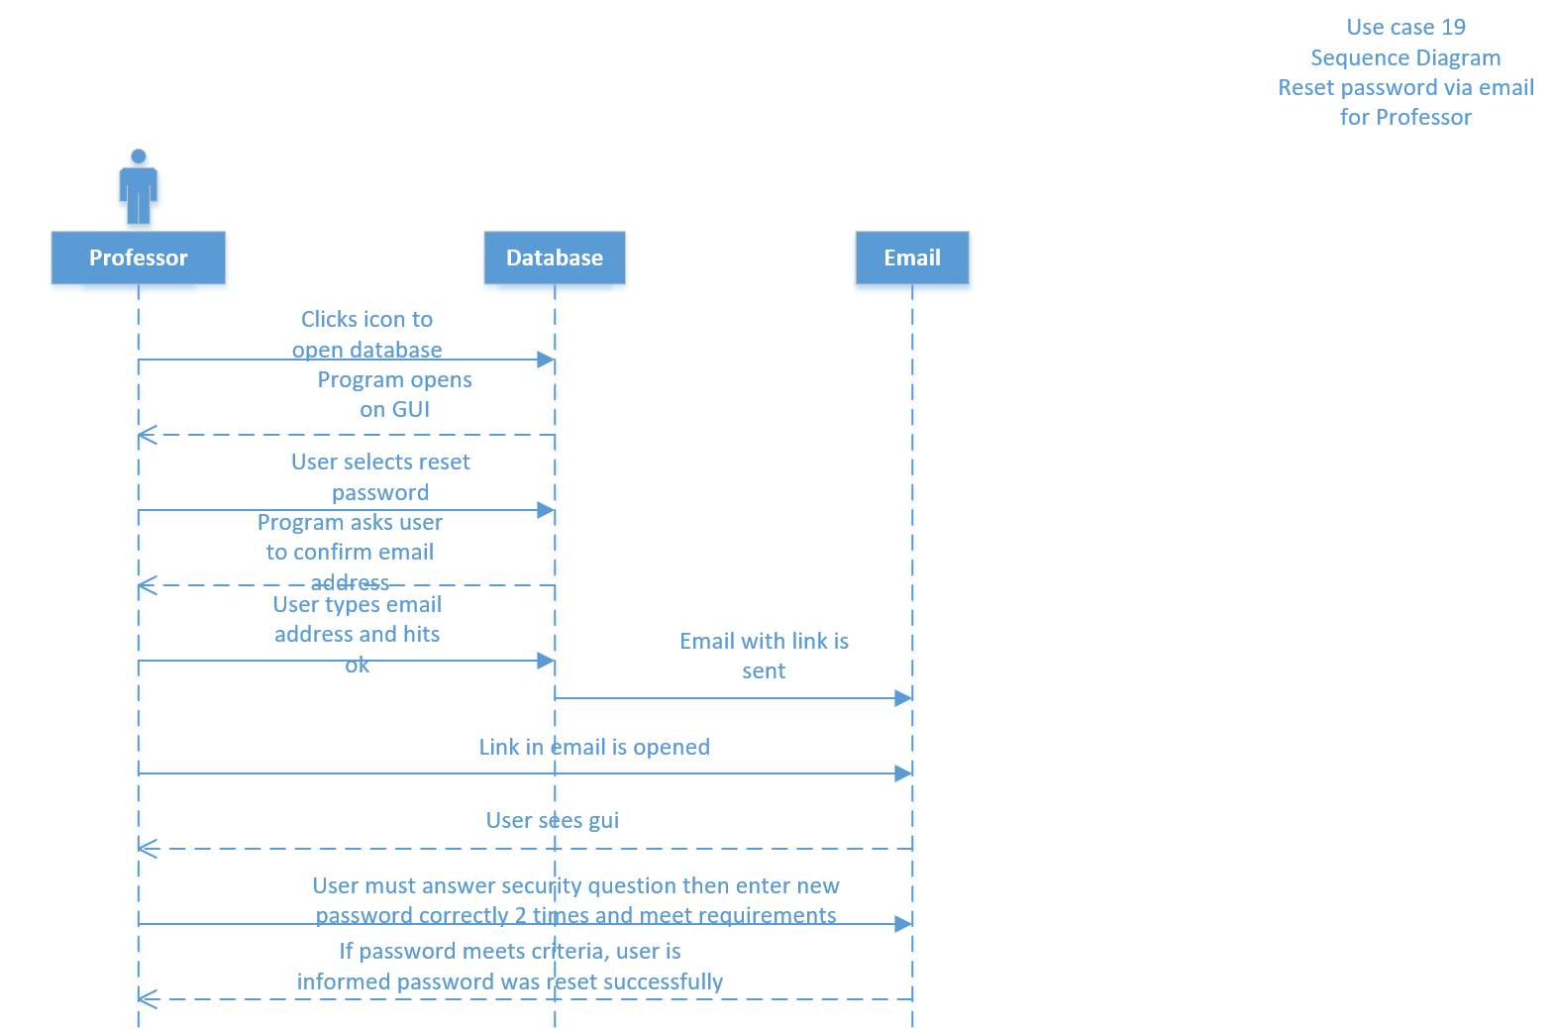

Sonar

Reset Committee Member Password Via Email

Version <1.0>

Revision History

|  |  |  |  |
| --- | --- | --- | --- |
| **Date** | **Version** | **Description** | **Author** |
| 19/Oct/16 | 1.0 | Use Case: Reset Committee member password via email | Christopher Meany |
|  |  |  |  |
|  |  |  |  |
|  |  |  |  |

Table of Contents

1. Reset Committee Member Password Via Email 4

1.1 Brief Description 4

2. Flow of Events 4

2.1 Basic Flow 4

2.2 Alternative Flows 4

2.2.1 New password entered in incorrect format 4

2.2.2 New passwords do not match 4

3. Special Requirements 4

3.1 System Requirements 4

4. Pre-conditions 4

4.1 Committee member must have administrator credentials 4

5. Post-conditions 4

5.1 Password is successfully changed 4

6. Extension Points 5

6.1 Passwords do not match 5

6.2 Passwords format is incorrect 5Use Case Specification: Reset Committee Member Password Via Email

# Committee member changes password via email

## Brief Description

When the committee member needs to change his or her password, they will submit a request to receive a link that will allow for them to change their password through their registered email.

# Flow of Events

## Basic Flow

* Actor – Committee member
* Committee member will navigate to log in screen and select change password button
* They will enter their username and then type their old password followed by their new password twice before hitting submit.
* If the new password meets the requirements set for a password, and is entered correctly twice, then the password will be reset successfully.

## Alternative Flows

Alternative flows are actions that will occur if the committee member fails to properly change their password.

### **Password does not meet the required standards**

If the password does not meet the standards set for an appropriate password, then the committee member will receive and error message prompting them to retype a new password.

### **Passwords do not match**

The user will have to type in a new password two times and make sure that they match or they will receive an error message prompting them to retype the new password.

# Special Requirements

These are requirements that must be filled to allow the committee member to be able to login and change their password

## System Requirements

* Access to Windows Server 2012
* Access SQL 2016
* Due to FERPA restrictions we must store student information and grades on secure University of Louisville servers
* Must have administrator credentials to the database to authorize them to make this change.

# Pre-conditions

These are conditions that must be met to allow for the committee to change their password.

## Access to the system with administrator rights

* Committee member must have administrator credentials and login credentials.
* Committee Member must be able to have access to the University of Louisville’s new system for the school of nursing.

# Post-conditions

Post conditions are what will take place after the user successfully changes their password.

## Password Reset

After the committee member successfully submits a new password that meets the requirements necessary for this system, they will have a new password.

# Extension Points

If committee member does not properly fill out the new password they will be given an error message to let them know to retry.

## Passwords do not match

The committee member will have to fill out a form where they enter a new password twice. If the two passwords do not match, they will receive and error message that will tell them to reenter their new passwords twice.

## Password does not meet required format

If the password does not meet the format required by the software, they will be given an error message to let them know to try a new password.

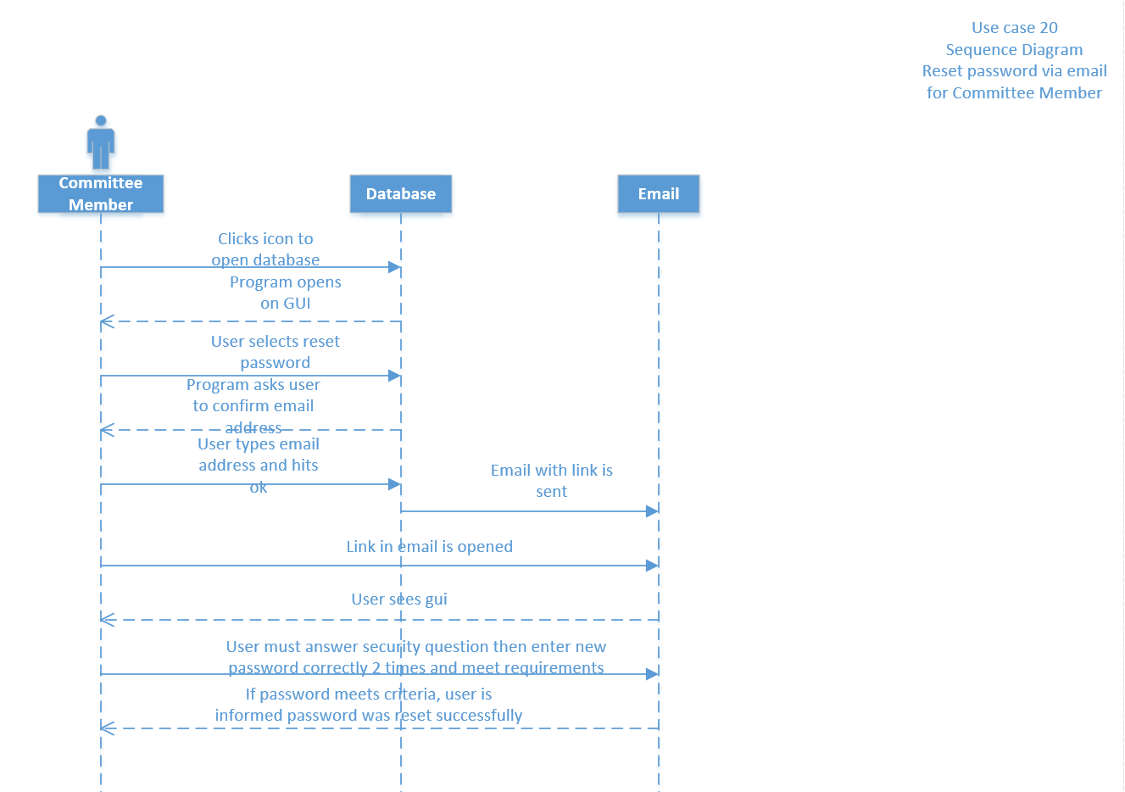

Sonar

Generate Automatic Emails for Student Compliance

Version <1.0>

Revision History

|  |  |  |  |
| --- | --- | --- | --- |
| **Date** | **Version** | **Description** | **Author** |
| 19/Oct/16 | 1.0 | Use Case: Generate automatic emails for student compliance | Christopher Meany |
|  |  |  |  |
|  |  |  |  |
|  |  |  |  |

Table of Contents

1. Generate Automatic Emails for Student Compliance 4

1.1 Brief Description 4

2. Flow of Events 4

2.1 Basic Flow 4

2.2 Alternative Flows 4

2.2.1 Emails are not sent in timely manner 4

3. Special Requirements 4

3.1 System Requirements 4

4. Pre-conditions 4

4.1 Student information date 4

5. Post-conditions 4

5.1 Compliance emails are sent 4

6. Extension Points 5

6.1 Invalid Input 5

# Generate Student Compliance Emails

## Brief Description

This will generate automatic emails to be sent to students to alert them to update certificates and licenses in a timely manner

# Flow of Events

## Basic Flow

* Actor- Student
* The database will automatically track students certifications and licenses
* When a student is within X number of days of a certification or license expiring, they will be sent an automatic email informing them of the certification or license that will expire and when it will expire

## Alternative Flows

Alternative flows are actions that will occur if the system does not do what it is supposed to do

### **Emails not sent in a timely manner**

This system should generate and send emails as reminders to student’s to allow them enough time to get back up to standards. However, this could have a potential issue of not enough notice given to allow the student to get themselves back into accordance.

# Special Requirements

These are requirements that must be met to allow the system to generate and send emails to students in a timely manner.

## System Requirements

* Access to Windows Server 2012
* Access SQL 2016
* Due to FERPA restrictions we must store student information and grades on secure University of Louisville servers
* System must be set to send emails whenever a student’s certifications or licenses are close to expiring automatically.

# Pre-conditions

These are conditions that must be met to make sure the system is sending emails as it should

## Student expiration dates must be entered correctly

For this system to work, the student’s expiration dates must be entered correctly, and the system must know how many days in advance it needs to send the emails to keep the student’s in compliance.

# Post-conditions

These are the outcomes following a working system.

## Emails are automatically generated and sent to the students

If the system is built correctly, the system will send emails to the students to alert them to update whatever certification or license they need to, to keep them in regulations.

# Extension Points

If information is entered incorrectly then they will not receive emails with enough time to stay in regulation.

## Invalid Input

If the information is entered incorrectly, then the system will not be able to properly keep them informed on when they need to update their certifications.

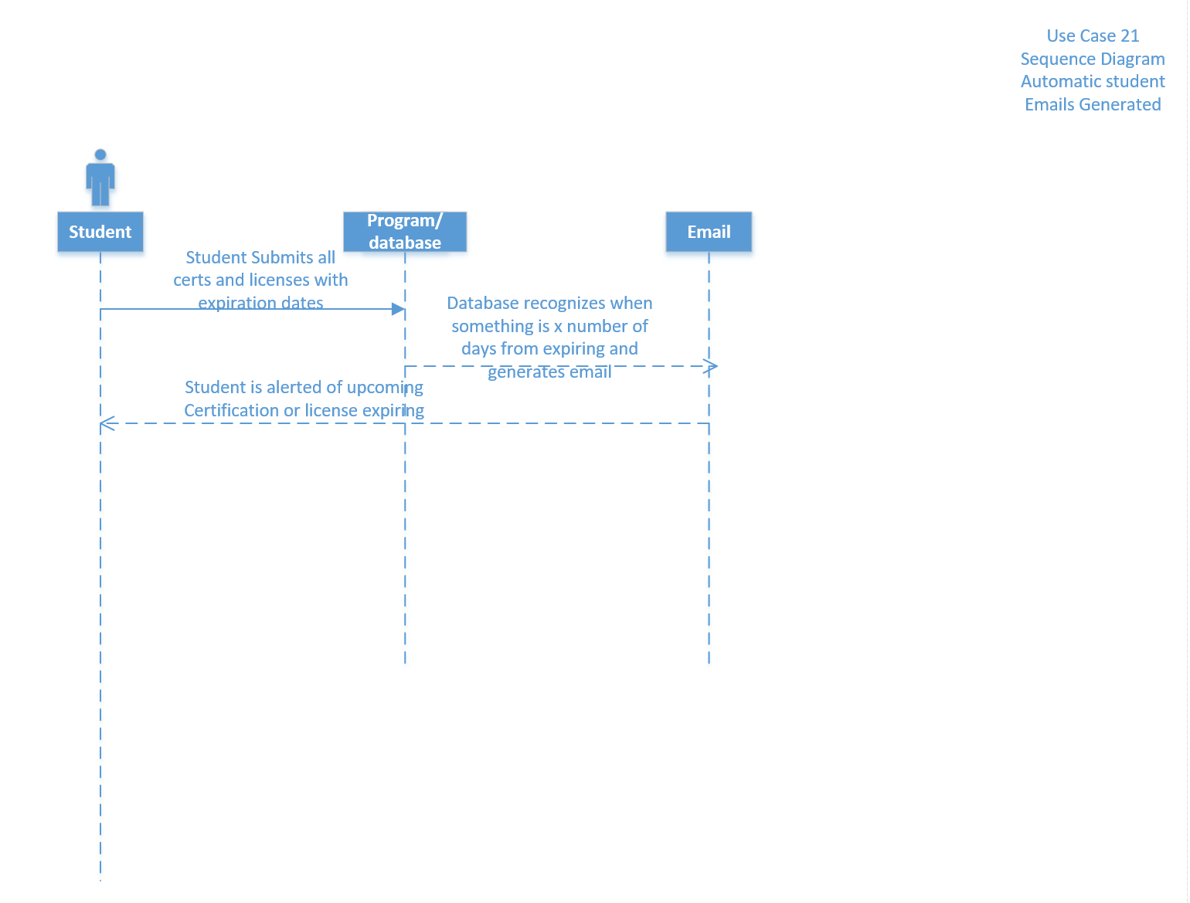

Sonar

Generate Email Templates

Version <1.0>

Revision History

|  |  |  |  |
| --- | --- | --- | --- |
| **Date** | **Version** | **Description** | **Author** |
| 19/Oct/16 | 1.0 | Use Case: Generate email templates | Christopher Meany |
|  |  |  |  |
|  |  |  |  |
|  |  |  |  |

Table of Contents

1. Generate Email Templates 4

1.1 Brief Description 4

2. Flow of Events 4

2.1 Basic Flow 4

2.2 Alternative Flows 4

2.2.1 Incorrect login credentials

3. Special Requirements 4

3.1 System Requirements 4

4. Pre-conditions 4

4.1 Templates must be pre-made 4

5. Post-conditions 4

5.1 Email templates are set 4

6. Extension Points 4

6.1 Templates stored incorrectly 4

# Generate Email Templates

## Brief Description

This will generate commonly used template emails for advisors to send to students.

# Basic Flow

* Actor – Advisor
* Advisor will log in on the main page with their administrator username and password
* They will click the generate email button
* After they click the generate email button they will be brought to a screen of pre written templates that they will chose from
* After they select a template it will open it in a blank email document
* They will type in the email address of the student or students they want to send it to and hit send after typing the email

## Alternative Flows

Alternative flows are actions that will occur if the system does not do what it is supposed to do

### **Templates do not open in blank email**

The system will have a selection of blank templates for the advisors to send quickly to the students. An error that can occur here is that the template when selected does not open in a blank email which would prevent an advisor from being able to quickly click the template and just fill in the email addresses costing them time.

# Special Requirements

These are requirements that must be met to allow the system to generate and send emails to students in a timely manner.

## System Requirements

* Access to Windows Server 2012
* Access SQL 2016
* Due to FERPA restrictions we must store student information and grades on secure University of Louisville servers
* System must have pre saved templates that when clicked will open in a blank email.

# Pre-conditions

These are conditions that must be met to make sure the system is sending emails as it should

## Templates must be accessible and open in a blank email

For this system to work, commonly used templates need to be pre-saved in and readily accessible.

# Post-conditions

These are the outcomes following a working system.

## Templates when clicked, open in a blank email

There will be pre-saved templates that when clicked, will open in a blank email document.

# Extension Points

If templates are stored incorrectly, they will not open in a blank email when clicked.

**6.1** **Templates stored incorrectly**

If the templates are not stored correctly in the database, then when clicked on, they will not open into a blank email causing the advisor to spend more time copying and pasting the template into an email.

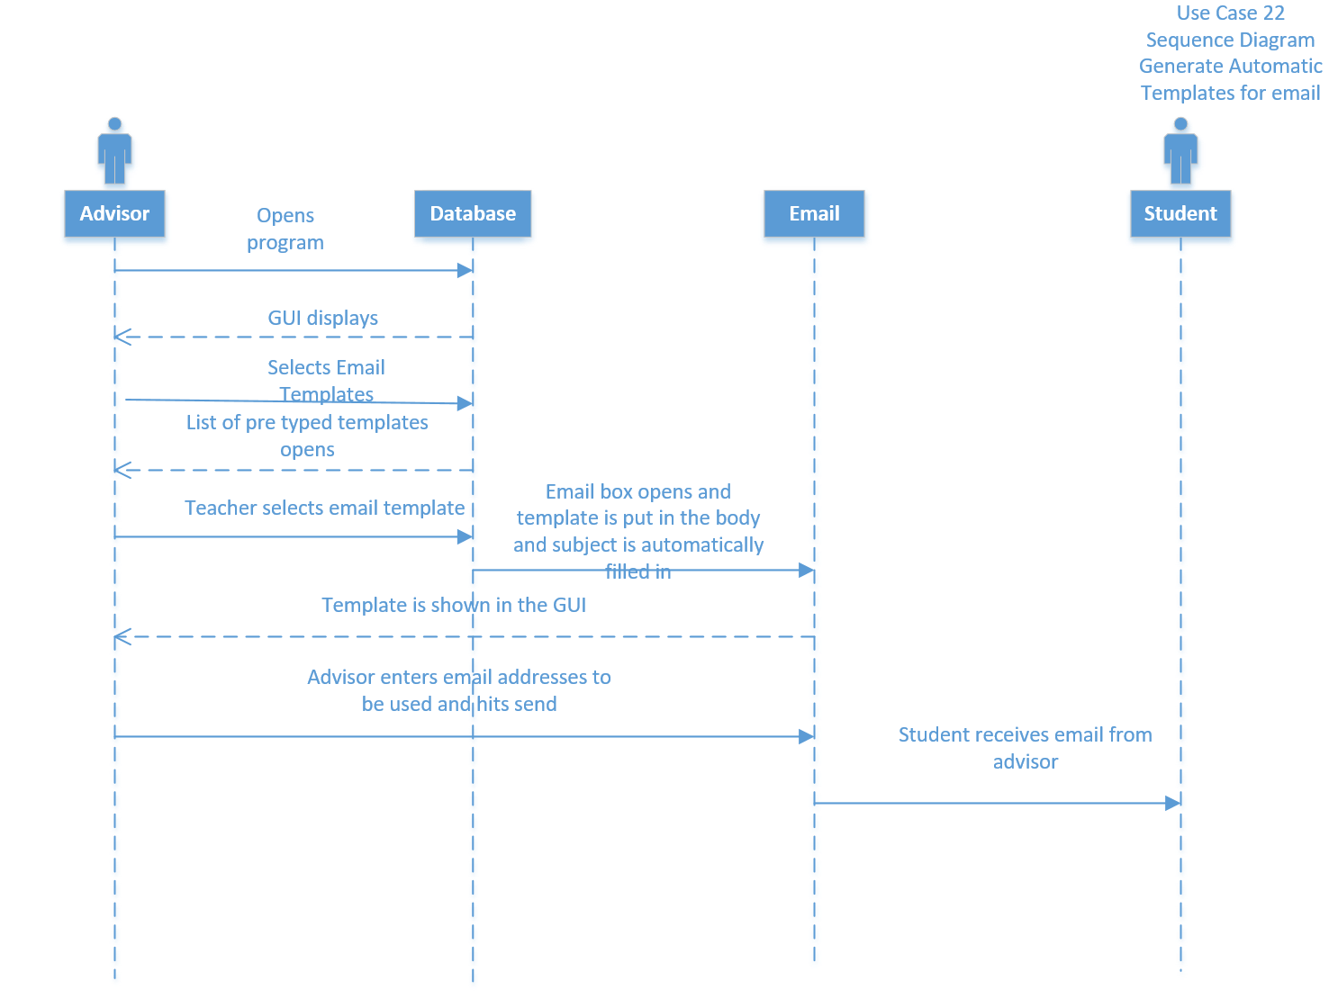

Sonar

Track Student Progress

Version <1.0>

Revision History

|  |  |  |  |
| --- | --- | --- | --- |
| **Date** | **Version** | **Description** | **Author** |
| 19/Oct/16 | 1.0 | Use Case: Track student progress | Christopher Meany |
|  |  |  |  |
|  |  |  |  |
|  |  |  |  |

Table of Contents

1. Track Student Progress 4

1.1 Brief Description 4

2. Flow of Events 4

2.1 Basic Flow 4

2.2 Alternative Flows 4

2.2.1 Information not entered correctly 4

2.2.2 Information not entered 4

3. Special Requirements 4

3.1 System Requirements 4

4. Pre-conditions 4

4.1 Access to system 4

4.2 Access to the grade 4

5. Post-conditions 4

5.1 Advisors are able to track progress of student 4

6. Extension Points 5

6.1 Invalid Input of information 5

6.2 Information not entered 5

Track Student Progress

# Track Student Progress

## Brief Description

This allows the advisors to track the student’s progress through the program

# Flow of Events

## Basic Flow

* Actor – Advisor
* The advisor first must log in with their administrator user name and log in password
* The advisor will be able to select a run query button
* This will allow them to run queries on an individual or multiple students at a time that will meet whatever needs they have
* This will assist the advisors in keeping current with the students and knowing more information about them more easily.

## Alternative Flows

Alternative flows are actions that occur if information is not entered correctly or not entered at all.

### **Information not entered correctly**

If the advisors do not enter the student’s information, grades, or certifications correctly, then this will cause issues with tracking them correctly as they progress through the program.

### **Information not entered**

If the advisors forget to submit and enter information on a student, then they will not be able to accurately track the student’s progress. If information is not entered, then the student will appear to be behind and can cause issues with scheduling and advising.

# Special Requirements

These are requirements that must be met to allow the advisors to track the student’s progress

## System Requirements

* Access to Windows Server 2012
* Access SQL 2016
* Due to FERPA restrictions we must store student information and grades on secure University of Louisville servers

# Pre-conditions

These are conditions that must be met to allow for the advisors to track the students.

## Access to the system

* Advisors must be able to log in
* They must be connected through the University of Louisville’s network

## Access to the student’s grades

**The advisor must be able to access the student’s grades to carry them over to the database system.**

# Post-conditions

These are the results if everything is tracked properly

## Advisor tracks student’s progress

If everything works correctly, and all information is entered correctly and in a timely manner, then the advisors will be able to track the student’s progress as the move through the program.

# Extension Points

If information is entered incorrectly or not entered at all, then advisors cannot properly track students

## Invalid Input of information

If information is put in incorrectly, then the advisors will have trouble advising students and tracking their progress as they would be giving bad information or not know where a student truly stands.

## Information not entered

If the information on a student is forgotten and not entered, then the system will show them as behind making it harder for an advisor to track the student correctly.

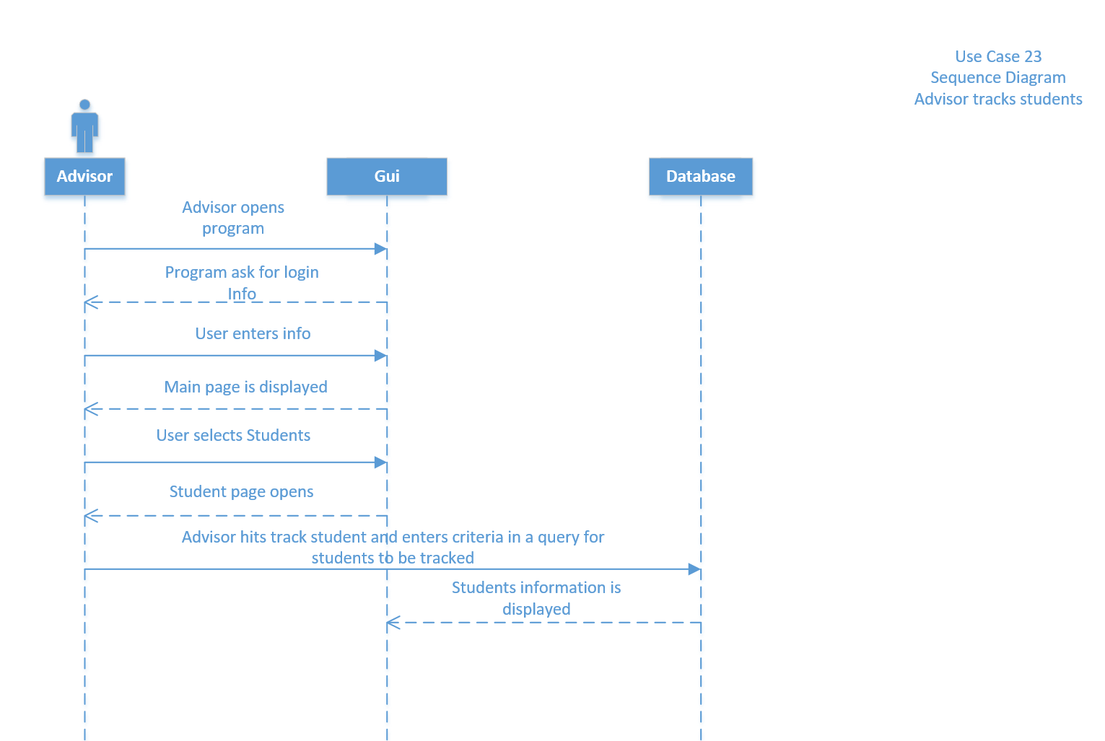

Sonar

Use Case Specification: Track Graduation

Version <1.0>

Revision History

|  |  |  |  |
| --- | --- | --- | --- |
| **Date** | **Version** | **Description** | **Author** |
| 19/Oct/16 | 1.0 | Use Case: Track Graduation | Christopher Meany |
|  |  |  |  |
|  |  |  |  |
|  |  |  |  |

Table of Contents

1. Track Graduation 4

1.1 Brief Description 4

2. Flow of Events 4

2.1 Basic Flow 4

2.2 Alternative Flows 4

2.2.1 Information not entered correctly 4

2.2.2 Information not entered 4

3. Special Requirements 4

3.1 System Requirements 4

4. Pre-conditions 4

4.1 Access to system 4

4.2 Access to the grade 4

5. Post-conditions 4

5.1 Advisors are able to track progress of student to graduation 5

6. Extension Points 5

6.1 Invalid Input of information 5

6.2 Information not entered 5

Use Case Specification: Track Graduation

# Track Graduation

## Brief Description

This allows the advisors to track the student’s progress through the program for graduation

# Flow of Events

## Basic Flow

* Actor- Advisor
* Advisor will log in with their username and password
* Advisors will be able to run queries and search students individually or multiple at a time
* They will be able to check off classes as passed and failed as students complete them
* The advisor will be able to see when students have completed their required curriculum making them eligible for graduation.

## Alternative Flows

Alternative flows are actions that occur if information is not entered correctly or not entered at all.

### **Information not entered correctly**

If the advisors do not enter the student’s information, grades, or certifications correctly, then this will cause issues with tracking their graduation date correctly as they progress through the program.

### **Information not entered**

If the advisors forget to submit and enter information on a student, then they will not be able to accurately track the student’s progress. If information is not entered, then the student will appear to be behind and can cause issues with scheduling and advising.

# Special Requirements

These are requirements that must be met to allow the advisors to track the student’s progress towards graduation

## System Requirements

* Access to Windows Server 2012
* Access SQL 2016
* Due to FERPA restrictions we must store student information and grades on secure University of Louisville servers

# Pre-conditions

These are conditions that must be met to allow for the advisors to track the student.s progress towards graduation.

## Access to the system

* Advisors must be able to log in to the system
* They must be connected through the University of Louisville’s network

## Access to the student’s grades

The advisor must be able to access the student’s grades to carry them over to the database system to show completion percentage towards graduation**.**

# Post-conditions

These are the results if everything is tracked properly

## Advisor tracks student’s progress to graduation

If everything works correctly, and all information is entered correctly and in a timely manner, then the advisors will be able to track the student’s progress as the move through the program and prepare them for graduation.

# Extension Points

If information is entered incorrectly or not entered at all, then advisors cannot properly track student’s progress towards graduation.

## Invalid Input of information

If information is put in incorrectly, then the advisors will have trouble advising students and tracking their progress as they would be giving bad information or not know where a student truly stands.

## Information not entered

If the information on a student is forgotten and not entered, then the system will show them as behind making it harder for an advisor to track the student correctly.

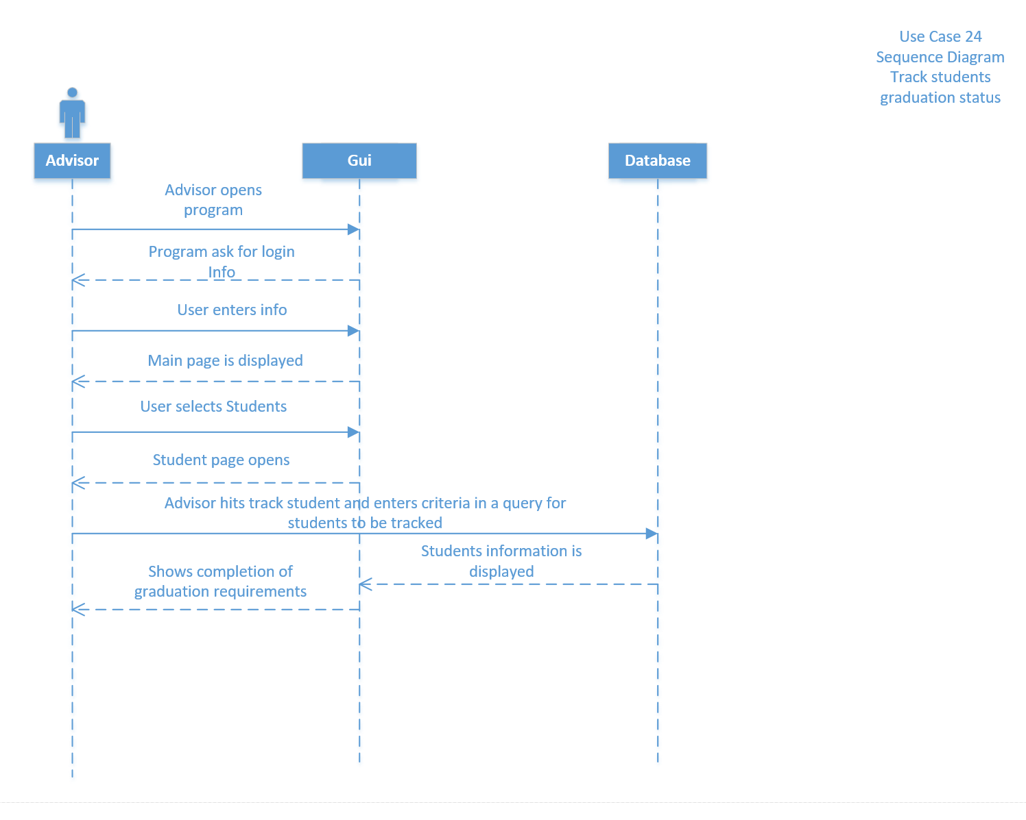



# Submission of Application to University

## Brief Description

Form will allow students to submit their application to university for consideration.

# Flow of Events

## Basic Flow

The actor in this case would be the prospective student. The prospective student will enter their, name, address, email, phone number, high school information, and score information for ACT and SAT for review by university in order to make a decision. All fields must be entered correctly before further steps would be allowed.

## Alternative Flows

### Incorrect Information entered

Alternative flow would occur if information being entered is not the right type for the field and might result in errors immediately or later on when the information is used for other purposes.

#### Reset Form

When incorrect information is entered on screen, or form produces an error, reset form will allow the form to be reloaded.

### Information not available

In the event, that student does not have required information available, form will allow the user to save the form to reenter the information.

# Special Requirements

## System Requirements

### Windows Server 2012

### Access SQL

## Legal/Security Requirements

System must be secure in order to protect student information being entered. The system will also need to be compliant with FERPA.

# Pre-conditions

System must be connected to internet for prospective students to be able to enter information. Connection to and from the system must be secure.

# Post-conditions

## Information sent to university

System will forward information collected from system to university of Louisville admissions office for consideration.

**5.2 Provide confirmation**

Confirmation will be provided to the user along with application number for tracking purposes.

# Extension Points

## Invalid Input

Invalid input would occur anytime Required fields are left empty, or incorrect charater/number types are entered in the field.

Use case 25: Submission of application to school of nursing.

Student goes to the webpage

Student verifies/edits the Full Name, Address, Email Address, High school, ACT, SAT and attaches required documentation

Student marks the check box to verify that information is correct.

Student clicks the submit button to submit the application

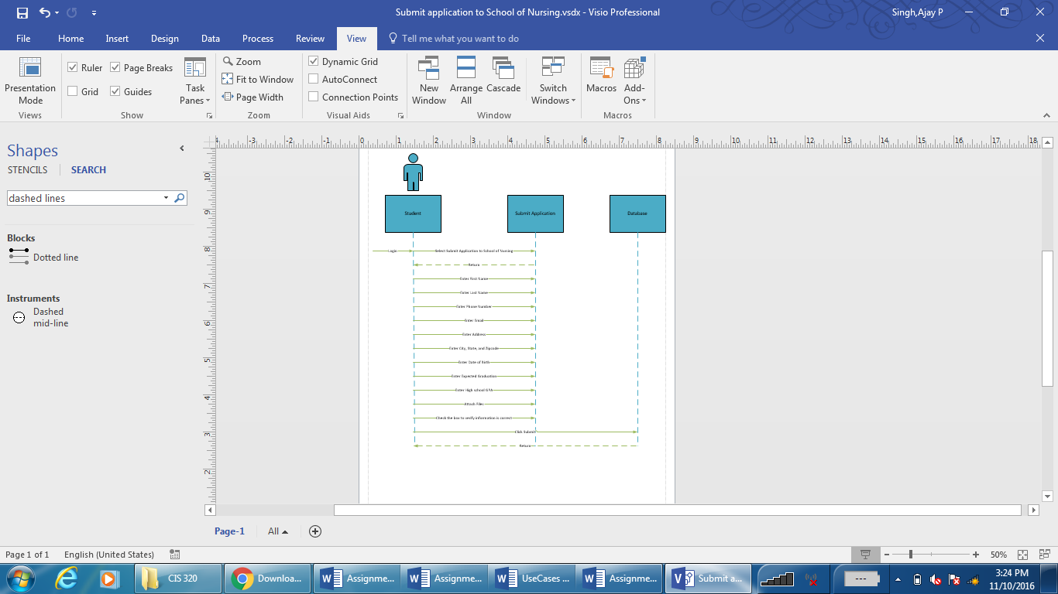



# Track Received Applications

## Brief Description

Primarily for use by advisors, this will allow them to track scholarships submitted by students. They will be able to track filing status, steps processed, and pay out status of the scholarship status.

# Flow of Events

## Basic Flow

Advisors will be able to use a tracking number or student ID to track scholarships for students. They will be able to see when the application was filed, if it was eligible, which part of the process the application is in, and the payout status.

## Alternative Flows

### Invalid tracking information

Tracking information is invalid as in is incomplete, or does not exit. This would result in an error that would allow advisor to re-enter information.

### Information does not exist

Information does not exist in the system yet. In this case system would allow user submit another application if allowed.

# Special Requirements

## System Requirements

* Windows Server 2012
* Access SQL 2016

## Legal Requirements

System must be compliant with FERPA regulations.

# Pre-conditions

## Access to system

Advisor must be logged into the system on University of Louisville secure system

## Access to Tracking information

Advisor must have access to the tracking information such as application number or student information before processing request through the system.

# Post-conditions

## Results provided

Tracking results are provided for the application.

## Submit new application

System would direct advisor to submit a new scholarship application.

# Extension Points

## Invalid input

System would provide an error along with a notification when a valid input isn’t entered or selection isn’t made.

* Invalid format
* Invalid length
* Invalid characters

Use case 26: Track Received Scholarships

Advisor Logs on to the system

Advisor selects Check Reports

Advisor selects student type, application type, semester.

Advisor enters student ID information

Advisor clicks generate.

Report for the submitted application is generated

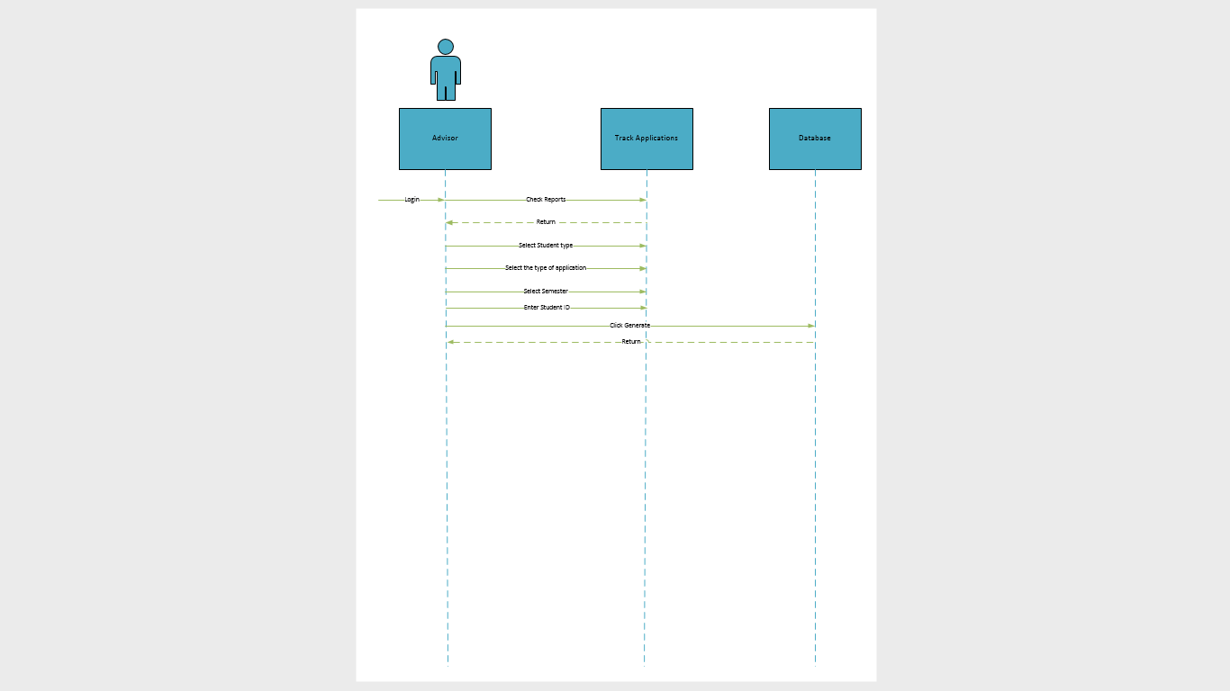



# Submit Scholarship Applications

## Brief Description

System would allow for submission of new applications for scholarship by students.

# Flow of Events

## Basic Flow

The actor in this case is the student who can use the system to file new application for scholarship. System would ask student to confirm some of the information already entered when student was created e.g. the contact number, email address, home address. It would also ask student to submit documentation such as transcripts, letters of recommendation and anything else that SON think they might need. Information entered from this will be transferred to the committee to help in their decision making process.

## Alternative Flows

### Required Fields not complete

Required information is not entered by the student resulting in an error. Some of the fields are not required, which is not part of this flow. Information such as contact information will be required resulting in errors if left empty, which in turn would result in interruption.

### Save for later

This would allow student to save their information if they don’t have required information available instead of having to start over. Students can just save the information in order to continue later after gathering information.

# Special Requirements

## System Requirements

* Windows server 2012
* Access SQL 2016
* Student account must be active in system.
* System and student must be connected via a secure connection.

## Legal Requirements

System must be compliant with FERPA Regulations.

# Pre-conditions

## Active Student Account

Student must have an active account with the university before access is allowed to the application system.

## Access to system

Student must be connected to the network and must have secure access to the system.

# Post-conditions

## Submit scholarship application

System would submit application for the student for review by committee and will email a tracking number to student and advisor.

# Extension Points

## Invalid input

System will provide an error whenever:

* Invalid characters are entered
* Input is of invalid length
* Format is incorrect

## Student does not exist

System would provide an error when the student trying to access the application portal does not exist in the system.





# Track scholarship eligibility

## Brief Description

Track scholarship eligibility will check eligibility of student to receive a scholar ship

# Flow of Events

## Basic Flow

## The actor in this case would be the advisor who will use information from *submit scholarship application* in order to check if the student qualifies for scholarships. Eligibility status will be to decide which applications will be accepted and forwarded to decision making committee.

## Alternative Flows

### **Missing Required information**

An error would result if the information provided by an advisor is incorrect causing incorrect eligibility status. Advisor might be entering wrong application number for student and mixes eligibility status for different students.

### **Reset Form**

Form will be reset for next application to complete tasks with least amount of delay

# Special Requirements

## System Requirements

* Access to Windows Server 2012
* Access SQL database
* Access to secure network

## Legal Requirements

System and user must be connected to secure network firewall and be compliant with FERPA regulations

# Pre-conditions

## Access to system

Advisor must have secure access to student information on the system. Access will be behind university firewall to keep student information safe.

## Valid Student

Student information must be valid before the process can be completed.

# Post-conditions

## Scholarship eligibility

System would provide the eligibility results to the advisor for application to move to next step

# Extension Points

## Invalid input

* Incorrect format
* Incorrect number of characters in a field
* Invalid characters
* Student does not exist in the system

Use Case 28: Submit Scholarships

Student logs in to the system using their credentials.

Student selects submit application(Scholarships)

Student Enters/Verifies their Name, Phone Number, email, Address, Date of Birth, Expected Graduation, and GPA

Student attaches required documents to the submission

Student verifies that all of the information is correct

Student clicks submit

Application is submitted for review

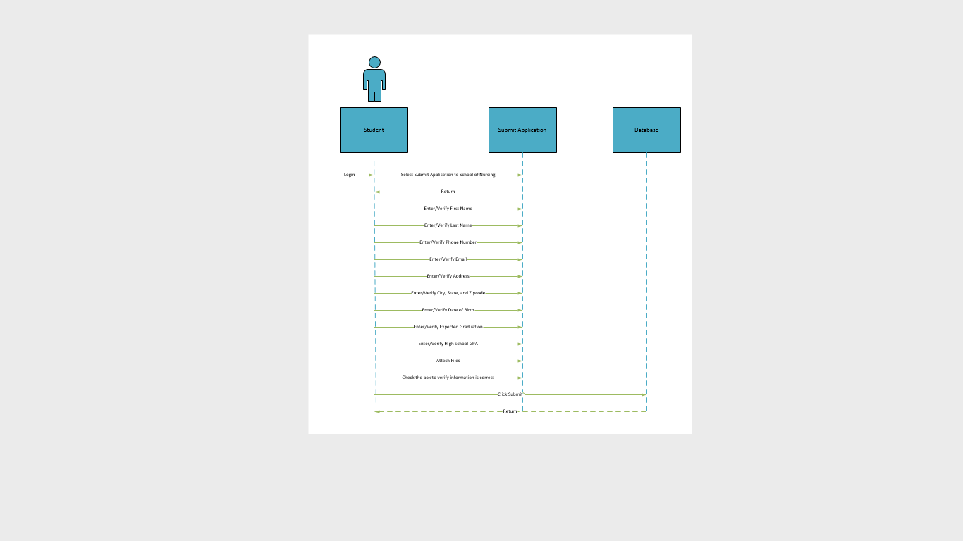



# Track Marketing efforts

## Brief Description

Track Marketing efforts will have advisors as the primary actor who will use the system to coordinate marketing efforts.

# Flow of Events

## Basic Flow

Advisors will use information from the database and run preset queries such as how many students that were contacted via email, web, phone applied for the school respectively. The queries will be managed as a team effort with the school of nursing to look at their needs. It can be modified in future but will track different measures such as student how many students were attracted from web, TV, and Billboard advertisements and how many of those students actually applied. The information and queries will be formatted to make it very easy to read and operate. Advisors will use the drop down boxes to get necessary data. Compare check boxes will allow advisors to compare the different on a single screen instead of printing out several reports.

## Alternative Flows

### Access backup

System will attempt to connect to backup if primary data is corrupt.

### Provide errors

System will provide error if the data in the primary and backup database is corrupt. Error will also appear if user tries to retrieve report before making selection, in effect requesting empty reports.

# Special Requirements

## System Requirements

* Access to windows server 2012
* Access SQL database
* Data must be available

## Legal Requirements

System must be compliant with FERPA and must keep student information safe from outside access.

# Pre-conditions

## Access to system

Advisors must have access to the system when they are connected to the network behind university firewall.

## Availability of valid data

System must contain valid data to be process and that data must be free from errors and redundancy.

# Post-conditions

## Marketing effort results

System will provide results for the selected options that can be used by advisors for decision making process.

## Errors

System will provide error if the data requested does not exist or was corrupted after attempting to load it from the back up.

# Extension Points

## Corrupt Data

Data could become corrupt in which case the system will try to retrieve good data for processing from backup.

## Valid data

Data used for processing must be redundancy and error free to provide accurate information to the user.

Use case 29: Track Marketing efforts

Advisor logs in to the system

Advisor selects view reports

Advisor selects student type, report type, semester, and year

Advisor clicks generate

Report is generated based on the selected criteria

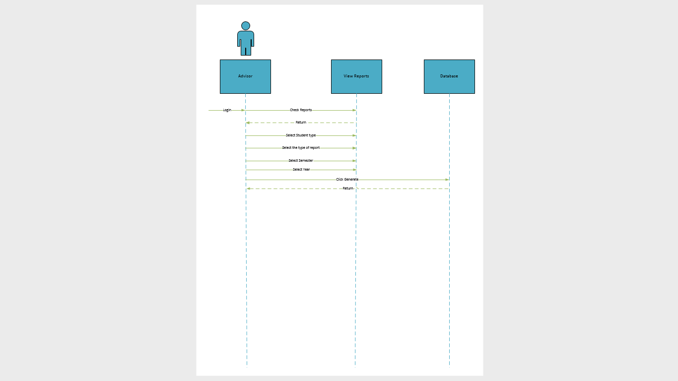



# View Reports for Admissions decisions

## Brief Description

Allows the board of admissions to go over application reports to make admission decision.

# Flow of Events

## Basic Flow

The actor in this case would be the board of admission which will log in to the system to retrieve report for all students. The report will comprise of their application, their personal letters, letters of recommendation, and their transcript.

## Alternative Flows

### Incomplete report

In some cases, the report might not contain the required/necessary information for the committee to make their decision. System will send the application back to advisor to gather the necessary information.

### Reset form

This will reset the form for board to enter information to pull the repost for the next student

# Special Requirements

## System Requirements

* Windows server 2012
* Access SQL database
* Preset instruction to generate reports with necessary information
* Board members must have secure access to the system
* Reports must be simple and easy to understand

## Legal Requirements

System must be compliant with FERPA.

# Pre-conditions

## Access to System

Board members must have access to the system using a secure network behind university firewalls

## Application must be filed by student

Application must be filed by students before board can user system to generate reports.

## Information in the system must be valid

System must have valid and up-to-date information for each student being considered.

# Post-conditions

## Admissions report generated

System will generate report for each student with necessary information to streamline decision making process for members of the board.

## Errors Generated

Errors could be generated due to corrupt or invalid information.

Use case 30: View Reports for admissions decisions

Board of Admissions member logs in to the system

Board of Admissions member selects view reports

Board of Admissions member selects student type, and report type

Board of Admissions member enters student ID

Board of Admissions member clicks generate

Report is generated based on the selected criteria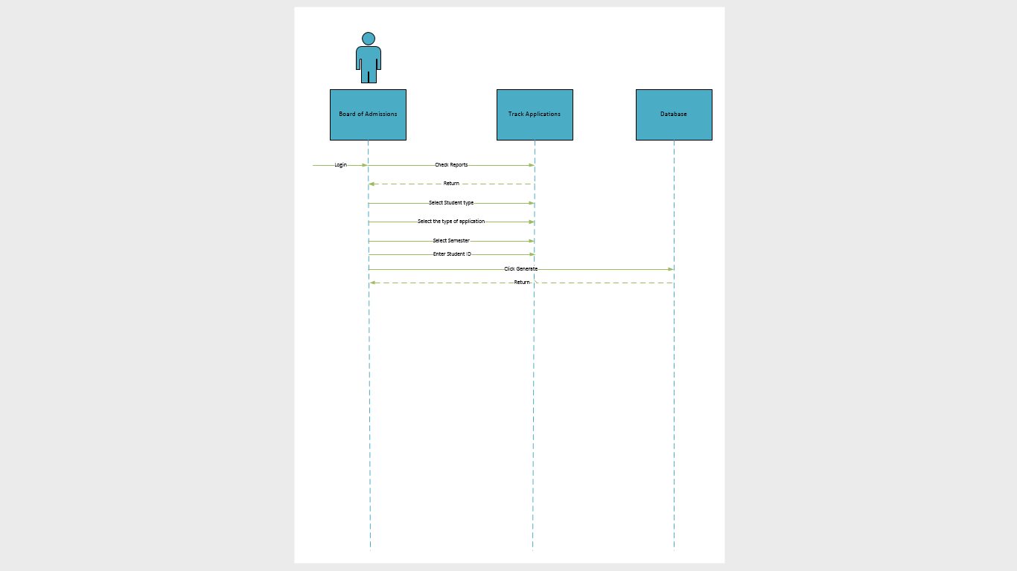



# Submission of program application

## Brief Description

This will allow students to submit application for their desired program of study

# Flow of Events

## Basic Flow

Students, being the primary actors, will be able to file their applications for entry into their program of study after being accepted into the university. Students will be required to submit their name, address, email address, contact number, grades, and submit documents such as transcripts, letters of recommendation and personal letter.

## Alternative Flows

### Invalid Input

In a case where the input by student is incorrect, system will provide an error notifying user of such. Invalid input could be in the form of invalid length, format, and/or characters. User is given chance to fix the error by changing input.

### Save for later

Allows student to save the application to be submitted later. All information already entered and saved is kept in the database for a limited amount of that will be determined by School of Nursing. Student will use the application number and pin to reload the application and complete it.

### Reset Form

User may want to reset the form and start the whole process again. This will reset the application for that.

# Special Requirements

## System Requirements

* Windows Server 2012
* Access SQL 2016
* Web for entry
* Secure network access for students.

## Legal requirements

System must be compliant with FERPA.

# Pre-conditions

## Access to System

System must be available to students over the internet.

## Valid Student account

Student must be enrolled at the university before being able to apply for a specific programs.

# Post-conditions

## Information sent to university

System will forward information collected from system to School of Nursing office for consideration.

**5.2 Provide confirmation**

Confirmation will be provided to the user along with application number for tracking purposes.

# Extension Points

## Invalid Input

Invalid input would occur anytime Required fields are left empty, or incorrect character/number types are entered in the field.

Use case 31: Submission of Program Application

Student logs in to the system using their credentials.

Student selects submit application(Scholarships)

Student Enters/Verifies their Name, Phone Number, email, Address, Date of Birth, Expected Graduation, and GPA

Student attaches required documents to the submission

Student verifies that all of the information is correct

Student clicks submit

Application is submitted for review

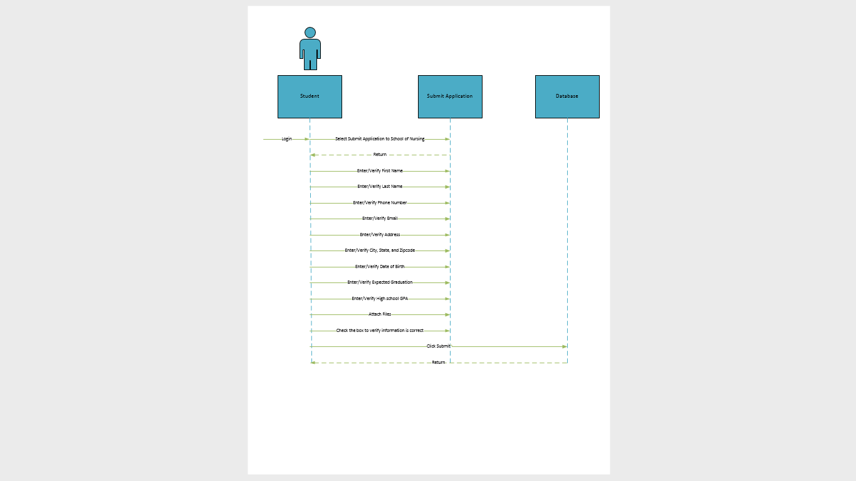



# Add to database storage

## Brief Description

Adds more storage to the existing database

# Flow of Events

## Basic Flow

Database will continue to grow with time, as new students are added, and more data is accumulated for each student. Staff, as the primary actors, will be able to expand storage for the database in the future to fit their needs at the time. This will lower the chances of them needing a new system any time soon. System admin can log in to the system and expand database storage up to the max available.

## Alternative Flows

### Max Size reached

In the event that the database is already using the max storage available on the server, system admin will be given the option request more storage to be added to the server by university IT which will allow system admin to expand storage later.

### Lower storage

System admin will have the option to lower size for the database if business needs require it.

# Special Requirements

## System requirements

Staff would need admin access for the following

* Microsoft windows server 2012
* SQL 2016

## Regulatory requirements

University IT is in control of the server and would have to authorize changes by SON staff members.

# Pre-conditions

## Access to system

Staff must have admin access to the data base and servers. Staff would require IT assistance in some scenarios such as adding more drives to the server.

# Post-conditions

## Database expanded

Database will be expanded to the desired size

## Error generated

Error could be generated if the database size is larger than server storage available or if the user does not have required access.

# Extension Points

## Dependencies

Database expansion is highly dependent on the server specifications that are controlled by university IT and must be updated by them. This results in a lot of added steps and would require additional time to get approval.

Use case 32: Add to database storage

System Admin logs in to the system

System admin verifies current database size

System admin enters the desired database size

System admin checks the checkbox to verify

System admin clicks expand

Database is expanded to the desired size depending on if enough physical storage is available

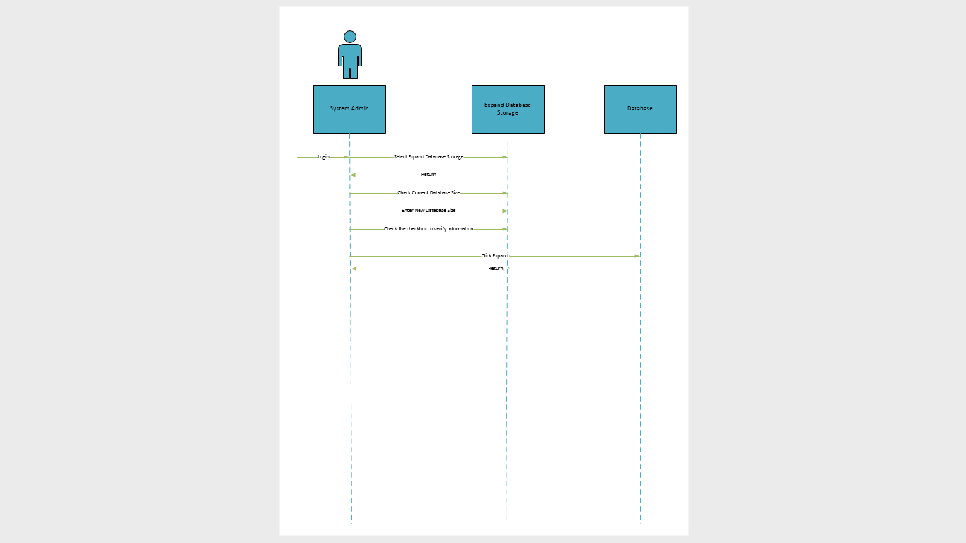

# Add graduated students to alumni list

## Brief Description

Allows advisors to add graduated students to alumni list.

# Flow of Events

## Basic Flow

Advisors as the primary actor will able to access information of students and add graduate students to the alumni list. This will generate a list of students that qualify preselected criteria and advisors will be able to select one, multiple, or all students and add them to the alumni list. This list could be used for soliciting donations, or provide updates to alumni about upcoming events etc.

## Alternative Flows

### None selected

At least one student must be selected for the task to be completed otherwise it will result in an error.

#### Cancel

In the event, an error is generated where advisor doesn’t make required selections, system will allow user to cancel the task and go to the previous screen.

### Reset Form

Form would allow user to reset the form which will unselect all selections for user to start over.

# Special Requirements

## System Requirements

* Microsoft windows server 2012
* SQL 2016

## Valid student information

Student must contain required information for students before student can be added to the alumni list.

## Legal Requirements

System must be compliant with FERPA regulations and hence must keep student information safe. Advisors will need to access system from behind the university firewall.

# Pre-conditions

## Access to system

Advisors must have access to system via a secure network

## Student required

Student must be in the database with appropriate information to be added on the alumni list.

# Post-conditions

## Alumni List updated

Selected students will be added to the alumni list.

## Errors Generated

Errors will be generated in the event student information is corrupt, invalid, or student already exists on the list.

# Extension Points

## Invalid Student data

Student information must exist in the system. The information must contain name, address, phone numbers, and email. Student must not be on the alumni list prior to the event.

Use case 33: Add graduated students to alumni list

Advisor logs in to the system

Advisor selects Add Graduated Students to alumni List

Advisor checks the checkbox to select students to be added to the list

Advisor clicks the add to list button

Graduated students are added to the alumni list

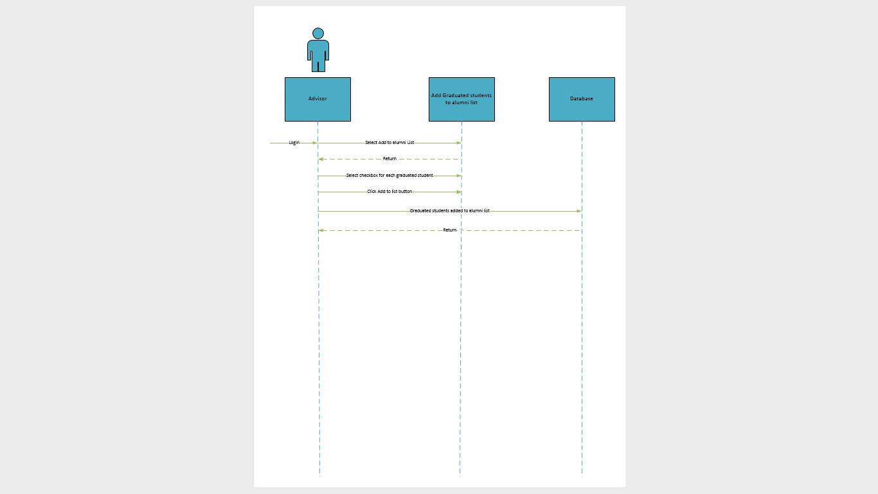



# Email Alumni form

## Brief Description

Allows advisors to email student added to the alumni list to request updated contact information

# Flow of Events

## Basic Flow

Advisors will be able to log in to the system in order to email graduated students being added to the alumni email list to provide their updated contact information. Advisors will be able to select one, multiple, or all students on the alumni list to send email requesting updated contact information. System will provide a templated which will automatically personalize email for each alumnus.

## Alternative Flows

### None selected

At least one student must be selected for the task to be completed otherwise it will result in an error.

#### Cancel

In the event, an error is generated where advisor doesn’t make required selections, system will allow user to cancel the task and go to the previous screen.

### Reset Form

Form would allow user to reset the form which will unselect all selections for user to start over.

# Special Requirements

## System Requirements

* Microsoft windows server 2012
* SQL 2016

## Student must be alumni

Student must be on the alumni list before they can be emailed to request updated information

## Legal Requirements

System must be compliant with FERPA regulations and hence must keep student information safe. Advisors will need to access system from behind the university firewall.

# Pre-conditions

## Access to system

Advisors must have access to system via a secure network

## Student required

Student must be in the database with appropriate information and be on the alumni list before they can be contacted

# Post-conditions

## Alumni List emailed

Selected students will be added to the alumni list.

## Errors Generated

Errors will be generated in the event student information is corrupt, invalid, or student has been contacted in the last 7 days.

# Extension Points

## Information Requested

Information requested via email will include current non-university email address, updated phone number, and mailing address.

Use case 34: Generate email alumni to request email updated contact information

Advisor logs in to the system

Advisor selects Generate alumni email List

Advisor checks the checkbox to select students to be added to the list

Advisor clicks the add to list button

Alumni list to mail is generated

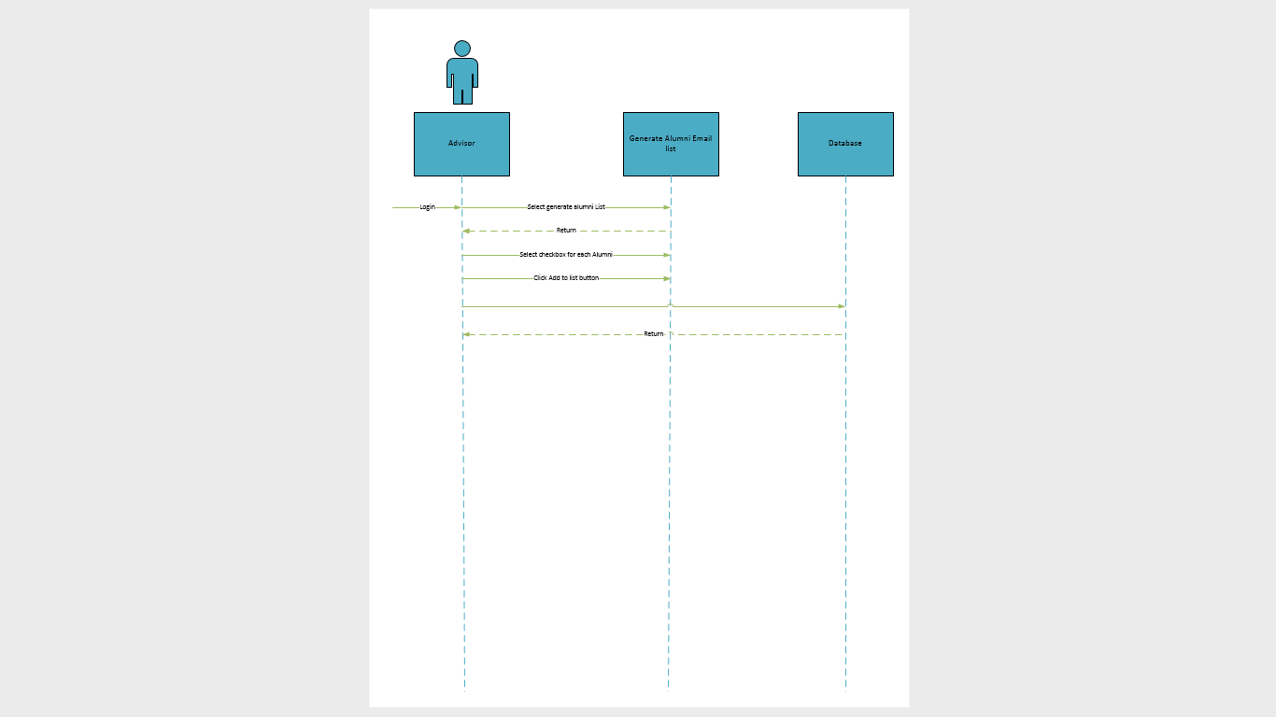



# Email Alumni form

## Brief Description

Advisors will use the form to update the contacts for alumni with information provided through the email.

# Flow of Events

## Basic Flow

Advisors will be able log into the system in order to update the Email, Phone number, and mailing address for the everyone on the alumni list.

## Alternative Flows

### None selected

At least one student must be selected to update the information for.

#### Cancel

In the event, an error is generated where advisor doesn’t make required selections, system will allow user to cancel the task and go to the previous screen.

### Reset Form

This will reset the form for advisor the clear the information for alum. This saves time for deleting data in each field.

# Special Requirements

## System Requirements

* Microsoft windows server 2012
* SQL 2016

## Student must be alumnus

Student must be on the alumni list before their information can be updated.

## Legal Requirements

System must be compliant with FERPA regulations and hence must keep student information safe. Advisors will need to access system from behind the university firewall to be safe. Contact information provided by alumni doesn’t have to behind university firewall and can be stored anywhere.

# Pre-conditions

## Access to system

Advisors must have access to system via a secure network.

## Student required

Student must be in the database with appropriate information and be on the alumni list before they can be contacted.

# Post-conditions

## Alumnus information updated

Contact information updated and replaced with information received from alumnus email response.

## Errors Generated

Errors will be generated in the event student information is corrupt, invalid, or alumnus does not exist in the system.

# Extension Points

## Information to be updated

Information requested via email will include current non-university email address, updated phone number, and mailing address.

Use case 35: Manually update alumni contact information from received email

Advisor logs in to the system using their credentials.

Advisor selects submit application(Scholarships)

Advisor Enters/Verifies their Name, Phone Number, email, and Address

Advisor verifies that all of the information is correct

Advisor clicks submit

Information is updated in the system

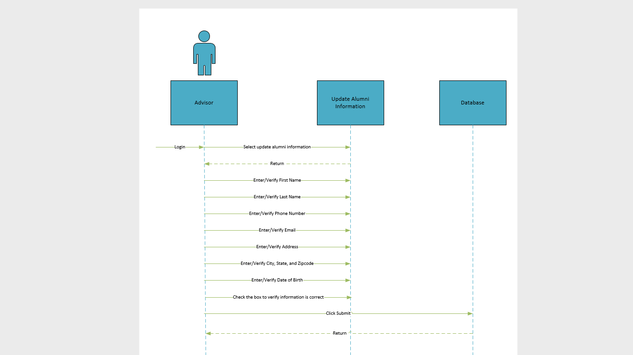



# Email Alumni form

## Brief Description

Allows advisors to email student added to the alumni list to request dontations.

# Flow of Events

## Basic Flow

Advisors will be able to log in to the system in order to email graduated on the alumni email list. Advisors will be able to select one, multiple, or all students on the alumni list to send email requesting donations. System will provide a template which will automatically personalize email for each alumnus.

## Alternative Flows

### None selected

At least one student must be selected for the task to be completed otherwise it will result in an error.

#### Cancel

In the event, an error is generated where advisor doesn’t make required selections, system will allow user to cancel the task and go to the previous screen.

### Reset Form

Form would allow user to reset the form which will unselect all selections for user to start over.

# Special Requirements

## System Requirements

* Microsoft windows server 2012
* SQL 2016

## Student must be alumni

Student must be on the alumni list before they can be emailed to request donations

## Legal Requirements

System must be compliant with FERPA regulations and hence must keep student information safe. Advisors will need to access system from behind the university firewall.

# Pre-conditions

## Access to system

Advisors must have access to system via a secure network

## Student required

Student must be in the database with appropriate information and be on the alumni list before they can be contacted

# Post-conditions

## Alumni List emailed

Selected students will be added to the alumni list.

## Errors Generated

Errors will be generated in the event student information is corrupt, invalid, or student has been contacted in the last 7 days.

# Extension Points

## Donations

Email will provide details on how alumni can provide support to the SON from the school website.

Use Case 36: Generate email list to ask alumni for donations

Advisor logs in to the system

Advisor selects Generate alumni email List

Advisor checks the checkbox to select students to be added to the list

Advisor clicks the add to list button

Alumni list to be emailed is generated



**Use Case 37: Create Upper Division Student**

**Create Upper Division Student**

**Brief Description**

*Create Upper Division Student will create a student in the database.*

**Flow of Events**

The actor in this case is the Advisor that is inputting upper division student information into the form and then submitting, which will create a student in the database. All required fields of the form must be correctly filled out to submit and create student.

**Basic Flow**

* Advisor selects create student
* Advisor inputs Student ID
* Advisor inputs University E-mail
* Advisor inputs First Name
* Advisor inputs MI
* Advisor inputs Last Name
* Advisor inputs Address
* Advisor inputs City
* Advisor selects State
* Advisor inputs Zip Code
* Advisor inputs Primary Phone Number
* Advisor inputs Secondary Phone Number
* Advisor checks/unchecks FAFSA
* Advisor checks/unchecks SAR
* Advisor checks/unchecks NSF Application
* Advisor checks/unchecks CPR Certification
* Advisor checks/unchecks HIPAA Training Courses
* Advisor checks/unchecks Blood borne Pathogen Compliance
* Advisor checks/unchecks Professional Liability Insurance
* Advisor checks/unchecks Immunization Compliance
* Advisor checks/unchecks Drug Screening
* Advisor selects Program
* Advisor selects Enrollment
* Advisor selects Anticipated Graduation Date
* Advisor inputs notes

**Alternative Flows**

Alternative flows are actions that occur when creating student does not properly occur.

Required Fields Not Complete

* Create button clicked
* Message pop up indicating unmet conditions

Reset Form

* Reset button clicked
* All fields cleared

**Special Requirements**

* Logged in with Advisor access

**System Requirements**

* Access to Windows server 2012
* Access SQL 2016
* Due to FERPA restrictions we must store student information and grades on secure University of Louisville servers

**Pre-conditions**

* Logged in

**Access to System**

* Advisor must be logged in
* Connected to secure network

**Post-conditions**

* Creation Successful

**Extension Points**

If a field on the form is not filled out in the correct format and message will pop-up describing discrepancy.

**Invalid input**

* Incorrect format
* Incorrect number of characters in a field
* Invalid characters

Use Case: 37

Create Upper Division Student

Advisor logs in

Advisor selects create student

Advisor Inputs/selects/checks following fields…

Advisor clicks create

Student is added to database

Once added successfully, returns to starting point

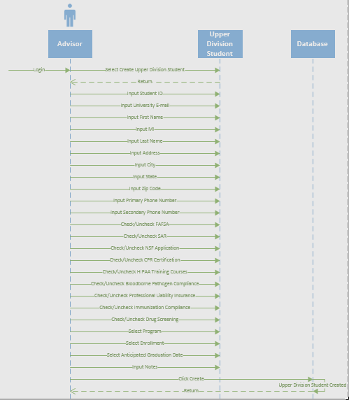

**Use Case 38: Edit Upper Division Student**

**Create Upper Division Student**

**Brief Description**

*Edit Upper Division Student will edit a student in the database.*

**Flow of Events**

The actor in this case is the Advisor that is inputting/editing upper division student information into the form and then submitting, which will update a student in the database. All required fields of the form must be correctly filled out to submit and create student.

**Basic Flow**

* Advisor selects edit student
* Advisor inputs/edits Student ID
* Advisor inputs/edits University E-mail
* Advisor inputs/edits First Name
* Advisor inputs/edits MI
* Advisor inputs/edits Last Name
* Advisor inputs/edits Address
* Advisor inputs/edits City
* Advisor selects/edits State
* Advisor inputs/edits Zip Code
* Advisor inputs/edits Primary Phone Number
* Advisor inputs/edits Secondary Phone Number
* Advisor checks/unchecks FAFSA
* Advisor checks/unchecks SAR
* Advisor checks/unchecks NSF Application
* Advisor checks/unchecks CPR Certification
* Advisor checks/unchecks HIPAA Training Courses
* Advisor checks/unchecks Blood borne Pathogen Compliance
* Advisor checks/unchecks Professional Liability Insurance
* Advisor checks/unchecks Immunization Compliance
* Advisor checks/unchecks Drug Screening
* Advisor selects/edits Program
* Advisor selects/edits Enrollment
* Advisor selects/edits Anticipated Graduation Date
* Advisor inputs/edits notes
* Advisor clicks save

**Alternative Flows**

Alternative flows are actions that occur when creating student does not properly occur.

Required Fields Not Complete

* Create button clicked
* Message pop up indicating unmet conditions

Delete Student

* Delete button clicked

**Special Requirements**

* Logged in with Advisor access

**System Requirements**

* Access to Windows server 2012
* Access SQL 2016
* Due to FERPA restrictions we must store student information and grades on secure University of Louisville servers

**Pre-conditions**

* Logged in

**Access to System**

* Advisor must be logged in
* Connected to secure network

**Post-conditions**

* Creation Successful

**Extension Points**

If a field on the form is not filled out in the correct format and message will pop-up describing discrepancy.

**Invalid input**

* Incorrect format
* Incorrect number of characters in a field
* Invalid characters

Use Case: 38

Edit Upper Division Student

Advisor logs in

Advisor selects edit student

Database is accessed to retrieve existing student

Advisor edits/inputs/selects/checks following fields…

Advisor clicks save

Student is updated in database

Once updated successfully, returns to starting point

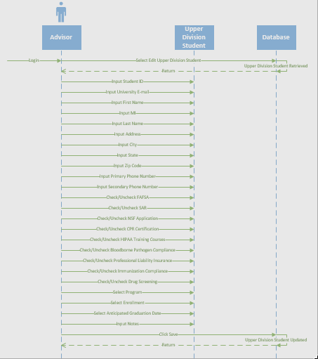

**Use Case 39: Delete Upper Division Student**

**Create Upper Division Student**

**Brief Description**

*Delete Upper Division Student will edit a student in the database.*

**Flow of Events**

The actor in this case is the Advisor that is deleting upper division student information from the database and moved to a temporary dump file. Advisor must also input login information to confirm delete action.

**Basic Flow**

* Advisor selects edit student
* Advisor clicks delete
* Advisor inputs username
* Advisor inputs password
* Advisor clicks delete

**Alternative Flows**

Alternative flows are actions that occur when creating student does not properly occur.

Required Fields Not Complete

* Create button clicked
* Message pop up indicating unmet conditions

Cancel

* Cancels button clicked
* Returns to edit student

**Special Requirements**

* Logged in with Advisor access

**System Requirements**

* Access to Windows server 2012
* Access SQL 2016
* Due to FERPA restrictions we must store student information and grades on secure University of Louisville servers

**Pre-conditions**

* Logged in

**Access to System**

* Advisor must be logged in
* Connected to secure network

**Post-conditions**

* Delete Successful

**Extension Points**

If a field on the form is not filled out in the correct format and message will pop-up describing discrepancy.

**Invalid input**

* Incorrect format
* Incorrect number of characters in a field
* Invalid characters

Use Case: 39

Delete Upper Division Student

Advisor logs in

Advisor selects edit student

Database is accessed to retrieve existing student

Advisor clicks delete

Advisor inputs username and login

Advisor confirms delete

Student is deleted from database and moved to temp dump file

Once deleted successfully, returns to starting point

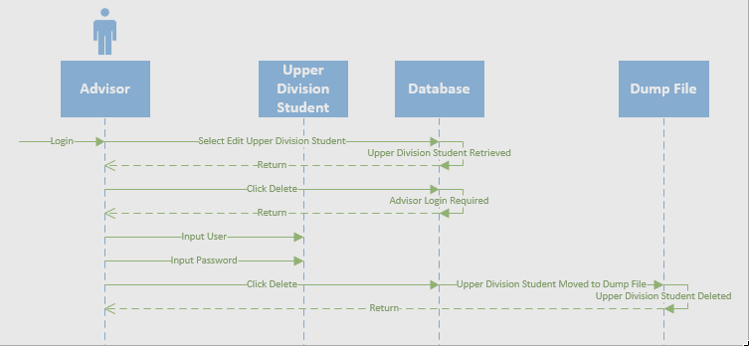

**Use Case 40: Create Lower Division Student**

**Create Lower Division Student**

**Brief Description**

*Create Lower Division Student will create a student in the database.*

**Flow of Events**

The actor in this case is the Advisor that is inputting lower division student information into the form and then submitting, which will create a student in the database. All required fields of the form must be correctly filled out to submit and create student.

**Basic Flow**

* Advisor selects create student
* Advisor inputs Student ID
* Advisor inputs University E-mail
* Advisor inputs First Name
* Advisor inputs MI
* Advisor inputs Last Name
* Advisor inputs Address
* Advisor inputs City
* Advisor selects State
* Advisor inputs Zip Code
* Advisor inputs Primary Phone Number
* Advisor inputs Secondary Phone Number
* Advisor checks/unchecks FAFSA
* Advisor checks/unchecks SAR
* Advisor checks/unchecks NSF Application
* Advisor checks/unchecks CPR Certification
* Advisor checks/unchecks HIPAA Training Courses
* Advisor checks/unchecks Blood borne Pathogen Compliance
* Advisor checks/unchecks Professional Liability Insurance
* Advisor checks/unchecks Immunization Compliance
* Advisor checks/unchecks Drug Screening
* Advisor selects Program
* Advisor selects Enrollment
* Advisor selects Anticipated Graduation Date
* Advisor inputs notes

**Alternative Flows**

Alternative flows are actions that occur when creating student does not properly occur.

Required Fields Not Complete

* Create button clicked
* Message pop up indicating unmet conditions

Reset Form

* Reset button clicked
* All fields cleared

**Special Requirements**

* Logged in with Advisor access

**System Requirements**

* Access to Windows server 2012
* Access SQL 2016
* Due to FERPA restrictions we must store student information and grades on secure University of Louisville servers

**Pre-conditions**

* Logged in

**Access to System**

* Advisor must be logged in
* Connected to secure network

**Post-conditions**

* Creation Successful

**Extension Points**

If a field on the form is not filled out in the correct format and message will pop-up describing discrepancy.

**Invalid input**

* Incorrect format
* Incorrect number of characters in a field
* Invalid characters

Use Case: 40

Create Lower Division Student

Advisor logs in

Advisor selects create student

Advisor Inputs/selects/checks following fields…

Advisor clicks create

Student is added to database

Once added successfully, returns to starting point

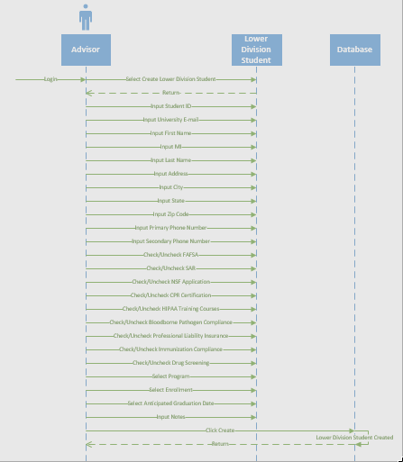

**Use Case 41: Edit Lower Division Student**

**Create Lower Division Student**

**Brief Description**

*Edit Lower Division Student will edit a student in the database.*

**Flow of Events**

The actor in this case is the Advisor that is inputting/editing lower division student information into the form and then submitting, which will update a student in the database. All required fields of the form must be correctly filled out to submit and create student.

**Basic Flow**

* Advisor selects edit student
* Advisor inputs/edits Student ID
* Advisor inputs/edits University E-mail
* Advisor inputs/edits First Name
* Advisor inputs/edits MI
* Advisor inputs/edits Last Name
* Advisor inputs/edits Address
* Advisor inputs/edits City
* Advisor selects/edits State
* Advisor inputs/edits Zip Code
* Advisor inputs/edits Primary Phone Number
* Advisor inputs/edits Secondary Phone Number
* Advisor checks/unchecks FAFSA
* Advisor checks/unchecks SAR
* Advisor checks/unchecks NSF Application
* Advisor checks/unchecks CPR Certification
* Advisor checks/unchecks HIPAA Training Courses
* Advisor checks/unchecks Blood borne Pathogen Compliance
* Advisor checks/unchecks Professional Liability Insurance
* Advisor checks/unchecks Immunization Compliance
* Advisor checks/unchecks Drug Screening
* Advisor selects/edits Program
* Advisor selects/edits Enrollment
* Advisor selects/edits Anticipated Graduation Date
* Advisor inputs/edits notes
* Advisor clicks save

**Alternative Flows**

Alternative flows are actions that occur when creating student does not properly occur.

Required Fields Not Complete

* Create button clicked
* Message pop up indicating unmet conditions

Delete Student

* Delete button clicked

**Special Requirements**

* Logged in with Advisor access

**System Requirements**

* Access to Windows server 2012
* Access SQL 2016
* Due to FERPA restrictions we must store student information and grades on secure University of Louisville servers

**Pre-conditions**

* Logged in

**Access to System**

* Advisor must be logged in
* Connected to secure network

**Post-conditions**

* Creation Successful

**Extension Points**

If a field on the form is not filled out in the correct format and message will pop-up describing discrepancy.

**Invalid input**

* Incorrect format
* Incorrect number of characters in a field
* Invalid characters

Use Case: 41

Edit Lower Division Student

Advisor logs in

Advisor selects edit student

Database is accessed to retrieve existing student

Advisor edits/inputs/selects/checks following fields…

Advisor clicks save

Student is updated in database

Once updated successfully, returns to starting point

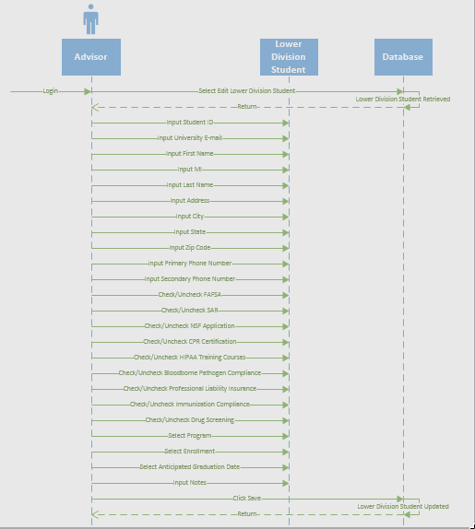

**Use Case 42: Lower Upper Division Student**

**Create Lower Division Student**

**Brief Description**

*Delete Lower Division Student will edit a student in the database.*

**Flow of Events**

The actor in this case is the Advisor that is deleting lower division student information from the database and moved to a temporary dump file. Advisor must also input login information to confirm delete action.

**Basic Flow**

* Advisor selects edit student
* Advisor clicks delete
* Advisor inputs username
* Advisor inputs password
* Advisor clicks delete

**Alternative Flows**

Alternative flows are actions that occur when creating student does not properly occur.

Required Fields Not Complete

* Create button clicked
* Message pop up indicating unmet conditions

Cancel

* Cancels button clicked
* Returns to edit student

**Special Requirements**

* Logged in with Advisor access

**System Requirements**

* Access to Windows server 2012
* Access SQL 2016
* Due to FERPA restrictions we must store student information and grades on secure University of Louisville servers

**Pre-conditions**

* Logged in

**Access to System**

* Advisor must be logged in
* Connected to secure network

**Post-conditions**

* Delete Successful

**Extension Points**

If a field on the form is not filled out in the correct format and message will pop-up describing discrepancy.

**Invalid input**

* Incorrect format
* Incorrect number of characters in a field
* Invalid characters

Use Case: 42

Delete Lower Division Student

Advisor logs in

Advisor selects edit student

Database is accessed to retrieve existing student

Advisor clicks delete

Advisor inputs username and login

Advisor confirms delete

Student is deleted from database and moved to temp dump file

Once deleted successfully, returns to starting point

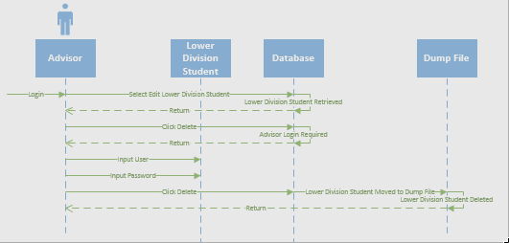

**Use Case 43: Create Perspective Student**

**Create Perspective Student**

**Brief Description**

*Create Perspective Student will create a student in the database.*

**Flow of Events**

The actor in this case is the Advisor that is inputting perspective student information into the form and then submitting, which will create a student in the database. All required fields of the form must be correctly filled out to submit and create student.

**Basic Flow**

* Advisor selects create student
* Advisor inputs Student ID
* Advisor inputs University E-mail
* Advisor inputs First Name
* Advisor inputs MI
* Advisor inputs Last Name
* Advisor inputs Address
* Advisor inputs City
* Advisor selects State
* Advisor inputs Zip Code
* Advisor inputs Primary Phone Number
* Advisor inputs Secondary Phone Number
* Advisor checks/unchecks FAFSA
* Advisor checks/unchecks SAR
* Advisor checks/unchecks NSF Application
* Advisor checks/unchecks CPR Certification
* Advisor checks/unchecks HIPAA Training Courses
* Advisor checks/unchecks Blood borne Pathogen Compliance
* Advisor checks/unchecks Professional Liability Insurance
* Advisor checks/unchecks Immunization Compliance
* Advisor checks/unchecks Drug Screening
* Advisor selects Program
* Advisor selects Enrollment
* Advisor selects Anticipated Graduation Date
* Advisor inputs notes

**Alternative Flows**

Alternative flows are actions that occur when creating student does not properly occur.

Required Fields Not Complete

* Create button clicked
* Message pop up indicating unmet conditions

Reset Form

* Reset button clicked
* All fields cleared

**Special Requirements**

* Logged in with Advisor access

**System Requirements**

* Access to Windows server 2012
* Access SQL 2016
* Due to FERPA restrictions we must store student information and grades on secure University of Louisville servers

**Pre-conditions**

* Logged in

**Access to System**

* Advisor must be logged in
* Connected to secure network

**Post-conditions**

* Creation Successful

**Extension Points**

If a field on the form is not filled out in the correct format and message will pop-up describing discrepancy.

**Invalid input**

* Incorrect format
* Incorrect number of characters in a field
* Invalid characters

Use Case: 43

Create Perspective Student

Advisor logs in

Advisor selects create student

Advisor Inputs/selects/checks following fields…

Advisor clicks create

Student is added to database

Once added successfully, returns to starting point

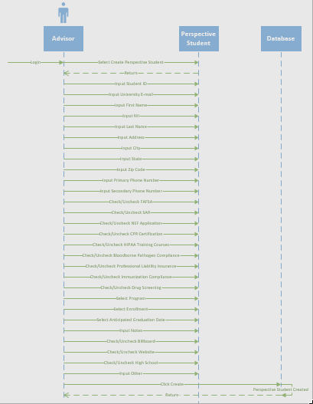

**Use Case 44: Edit Upper Division Student**

**Create Perspective Student**

**Brief Description**

*Edit Perspective Student will edit a student in the database.*

**Flow of Events**

The actor in this case is the Advisor that is inputting/editing perspective student information into the form and then submitting, which will update a student in the database. All required fields of the form must be correctly filled out to submit and create student.

**Basic Flow**

* Advisor selects edit student
* Advisor inputs/edits Student ID
* Advisor inputs/edits University E-mail
* Advisor inputs/edits First Name
* Advisor inputs/edits MI
* Advisor inputs/edits Last Name
* Advisor inputs/edits Address
* Advisor inputs/edits City
* Advisor selects/edits State
* Advisor inputs/edits Zip Code
* Advisor inputs/edits Primary Phone Number
* Advisor inputs/edits Secondary Phone Number
* Advisor checks/unchecks FAFSA
* Advisor checks/unchecks SAR
* Advisor checks/unchecks NSF Application
* Advisor checks/unchecks CPR Certification
* Advisor checks/unchecks HIPAA Training Courses
* Advisor checks/unchecks Blood borne Pathogen Compliance
* Advisor checks/unchecks Professional Liability Insurance
* Advisor checks/unchecks Immunization Compliance
* Advisor checks/unchecks Drug Screening
* Advisor selects/edits Program
* Advisor selects/edits Enrollment
* Advisor selects/edits Anticipated Graduation Date
* Advisor inputs/edits notes
* Advisor clicks save

**Alternative Flows**

Alternative flows are actions that occur when creating student does not properly occur.

Required Fields Not Complete

* Create button clicked
* Message pop up indicating unmet conditions

Delete Student

* Delete button clicked

**Special Requirements**

* Logged in with Advisor access

**System Requirements**

* Access to Windows server 2012
* Access SQL 2016
* Due to FERPA restrictions we must store student information and grades on secure University of Louisville servers

**Pre-conditions**

* Logged in

**Access to System**

* Advisor must be logged in
* Connected to secure network

**Post-conditions**

* Creation Successful

**Extension Points**

If a field on the form is not filled out in the correct format and message will pop-up describing discrepancy.

**Invalid input**

* Incorrect format
* Incorrect number of characters in a field
* Invalid characters

Use Case: 43

Create Perspective Student

Advisor logs in

Advisor selects create student

Advisor Inputs/selects/checks following fields…

Advisor clicks create

Student is added to database

Once added successfully, returns to starting point



**Use Case 45: Delete Perspective Student**

**Create Perspective Division Student**

**Brief Description**

*Delete Perspective Student will edit a student in the database.*

**Flow of Events**

The actor in this case is the Advisor that is deleting perspective student information from the database and moved to a temporary dump file. Advisor must also input login information to confirm delete action.

**Basic Flow**

* Advisor selects edit student
* Advisor clicks delete
* Advisor inputs username
* Advisor inputs password
* Advisor clicks delete

**Alternative Flows**

Alternative flows are actions that occur when creating student does not properly occur.

Required Fields Not Complete

* Create button clicked
* Message pop up indicating unmet conditions

Cancel

* Cancels button clicked
* Returns to edit student

**Special Requirements**

* Logged in with Advisor access

**System Requirements**

* Access to Windows server 2012
* Access SQL 2016
* Due to FERPA restrictions we must store student information and grades on secure University of Louisville servers

**Pre-conditions**

* Logged in

**Access to System**

* Advisor must be logged in
* Connected to secure network

**Post-conditions**

* Delete Successful

**Extension Points**

If a field on the form is not filled out in the correct format and message will pop-up describing discrepancy.

**Invalid input**

* Incorrect format
* Incorrect number of characters in a field
* Invalid characters

Use Case: 45

Delete Perspective Student

Advisor logs in

Advisor selects edit student

Database is accessed to retrieve existing student

Advisor clicks delete

Advisor inputs username and login

Advisor confirms delete

Student is deleted from database and moved to temp dump file

Once deleted successfully, returns to starting point

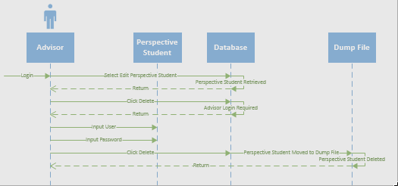

**Use Case 46: Create Graduate**

**Create Graduate**

**Brief Description**

*Create Graduate will create a student in the database.*

**Flow of Events**

The actor in this case is the Advisor that is inputting graduate information into the form and then submitting, which will create a student in the database. All required fields of the form must be correctly filled out to submit and create student.

**Basic Flow**

* Advisor selects create student
* Advisor inputs Student ID
* Advisor inputs University E-mail
* Advisor inputs First Name
* Advisor inputs MI
* Advisor inputs Last Name
* Advisor inputs Address
* Advisor inputs City
* Advisor selects State
* Advisor inputs Zip Code
* Advisor inputs Primary Phone Number
* Advisor inputs Secondary Phone Number
* Advisor inputs Employer
* Advisor selects Salary Range
* Advisor selects Program
* Advisor selects Enrollment
* Advisor selects Anticipated Graduation Date
* Advisor inputs notes

**Alternative Flows**

Alternative flows are actions that occur when creating student does not properly occur.

Required Fields Not Complete

* Create button clicked
* Message pop up indicating unmet conditions

Reset Form

* Reset button clicked
* All fields cleared

**Special Requirements**

* Logged in with Advisor access

**System Requirements**

* Access to Windows server 2012
* Access SQL 2016
* Due to FERPA restrictions we must store student information and grades on secure University of Louisville servers

**Pre-conditions**

* Logged in

**Access to System**

* Advisor must be logged in
* Connected to secure network

**Post-conditions**

* Creation Successful

**Extension Points**

If a field on the form is not filled out in the correct format and message will pop-up describing discrepancy.

**Invalid input**

* Incorrect format
* Incorrect number of characters in a field
* Invalid characters

Use Case: 46

Create Graduate

Advisor logs in

Advisor selects create student

Advisor Inputs/selects/checks following fields…

Advisor clicks create

Student is added to database

Once added successfully, returns to starting point

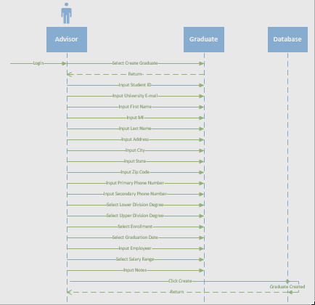

**Use Case 47: Edit Graduate**

**Create Graduate**

**Brief Description**

*Edit Graduate will edit a student in the database.*

**Flow of Events**

The actor in this case is the Advisor that is inputting/editing graduate information into the form and then submitting, which will update a student in the database. All required fields of the form must be correctly filled out to submit and create student.

**Basic Flow**

* Advisor selects edit student
* Advisor inputs/edits Student ID
* Advisor inputs/edits University E-mail
* Advisor inputs/edits First Name
* Advisor inputs/edits MI
* Advisor inputs/edits Last Name
* Advisor inputs/edits Address
* Advisor inputs/edits City
* Advisor selects/edits State
* Advisor inputs/edits Zip Code
* Advisor inputs/edits Primary Phone Number
* Advisor inputs/edits Secondary Phone Number
* Advisor inputs/edits Employer
* Advisor selects/edits Salary Range
* Advisor selects/edits Program
* Advisor selects/edits Enrollment
* Advisor selects/edits Anticipated Graduation Date
* Advisor inputs/edits notes
* Advisor clicks save

**Alternative Flows**

Alternative flows are actions that occur when creating student does not properly occur.

Required Fields Not Complete

* Create button clicked
* Message pop up indicating unmet conditions

Delete Student

* Delete button clicked

**Special Requirements**

* Logged in with Advisor access

**System Requirements**

* Access to Windows server 2012
* Access SQL 2016
* Due to FERPA restrictions we must store student information and grades on secure University of Louisville servers

**Pre-conditions**

* Logged in

**Access to System**

* Advisor must be logged in
* Connected to secure network

**Post-conditions**

* Creation Successful

**Extension Points**

If a field on the form is not filled out in the correct format and message will pop-up describing discrepancy.

**Invalid input**

* Incorrect format
* Incorrect number of characters in a field
* Invalid characters

Use Case: 47

Edit Graduate

Advisor logs in

Advisor selects edit student

Database is accessed to retrieve existing student

Advisor edits/inputs/selects/checks following fields…

Advisor clicks save

Student is updated in database

Once updated successfully, returns to starting point

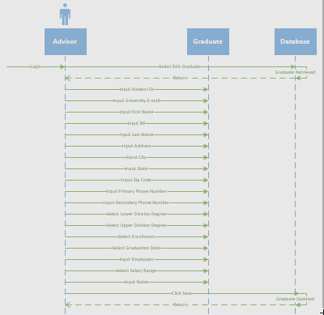

**Use Case 48: Delete Graduate**

**Create Graduate**

**Brief Description**

*Delete Graduate will edit a student in the database.*

**Flow of Events**

The actor in this case is the Advisor that is deleting graduate information from the database and moved to a temporary dump file. Advisor must also input login information to confirm delete action.

**Basic Flow**

* Advisor selects edit student
* Advisor clicks delete
* Advisor inputs username
* Advisor inputs password
* Advisor clicks delete

**Alternative Flows**

Alternative flows are actions that occur when creating student does not properly occur.

Required Fields Not Complete

* Create button clicked
* Message pop up indicating unmet conditions

Cancel

* Cancels button clicked
* Returns to edit student

**Special Requirements**

* Logged in with Advisor access

**System Requirements**

* Access to Windows server 2012
* Access SQL 2016
* Due to FERPA restrictions we must store student information and grades on secure University of Louisville servers

**Pre-conditions**

* Logged in

**Access to System**

* Advisor must be logged in
* Connected to secure network

**Post-conditions**

* Delete Successful

**Extension Points**

If a field on the form is not filled out in the correct format and message will pop-up describing discrepancy.

**Invalid input**

* Incorrect format
* Incorrect number of characters in a field
* Invalid characters

Use Case: 48

Delete Graduate

Advisor logs in

Advisor selects edit student

Database is accessed to retrieve existing student

Advisor clicks delete

Advisor inputs username and login

Advisor confirms delete

Student is deleted from database and moved to temp dump file

Once deleted successfully, returns to starting point

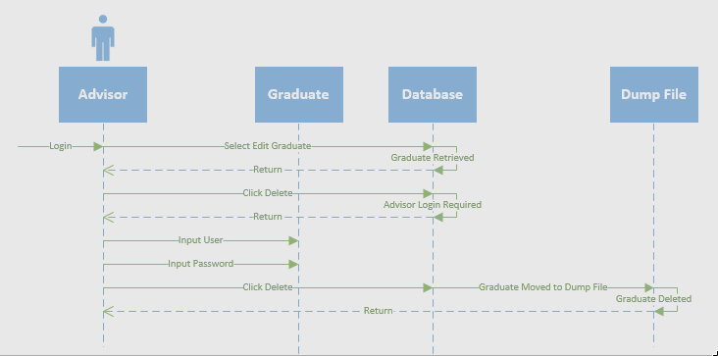

Create Admin

# Use-Case Name

Create Admin

## Brief Description

When the system is designed, there will be an Admin account created for the initial setup purposes. In order to ensure the administrative role can change hands, and to provide support for multiple administrator accounts (should the school ever need it) the SONAR system will need a page for creating admin users. Below is the flow describing how to complete this task.

# Flow of Events

## Basic Flow

## The Admin will browse from their home page to the Manage Users tab

* Next the Admin will be presented with a list box on the left side of the screen, which contains all of the users currently in the system. There will be search bar to the right of the list box which allows the admin to search through the list of users, and a button beneath the search bar labeled Create Users
* The Admin will click the Create User button
* Admin will be presented with a new screen, on the top left of the create user screen will be a drop down box the admin must click to select a user type. The admin will click the dropdown and select Admin
* The admin will then enter the username, a temporary password, first name, last name, employeeID, middle initial, address, city, state, zip, primary and secondary phone. Required fields are Username, password, first name, and last name. The rest can be filled out by the new administrator when the first log on to the SONAR system as they will be prompted to complete the information upon logging in.
* The Admin will hit the Finish button that appears beneath the user information after it has all been filled out.

## Alternative Flows

### Cancel Create User

* Should the admin wish to cancel the creation of a user, all they must do is click the Cancel button located to the right of the Create button on the Create Admin page.

# Special Requirements

## < First Special Requirement >

Must be connected to School of Nursing network or connected through virtual Lab.

# Pre-conditions

## User Type

The use of the system must be and Admin.

## Logged In

The Admin must be successfully logged into the system.

# Post-conditions

## New Admin Created

A new Admin account will have been created, and will have the full privileges associated with that account.

# Extension Points

## Incomplete Required Fields Finish

If the admin creating the account has not filled out the required fields (indicated as required by the asterisk next to the field name) and the admin clicks the finish button, and error will display asking the admin to enter information into the required fields before continuing.

## Incomplete Required Fields Browse

If the admin creating the account has not filled out the required fields, and the admin tries to browse away from the create admin page, they will be prompted with an error asking if they wish to discard the information they have previously entered. If the admin click Yes, the admin will leave the page, and lose any information they had previously entered. If they click No, the admin will stay on the current page until they hit finish or cancel.

Create Administrator

The Admin will browse from their home page to the Manage Users tab

- Next the Admin will be presented with a list box on the left side of the screen, which contains all of the

users currently in the system. There will be search bar to the right of the list box which allows the

admin to search through the list of users, and a button beneath the search bar labeled Create Users

- The Admin will click the Create User button

- Admin will be presented with a new screen, on the top left of the create user screen will be a drop

down box the admin must click to select a user type. The admin will click the dropdown and select

Admin

- The admin will then enter the username, a temporary password, first name, last name, employeeID,

middle initial, address, city, state, zip, primary and secondary phone. Required fields are Username,

password, first name, and last name. The rest can be filled out by the new administrator when the first

log on to the SONAR system as they will be prompted to complete the information upon logging in.

- The Admin will hit the Finish button that appears beneath the user information after it has all been

filled out.

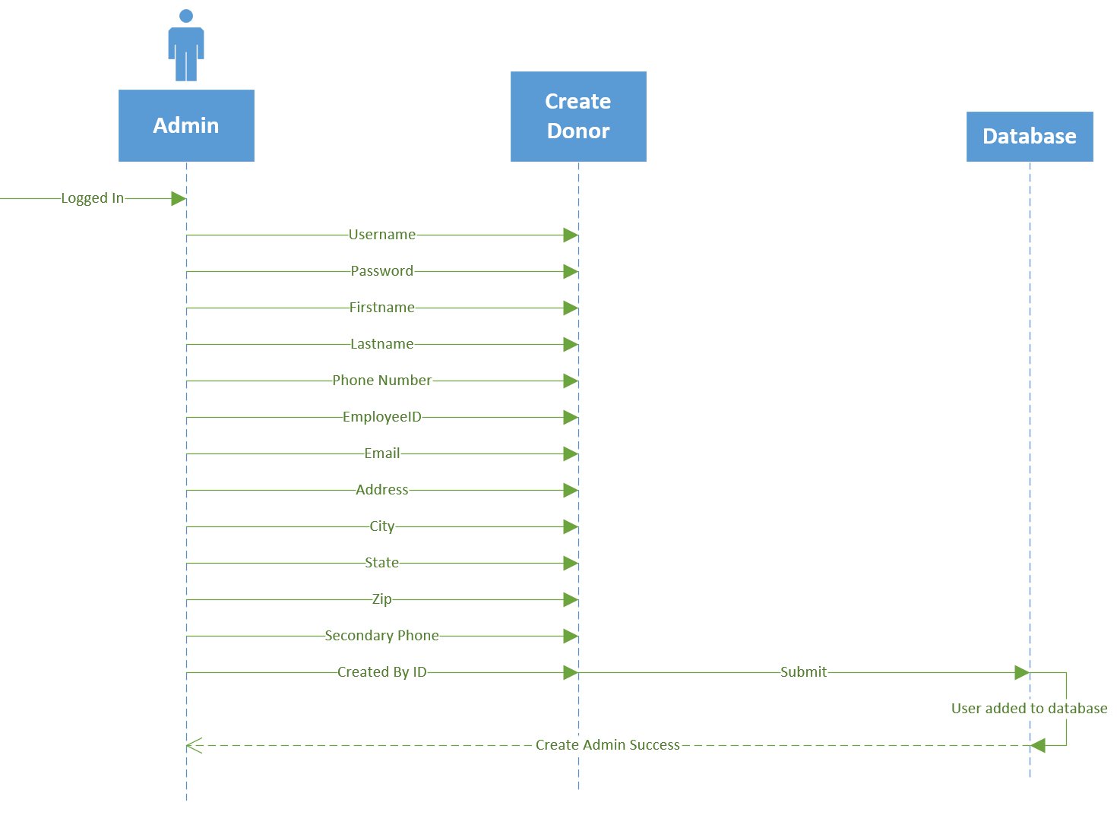

Create Professor

# Use-Case Name

Create Professor

## Brief Description

Professor accounts will need be created in order to allow the professors using the system to upload grades to it. This process is described below

# Flow of Events

## Basic Flow

## The Admin will browse from their home page to the Manage Users tab

* Next the Admin will be presented with a list box on the left side of the screen, which contains all of the users currently in the system. There will be search bar to the right of the list box which allows the admin to search through the list of users, and a button beneath the search bar labeled Create Users
* The Admin will click the Create User button
* Admin will be presented with a new screen, on the top left of the create user screen will be a drop down box the admin must click to select a user type. The admin will click the dropdown and select Professor
* The admin will then enter the username, a temporary password, first name, last name, employeeID, middle initial, address, city, state, zip, primary and secondary phone. Required fields are Username, password, first name, and last name. The rest can be filled out by the new professor when the first log on to the SONAR system as they will be prompted to complete the information upon logging in.
* The Admin will hit the Finish button that appears beneath the user information after it has all been filled out.

## Alternative Flows

### Cancel Create User

* Should the admin wish to cancel the creation of a user, all they must do is click the Cancel button located to the right of the Create button on the Create Admin page.

# Special Requirements

## Connectivity

Must be connected to School of Nursing network or connected through virtual Lab.

# Pre-conditions

## User Type

The user of the system must be and Admin.

## Logged In

The Admin must be successfully logged into the system.

# Post-conditions

## New Admin Created

A new Professor account will have been created, and will have the full privileges associated with that account.

# Extension Points

## Incomplete Required Fields Finish

If the admin creating the account has not filled out the required fields (indicated as required by the asterisk next to the field name) and the admin clicks the finish button, and error will display asking the admin to enter information into the required fields before continuing.

## Incomplete Required Fields Browse

If the admin creating the account has no filled out the required fields, and the admin tries to browse away from the create admin page, they will be prompted with an error asking if they wish to discard the information they have previously entered. If the admin clicks Yes, the admin will leave the page, and lose any information they had previously entered. If they click No, the admin will stay on the current page until they hit finish or cancel.

Create Professor

The Admin will browse from their home page to the Manage Users tab

- Next the Admin will be presented with a list box on the left side of the screen, which contains all of the

users currently in the system. There will be search bar to the right of the list box which allows the

admin to search through the list of users, and a button beneath the search bar labeled Create Users

- The Admin will click the Create User button

- Admin will be presented with a new screen, on the top left of the create user screen will be a drop

down box the admin must click to select a user type. The admin will click the dropdown and select

Professor

- The admin will then enter the username, a temporary password, first name, last name, employeeID,

middle initial, address, city, state, zip, primary and secondary phone. Required fields are Username,

password, first name, and last name. The rest can be filled out by the new professor when the first log

on to the SONAR system as they will be prompted to complete the information upon logging in.

- The Admin will hit the Finish button that appears beneath the user information after it has all been

filled out.

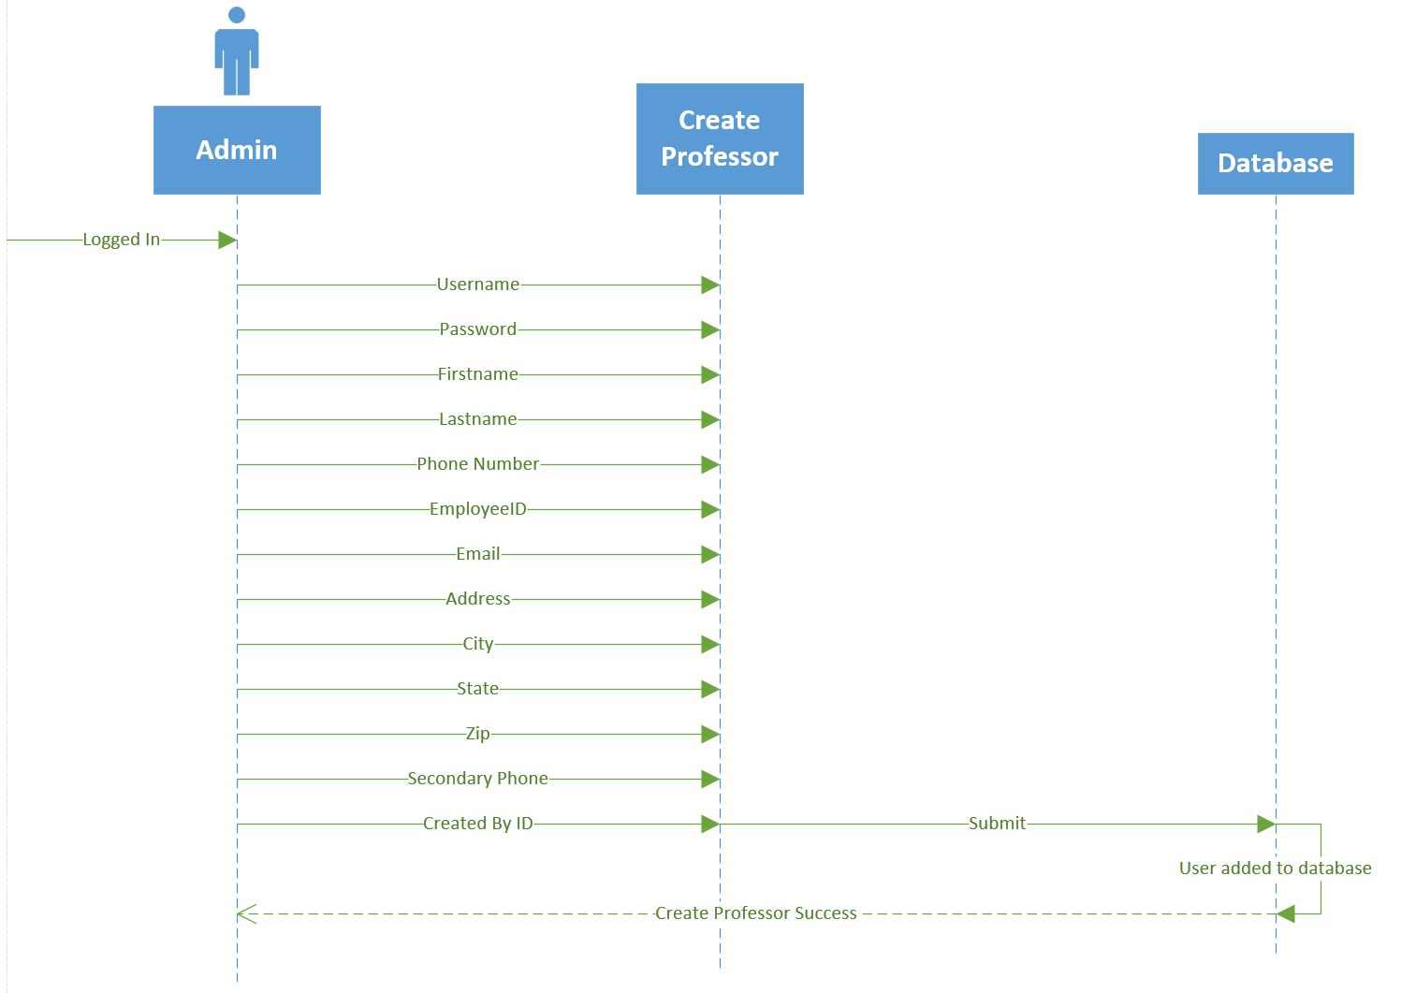

Create Advisor

# Use-Case Name

Create Advisor

## Brief Description

Advisor accounts will need to be created in order to grant SON advisors access to the system and the ability to create, update, and delete students. As well as track student progress and pull reports. The following describes how Advisors are to be created.

# Flow of Events

## Basic Flow

## The Admin will browse from their home page to the Manage Users tab

* Next the Admin will be presented with a list box on the left side of the screen, which contains all of the users currently in the system. There will be search bar to the right of the list box which allows the admin to search through the list of users, and a button beneath the search bar labeled Create Users
* The Admin will click the Create User button
* Admin will be presented with a new screen, on the top left of the create user screen will be a drop down box the admin must click to select a user type. The admin will click the dropdown and select Advisor
* The admin will then enter the username, a temporary password, first name, last name, employeeID, middle initial, address, city, state, zip, primary and secondary phone. Required fields are Username, password, first name, and last name. The rest can be filled out by the new advisor when they first log on to the SONAR system as they will be prompted to complete the information upon logging in.
* The Admin will hit the Finish button that appears beneath the user information after it has all been filled out.

## Alternative Flows

### Cancel Create User

* Should the admin wish to cancel the creation of a user, all they must do is click the Cancel button located to the right of the Create button on the Create Admin page.

# Special Requirements

## Connectivity

Must be connected to School of Nursing network or connected through virtual Lab.

# Pre-conditions

## User Type

The user of the system must be and Admin.

## Logged In

The Admin must be successfully logged into the system.

# Post-conditions

## New Admin Created

A new Advisor account will have been created, and will have the full privileges associated with that account.

# Extension Points

## Incomplete Required Fields Finish

If the admin creating the account has not filled out the required fields (indicated as required by the asterisk next to the field name) and the admin clicks the finish button, and error will display asking the admin to enter information into the required fields before continuing.

## Incomplete Required Fields Browse

If the admin creating the account has no filled out the required fields, and the admin tries to browse away from the create admin page, they will be prompted with an error asking if they wish to discard the information they have previously entered. If the admin clicks Yes, the admin will leave the page, and lose any information they had previously entered. If they click No, the admin will stay on the current page until they hit finish or cancel.

Create Advisor

The Admin will browse from their home page to the Manage Users tab

- Next the Admin will be presented with a list box on the left side of the screen, which contains all of the

users currently in the system. There will be search bar to the right of the list box which allows the

admin to search through the list of users, and a button beneath the search bar labeled Create Users

- The Admin will click the Create User button

- Admin will be presented with a new screen, on the top left of the create user screen will be a drop

down box the admin must click to select a user type. The admin will click the dropdown and select Advisor

- The admin will then enter the username, a temporary password, first name, last name, employeeID,

middle initial, address, city, state, zip, primary and secondary phone. Required fields are Username,

password, first name, and last name. The rest can be filled out by the new advisor when they first log

on to the SONAR system as they will be prompted to complete the information upon logging in.

- The Admin will hit the Finish button that appears beneath the user information after it has all been

filled out.

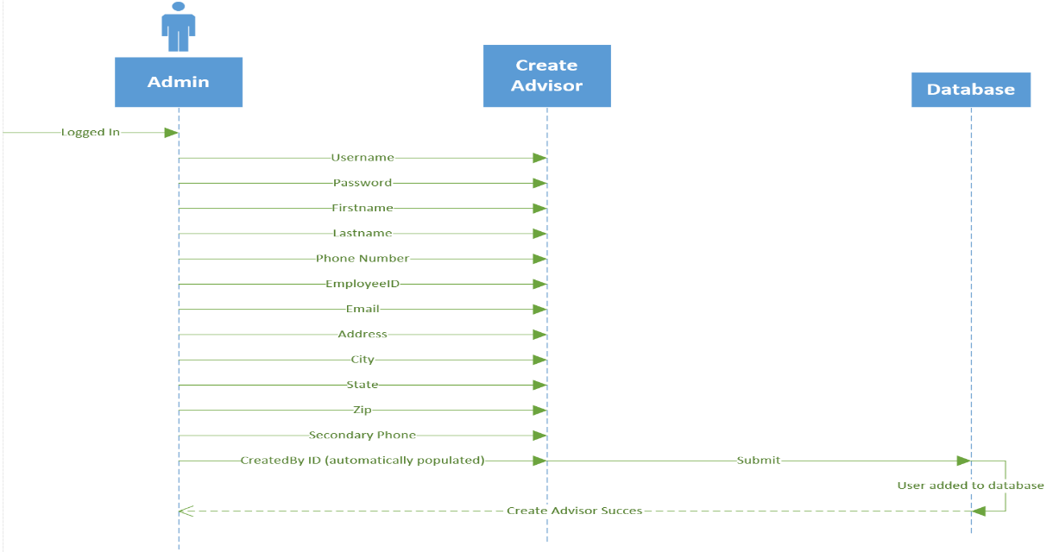

Create Committee Member

# Use-Case Name

Create Committee Member

## Brief Description

Advisor accounts will need to be created in order to grant SON advisors access to the system and the ability to create, update, and delete students. As well as track student progress and pull reports. The following describes how Advisors are to be created.

# Flow of Events

## Basic Flow

## The Admin will browse from their home page to the Manage Users tab

* Next the Admin will be presented with a list box on the left side of the screen, which contains all of the users currently in the system. There will be search bar to the right of the list box which allows the admin to search through the list of users, and a button beneath the search bar labeled Create Users
* The Admin will click the Create User button
* Admin will be presented with a new screen, on the top left of the create user screen will be a drop down box the admin must click to select a user type. The admin will click the dropdown and select Committee Member
* The admin will then enter the username, a temporary password, first name, last name, employeeID, middle initial, address, city, state, zip, primary and secondary phone. Required fields are Username, password, first name, and last name. The rest can be filled out by the new professor when they first log on to the SONAR system as they will be prompted to complete the information upon logging in.
* The Admin will hit the Finish button that appears beneath the user information after it has all been filled out.

## Alternative Flows

### Cancel Create User

* Should the admin wish to cancel the creation of a user, all they must do is click the Cancel button located to the right of the Create button on the Create Admin page.

# Special Requirements

## Connectivity

Must be connected to School of Nursing network or connected through virtual Lab.

# Pre-conditions

## User Type

The user of the system must be and Admin.

## Logged In

The Admin must be successfully logged into the system.

# Post-conditions

## New Admin Created

A new Committee Member account will have been created, and will have the full privileges associated with that account.

# Extension Points

## Incomplete Required Fields Finish

If the admin creating the account has not filled out the required fields (indicated as required by the asterisk next to the field name) and the admin clicks the finish button, and error will display asking the admin to enter information into the required fields before continuing.

## Incomplete Required Fields Browse

If the admin creating the account has no filled out the required fields, and the admin tries to browse away from the create admin page, they will be prompted with an error asking if they wish to discard the information they have previously entered. If the admin clicks Yes, the admin will leave the page, and lose any information they had previously entered. If they click No, the admin will stay on the current page until they hit finish or cancel.

Create Committee Member

The Admin will browse from their home page to the Manage Users tab

- Next the Admin will be presented with a list box on the left side of the screen, which contains all of the

users currently in the system. There will be search bar to the right of the list box which allows the

admin to search through the list of users, and a button beneath the search bar labeled Create Users

- The Admin will click the Create User button

- Admin will be presented with a new screen, on the top left of the create user screen will be a drop

down box the admin must click to select a user type. The admin will click the dropdown and select

Committee Member

- The admin will then enter the username, a temporary password, first name, last name, employeeID,

middle initial, address, city, state, zip, primary and secondary phone. Required fields are Username,

password, first name, and last name. The rest can be filled out by the new professor when they first log

on to the SONAR system as they will be prompted to complete the information upon logging in.

- The Admin will hit the Finish button that appears beneath the user information after it has all been

filled out.

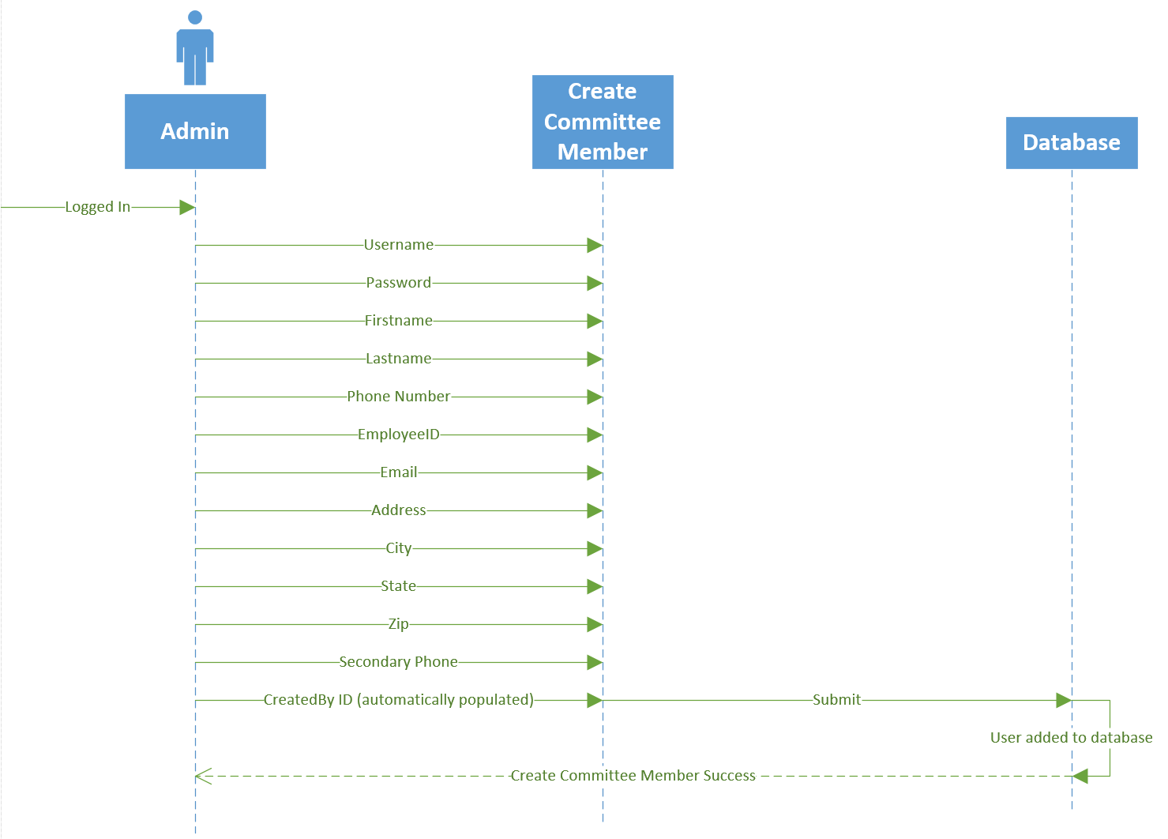

Update Admin

# Use-Case Name

Update Admin

## Brief Description

As information changes, Admins will need the ability to update their information in order to stay current. This also allows passwords to be manually changed as a fail-safe to the email resets should the admin need their password changed.

# Flow of Events

## Basic Flow

## The Admin will browse from their home page to the Manage Users tab

* Next the Admin will be presented with a list box on the left side of the screen, which contains all of the users currently in the system. There will be search bar to the right of the list box which allows the admin to search through the list of users, and a button beneath the search bar labeled Create Users
* The admin enter the first name, last name, email, or employeeID/Student ID they wish to update and hit enter.
* Next the admin will double click the user in the listbox they wish to edit. This will open up a page that displays the user’s information.
* The Admin will make the changes they wish to make and hit save.

## Alternative Flows

### Cancel Update

## The Admin will browse from their home page to the Manage Users tab

* Next the Admin will be presented with a list box on the left side of the screen, which contains all of the users currently in the system. There will be search bar to the right of the list box which allows the admin to search through the list of users, and a button beneath the search bar labeled Create Users
* The admin enter the first name, last name, email, or employeeID/Student ID they wish to update and hit enter.
* Next the advisor will double click the user in the listbox they wish to edit. This will open up a page that displays the user’s information.
* The admin will hit cancel to gracefully stop the update.

# Special Requirements

## Connectivity

Must be connected to School of Nursing network or connected through virtual Lab.

# Pre-conditions

## User Type

The use of the system must be and Advisor

## Logged In

The Advisor must be successfully logged into the system.

# Post-conditions

## Updated User

The user the admin has chosen to edit will be saved to the system with updated values.

# Extension Points

## Incomplete Required Fields Finish

If the admin has cleared out one of the users required fields and attempts to save, the system will display an error asking the admin to fill in the required field before continuing.

## Incomplete Required Fields Browse

If the admin has updated values and they do not save, then try to browse to another page using the currently open tab, the system will display an error asking the admin if they wish to continue away from the page and discard the changes made. If the admin hits Yes, the information previously entered will be discarded and the page will change. If the admin hit No, the system will remain on the current page and allow the admin to continue editing the user, or save the changes to the user and populate these changes in the system.

Update Admin

The Admin will browse from their home page to the Manage Users tab

- Next the Admin will be presented with a list box on the left side of the screen, which contains all of the

users currently in the system. There will be search bar to the right of the list box which allows the

admin to search through the list of users, and a button beneath the search bar labeled Create Users

- The admin enter the first name, last name, email, or employeeID/Student ID they wish to update and

hit enter.

- Next the admin will double click the user in the listbox they wish to edit. This will open up a page that

displays the user’s information.

- The Admin will make the changes they wish to make and hit save.

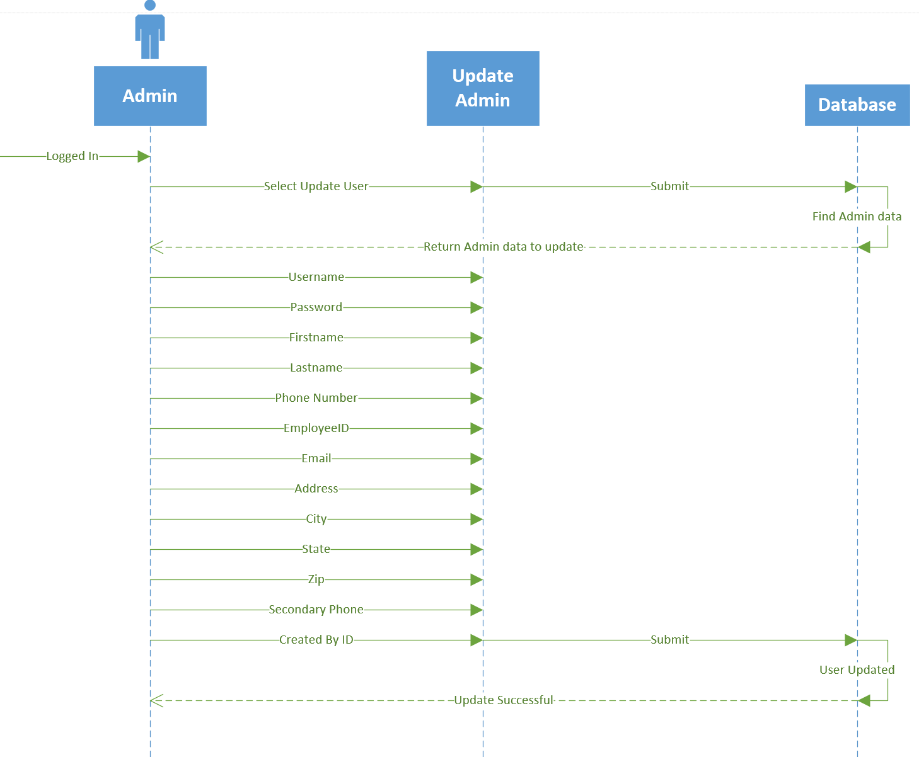

Update Professor

# Use-Case Name

Update Professor

## Brief Description

As information changes, Admins will need the ability to update their information in order to stay current. This also allows passwords to be manually changed as a fail-safe to the email resets should the admin need their password changed.

# Flow of Events

## Basic Flow

## The Admin will browse from their home page to the Manage Users tab

* Next the Admin will be presented with a list box on the left side of the screen, which contains all of the users currently in the system. There will be search bar to the right of the list box which allows the admin to search through the list of users, and a button beneath the search bar labeled Create Users
* The admin enter the first name, last name, email, or employeeID/Student ID they wish to update and hit enter.
* Next the advisor will double click the user in the listbox they wish to edit. This will open up a page that displays the user’s information.
* The Admin will make the changes they wish to make and hit save.

## Alternative Flows

### Cancel Update

## The Admin will browse from their home page to the Manage Users tab

* Next the Admin will be presented with a list box on the left side of the screen, which contains all of the users currently in the system. There will be search bar to the right of the list box which allows the admin to search through the list of users, and a button beneath the search bar labeled Create Users
* The admin enter the first name, last name, email, or employeeID/Student ID they wish to update and hit enter.
* Next the admin will double click the user in the listbox they wish to edit. This will open up a page that displays the user’s information.
* The admin will hit cancel to gracefully stop the update.

# Special Requirements

## Connectivity

Must be connected to School of Nursing network or connected through virtual Lab.

# Pre-conditions

## User Type

The use of the system must be and Admin

## Logged In

The Admin must be successfully logged into the system.

# Post-conditions

## Updated User

The user the admin has chosen to edit will be saved to the system with updated values.

# Extension Points

## Incomplete Required Fields Finish

If the admin has cleared out one of the users required fields and attempts to save, the system will display an error asking the admin to fill in the required field before continuing.

## Incomplete Required Fields Browse

If the admin has updated values and they do not save, then try to browse to another page using the currently open tab, the system will display an error asking the admin if they wish to continue away from the page and discard the changes made. If the admin hits Yes, the information previously entered will be discarded and the page will change. If the admin hit No, the system will remain on the current page and allow the admin to continue editing the user, or save the changes to the user and populate these changes in the system.

Update Professor

The Admin will browse from their home page to the Manage Users tab

- Next the Admin will be presented with a list box on the left side of the screen, which contains all of the

users currently in the system. There will be search bar to the right of the list box which allows the

admin to search through the list of users, and a button beneath the search bar labeled Create Users

- The admin enter the first name, last name, email, or employeeID/Student ID they wish to update and

hit enter.

- Next the advisor will double click the user in the listbox they wish to edit. This will open up a page

that displays the user’s information.

- The Admin will make the changes they wish to make and hit save.

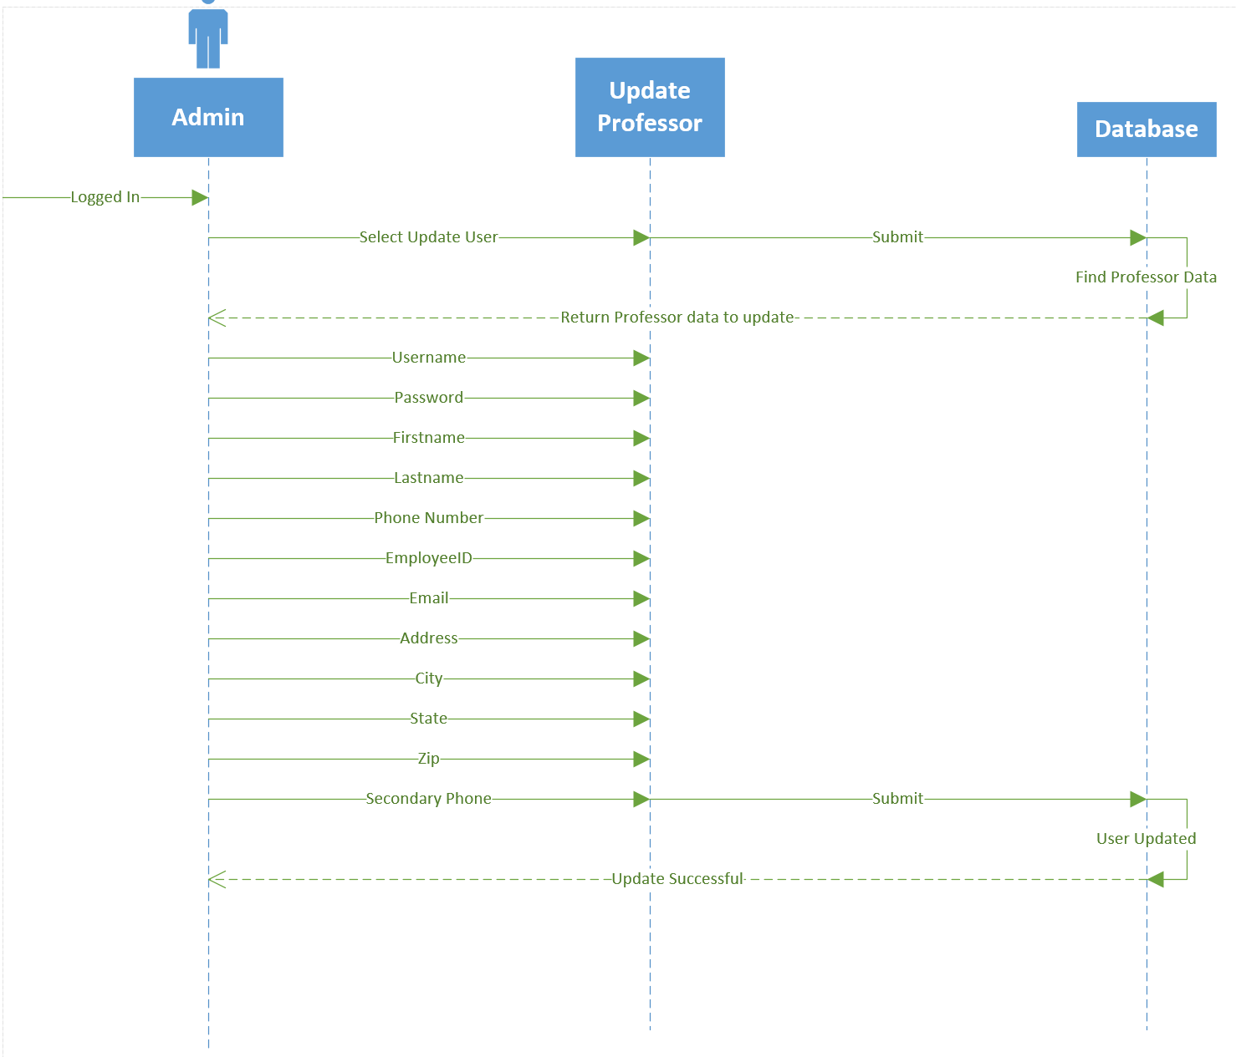

Update Advisor

# Use-Case Name

Update Advisor

## Brief Description

As information changes, Admins will need the ability to update their information in order to stay current. This also allows passwords to be manually changed as a fail-safe to the email resets should the admin need their password changed.

# Flow of Events

## Basic Flow

## The Admin will browse from their home page to the Manage Users tab

* Next the Admin will be presented with a list box on the left side of the screen, which contains all of the users currently in the system. There will be search bar to the right of the list box which allows the admin to search through the list of users, and a button beneath the search bar labeled Create Users
* The admin enter the first name, last name, email, or employeeID/Student ID they wish to update and hit enter.
* Next the admin will double click the user in the listbox they wish to edit. This will open up a page that displays the user’s information.
* The Admin will make the changes they wish to make and hit save.

## Alternative Flows

### Cancel Update

## The Admin will browse from their home page to the Manage Users tab

* Next the Admin will be presented with a list box on the left side of the screen, which contains all of the users currently in the system. There will be search bar to the right of the list box which allows the admin to search through the list of users, and a button beneath the search bar labeled Create Users
* The admin enter the first name, last name, email, or employeeID/Student ID they wish to update and hit enter.
* Next the advisor will double click the user in the listbox they wish to edit. This will open up a page that displays the user’s information.
* The admin will hit cancel to gracefully stop the update.

# Special Requirements

## Connectivity

Must be connected to School of Nursing network or connected through virtual Lab.

# Pre-conditions

## User Type

The use of the system must be and Admin

## Logged In

The Admin must be successfully logged into the system.

# Post-conditions

## Updated User

The user the admin has chosen to edit will be saved to the system with updated values.

# Extension Points

## Incomplete Required Fields Finish

If the admin has cleared out one of the users required fields and attempts to save, the system will display an error asking the admin to fill in the required field before continuing.

## Incomplete Required Fields Browse

If the admin has updated values and they do not save, then try to browse to another page using the currently open tab, the system will display an error asking the admin if they wish to continue away from the page and discard the changes made. If the admin hits Yes, the information previously entered will be discarded and the page will change. If the admin hit No, the system will remain on the current page and allow the admin to continue editing the user, or save the changes to the user and populate these changes in the system.

Update Advisor

The Admin will browse from their home page to the Manage Users tab

- Next the Admin will be presented with a list box on the left side of the screen, which contains all of the

users currently in the system. There will be search bar to the right of the list box which allows the

admin to search through the list of users, and a button beneath the search bar labeled Create Users

- The admin enter the first name, last name, email, or employeeID/Student ID they wish to update and

hit enter.

- Next the admin will double click the user in the listbox they wish to edit. This will open up a page that

displays the user’s information.

- The Admin will make the changes they wish to make and hit save.

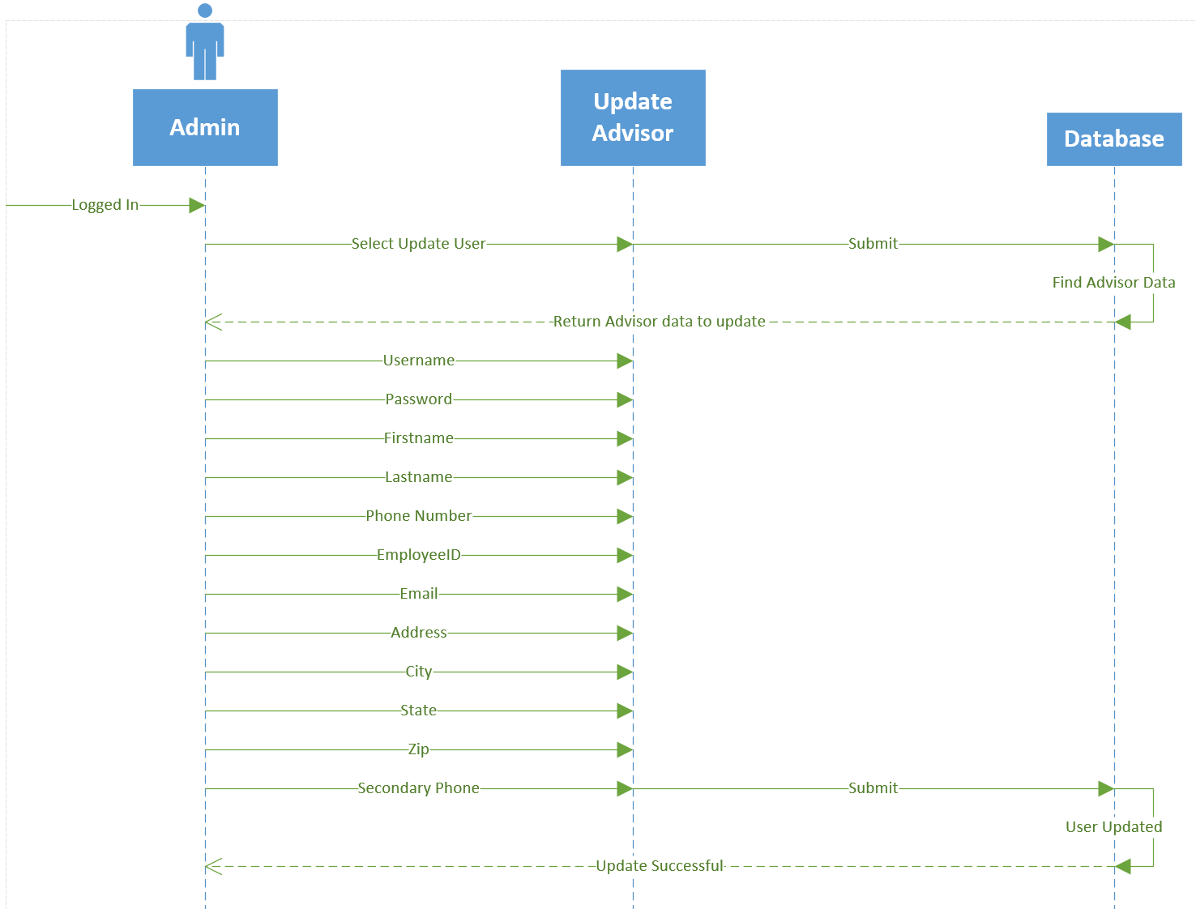

Update Professor

# Use-Case Name

Update Committee Member

## Brief Description

As information changes, Admins will need the ability to update their information in order to stay current. This also allows passwords to be manually changed as a fail-safe to the email resets should the admin need their password changed.

# Flow of Events

## Basic Flow

## The Admin will browse from their home page to the Manage Users tab

* Next the Admin will be presented with a list box on the left side of the screen, which contains all of the users currently in the system. There will be search bar to the right of the list box which allows the admin to search through the list of users, and a button beneath the search bar labeled Create Users
* The admin enter the first name, last name, email, or employeeID/Student ID they wish to update and hit enter.
* Next the admin will double click the user in the listbox they wish to edit. This will open up a page that displays the user’s information.
* The Admin will make the changes they wish to make and hit save.

## Alternative Flows

### Cancel Update

## The Admin will browse from their home page to the Manage Users tab

* Next the Admin will be presented with a list box on the left side of the screen, which contains all of the users currently in the system. There will be search bar to the right of the list box which allows the admin to search through the list of users, and a button beneath the search bar labeled Create Users
* The admin enter the first name, last name, email, or employeeID/Student ID they wish to update and hit enter.
* Next the advisor will double click the user in the listbox they wish to edit. This will open up a page that displays the user’s information.
* The admin will hit cancel to gracefully stop the update.

# Special Requirements

## Connectivity

Must be connected to School of Nursing network or connected through virtual Lab.

# Pre-conditions

## User Type

The use of the system must be and Admin

## Logged In

The Admin must be successfully logged into the system.

# Post-conditions

## Updated User

The user the admin has chosen to edit will be saved to the system with updated values.

# Extension Points

## Incomplete Required Fields Finish

If the admin has cleared out one of the users required fields and attempts to save, the system will display an error asking the admin to fill in the required field before continuing.

## Incomplete Required Fields Browse

If the admin has updated values and they do not save, then try to browse to another page using the currently open tab, the system will display an error asking the admin if they wish to continue away from the page and discard the changes made. If the admin hits Yes, the information previously entered will be discarded and the page will change. If the admin hit No, the system will remain on the current page and allow the admin to continue editing the user, or save the changes to the user and populate these changes in the system.

Update Professor

The Admin will browse from their home page to the Manage Users tab

- Next the Admin will be presented with a list box on the left side of the screen, which contains all of the

users currently in the system. There will be search bar to the right of the list box which allows the

admin to search through the list of users, and a button beneath the search bar labeled Create Users

- The admin enter the first name, last name, email, or employeeID/Student ID they wish to update and

hit enter.

- Next the advisor will double click the user in the listbox they wish to edit. This will open up a page

that displays the user’s information.

- The Admin will make the changes they wish to make and hit save.



Delete Admin

# Use-Case Name

Delete Admin

## Brief Description

It is not expected the once an admin is created, they will always be a part of the School of Nursing. In case an admin needs to have their access turned off, there will be an option that will ‘delete’ the admin from the system. This will effectively turn off the administrator’s access, and their login will no longer function.

# Flow of Events

## Basic Flow

## The Admin will browse from their home page to the Manage Users tab

* Next the Admin will be presented with a list box on the left side of the screen, which contains all of the users currently in the system. There will be search bar to the right of the list box which allows the admin to search through the list of users, and a button beneath the search bar labeled Create Users
* The admin enter the first name, last name, email, or employeeID/Student ID they wish to update and hit enter.
* Next the admin will double click the user in the listbox they wish to edit. This will open up a page that displays the user’s information.
* The Admin will hit the Delete button and save.

## Alternative Flows

### Cancel Delete

## The Admin will browse from their home page to the Manage Users tab

* Next the Admin will be presented with a list box on the left side of the screen, which contains all of the users currently in the system. There will be search bar to the right of the list box which allows the admin to search through the list of users, and a button beneath the search bar labeled Create Users
* The admin enter the first name, last name, email, or employeeID/Student ID they wish to update and hit enter.
* Next the admin will double click the user in the listbox they wish to edit. This will open up a page that displays the user’s information.
* The admin will hit Cancel to stop delete.

# Special Requirements

## Connectivity

Must be connected to School of Nursing network or connected through virtual Lab.

# Pre-conditions

## User Type

The use of the system must be and Admin

## Logged In

The Admin must be successfully logged into the system.

# Post-conditions

## ‘Deleted’ User

The user the admin deleted will no longer be able to log in. The information regarding that specific user will be maintained for referential purposes only.

# Extension Points

## Deleted Wrong User

If a user is wrongfully deleted, they will still be searchable in the list as the rest of the users. All an admin would have to do is search through the list, either manually or with the search tool, double click the ‘deleted’ user, and check the Restore checkbox on the bottom right corner of the users page, and hit Save.

Delete Administrator

The Admin will browse from their home page to the Manage Users tab

- Next the Admin will be presented with a list box on the left side of the screen, which contains all of the

users currently in the system. There will be search bar to the right of the list box which allows the

admin to search through the list of users, and a button beneath the search bar labeled Create Users

- The admin enter the first name, last name, email, or employeeID/Student ID they wish to update and

hit enter.

- Next the admin will double click the user in the listbox they wish to edit. This will open up a page that

displays the user’s information.

- The Admin will hit the Delete button and save.

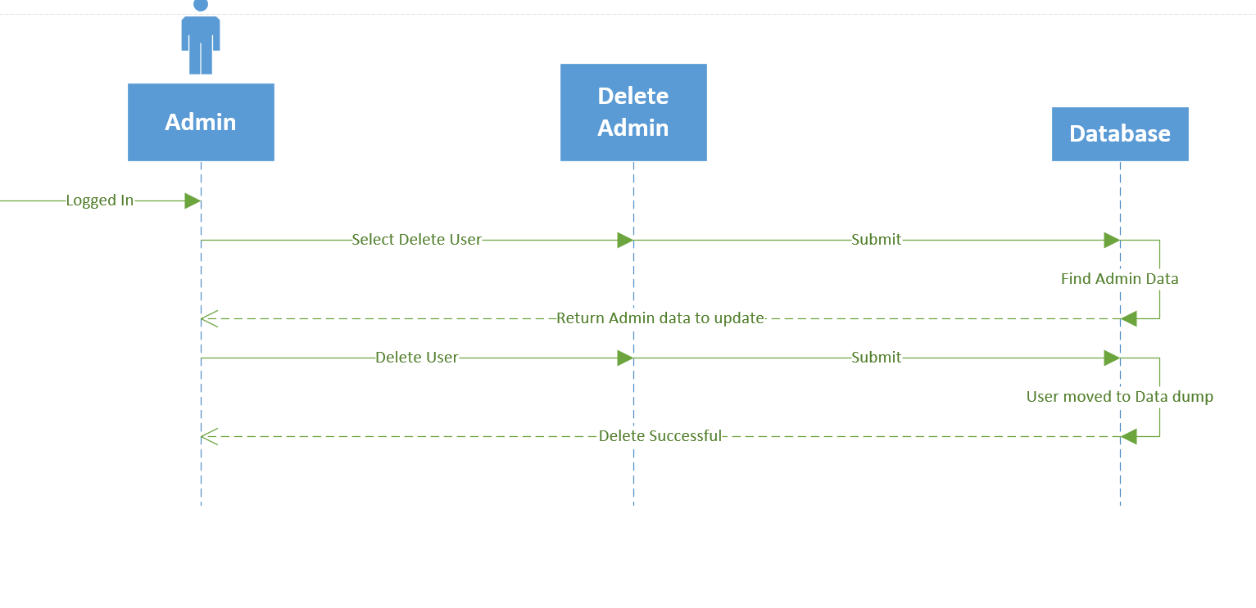

Delete Professor

# Use-Case Name

Delete Professor

## Brief Description

It is not expected the once an admin is created, they will always be a part of the School of Nursing. In case an admin needs to have their access turned off, there will be an option that will ‘delete’ the admin from the system. This will effectively turn off the administrator’s access, and their login will no longer function.

# Flow of Events

## Basic Flow

## The Admin will browse from their home page to the Manage Users tab

* Next the Admin will be presented with a list box on the left side of the screen, which contains all of the users currently in the system. There will be search bar to the right of the list box which allows the admin to search through the list of users, and a button beneath the search bar labeled Create Users
* The admin enter the first name, last name, email, or employeeID/Student ID they wish to update and hit enter.
* Next the admin will double click the user in the listbox they wish to edit. This will open up a page that displays the user’s information.
* The Admin will hit the Delete button and save.

## Alternative Flows

### Cancel Delete

## The Admin will browse from their home page to the Manage Users tab

* Next the Admin will be presented with a list box on the left side of the screen, which contains all of the users currently in the system. There will be search bar to the right of the list box which allows the admin to search through the list of users, and a button beneath the search bar labeled Create Users
* The admin enter the first name, last name, email, or employeeID/Student ID they wish to update and hit enter.
* Next the admin will double click the user in the listbox they wish to edit. This will open up a page that displays the user’s information.
* The admin will hit Cancel to stop delete.

# Special Requirements

## Connectivity

Must be connected to School of Nursing network or connected through virtual Lab.

# Pre-conditions

## User Type

The use of the system must be and Admin

## Logged In

The Admin must be successfully logged into the system.

# Post-conditions

## ‘Deleted’ User

The user the admin deleted will no longer be able to log in. The information regarding that specific user will be maintained for referential purposes only.

# Extension Points

## Deleted Wrong User

If a user is wrongfully deleted, they will still be searchable in the list as the rest of the users. All an admin would have to do is search through the list, either manually or with the search tool, double click the ‘deleted’ user, and check the Restore checkbox on the bottom right corner of the users page, and hit Save.

Delete Professor

The Admin will browse from their home page to the Manage Users tab

- Next the Admin will be presented with a list box on the left side of the screen, which contains all of the

users currently in the system. There will be search bar to the right of the list box which allows the

admin to search through the list of users, and a button beneath the search bar labeled Create Users

- The admin enter the first name, last name, email, or employeeID/Student ID they wish to update and

hit enter.

- Next the admin will double click the user in the listbox they wish to edit. This will open up a page that

displays the user’s information.

- The Admin will hit the Delete button and save.

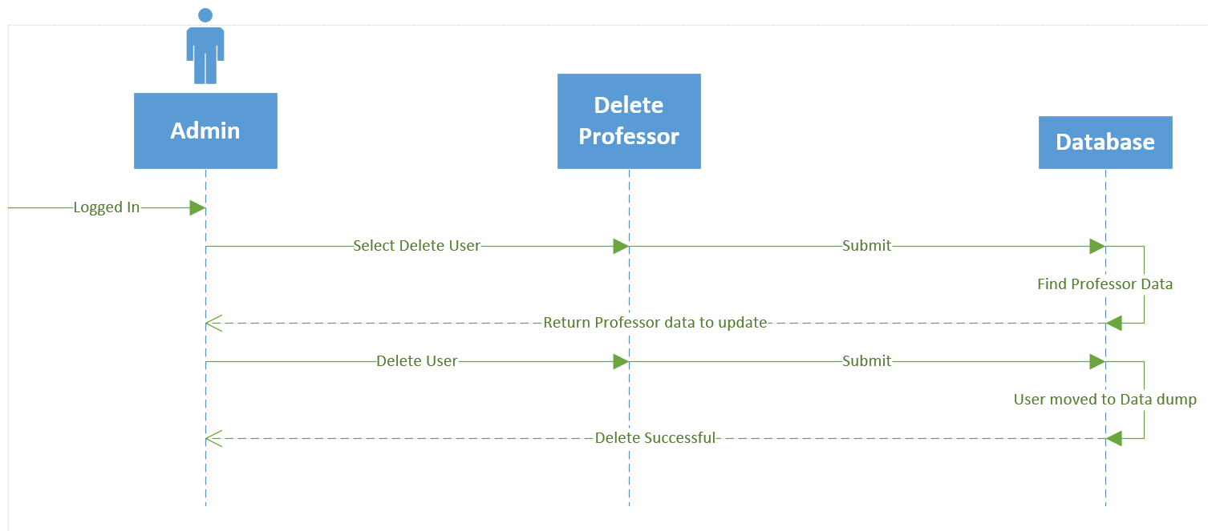

Delete Advisor

# Use-Case Name

Delete Advisor

## Brief Description

It is not expected the once an admin is created, they will always be a part of the School of Nursing. In case an admin needs to have their access turned off, there will be an option that will ‘delete’ the admin from the system. This will effectively turn off the administrator’s access, and their login will no longer function.

# Flow of Events

## Basic Flow

## The Admin will browse from their home page to the Manage Users tab

* Next the Admin will be presented with a list box on the left side of the screen, which contains all of the users currently in the system. There will be search bar to the right of the list box which allows the admin to search through the list of users, and a button beneath the search bar labeled Create Users
* The admin enter the first name, last name, email, or employeeID/Student ID they wish to update and hit enter.
* Next the admin will double click the user in the listbox they wish to edit. This will open up a page that displays the user’s information.
* The Admin will hit the Delete button and save.

## Alternative Flows

### Cancel Delete

## The Admin will browse from their home page to the Manage Users tab

* Next the Admin will be presented with a list box on the left side of the screen, which contains all of the users currently in the system. There will be search bar to the right of the list box which allows the admin to search through the list of users, and a button beneath the search bar labeled Create Users
* The admin enter the first name, last name, email, or employeeID/Student ID they wish to update and hit enter.
* Next the admin will double click the user in the listbox they wish to edit. This will open up a page that displays the user’s information.
* The admin will hit Cancel to stop delete.

# Special Requirements

## Connectivity

Must be connected to School of Nursing network or connected through virtual Lab.

# Pre-conditions

## User Type

The use of the system must be and Admin

## Logged In

The Admin must be successfully logged into the system.

# Post-conditions

## ‘Deleted’ User

The user the admin deleted will no longer be able to log in. The information regarding that specific user will be maintained for referential purposes only.

# Extension Points

## Deleted Wrong User

If a user is wrongfully deleted, they will still be searchable in the list as the rest of the users. All an admin would have to do is search through the list, either manually or with the search tool, double click the ‘deleted’ user, and check the Restore checkbox on the bottom right corner of the users page, and hit Save.

Delete Advisor

The Admin will browse from their home page to the Manage Users tab

- Next the Admin will be presented with a list box on the left side of the screen, which contains all of the

users currently in the system. There will be search bar to the right of the list box which allows the

admin to search through the list of users, and a button beneath the search bar labeled Create Users

- The admin enter the first name, last name, email, or employeeID/Student ID they wish to update and

hit enter.

- Next the admin will double click the user in the listbox they wish to edit. This will open up a page that

displays the user’s information.

- The Admin will hit the Delete button and save.

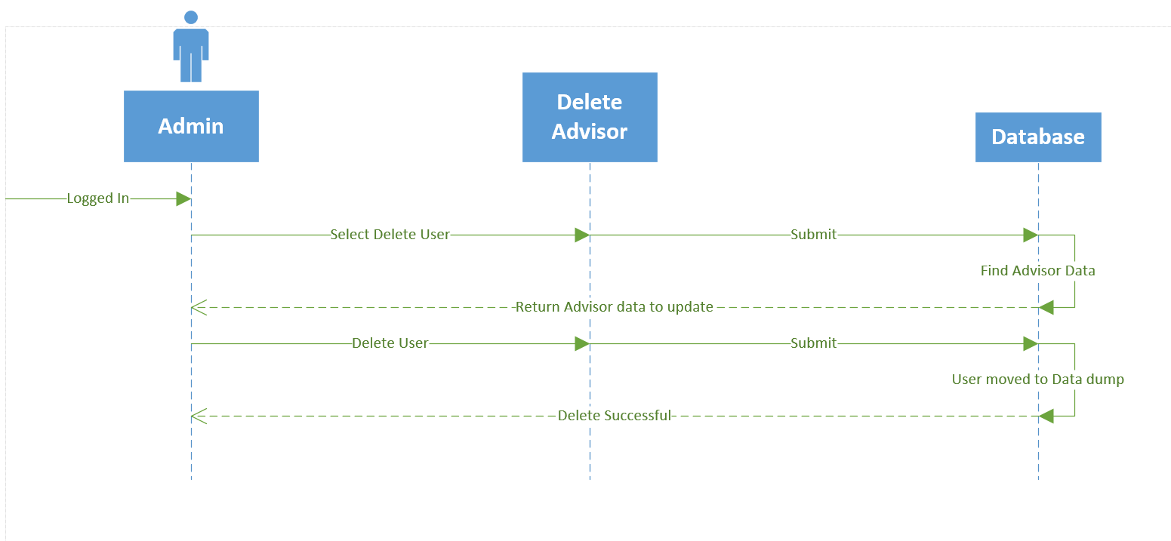

Delete Committee Member

# Use-Case Name

Delete Committee Member

## Brief Description

It is not expected the once an admin is created, they will always be a part of the School of Nursing. In case an admin needs to have their access turned off, there will be an option that will ‘delete’ the admin from the system. This will effectively turn off the administrator’s access, and their login will no longer function.

# Flow of Events

## Basic Flow

## The Admin will browse from their home page to the Manage Users tab

* Next the Admin will be presented with a list box on the left side of the screen, which contains all of the users currently in the system. There will be search bar to the right of the list box which allows the admin to search through the list of users, and a button beneath the search bar labeled Create Users
* The admin enter the first name, last name, email, or employeeID/Student ID they wish to update and hit enter.
* Next the admin will double click the user in the listbox they wish to edit. This will open up a page that displays the user’s information.
* The Admin will hit the Delete button and save.

## Alternative Flows

### Cancel Delete

## The Admin will browse from their home page to the Manage Users tab

* Next the Admin will be presented with a list box on the left side of the screen, which contains all of the users currently in the system. There will be search bar to the right of the list box which allows the admin to search through the list of users, and a button beneath the search bar labeled Create Users
* The admin enter the first name, last name, email, or employeeID/Student ID they wish to update and hit enter.
* Next the admin will double click the user in the listbox they wish to edit. This will open up a page that displays the user’s information.
* The admin will hit Cancel to stop delete.

# Special Requirements

## Connectivity

Must be connected to School of Nursing network or connected through virtual Lab.

# Pre-conditions

## User Type

The use of the system must be and Admin

## Logged In

The Admin must be successfully logged into the system.

# Post-conditions

## ‘Deleted’ User

The user the admin deleted will no longer be able to log in. The information regarding that specific user will be maintained for referential purposes only.

# Extension Points

## Deleted Wrong User

If a user is wrongfully deleted, they will still be searchable in the list as the rest of the users. All an admin would have to do is search through the list, either manually or with the search tool, double click the ‘deleted’ user, and check the Restore checkbox on the bottom right corner of the users page, and hit Save.

Use case 60:

## The Admin will browse from their home page to the Manage Users tab

* Next the Admin will be presented with a list box on the left side of the screen, which contains all of the users currently in the system. There will be search bar to the right of the list box which allows the admin to search through the list of users, and a button beneath the search bar labeled Create Users
* The admin enter the first name, last name, email, or employeeID/Student ID they wish to update and hit enter.
* Next the admin will double click the user in the listbox they wish to edit. This will open up a page that displays the user’s information.
* The Admin will hit the Delete button and save.

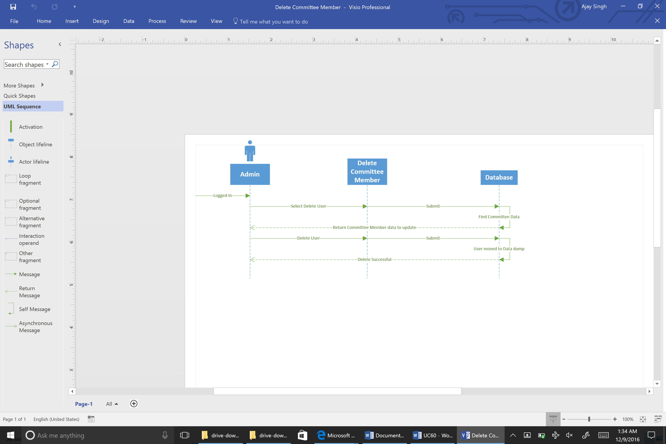

Submit Student Documents

# Use-Case Name

Submit Student Documents

## Brief Description

Students will periodically need to upload documents to the system for Advisors to review. The flow below describes how students will upload documents for Advisors to review.

# Flow of Events

## Basic Flow

## The student will brows to the Upload Documents tab from the student homepage.

* The student will select the document type they wish to upload, and then hit Browse.
* The student will see a File Explorer windows open, they will brows the file they wish to upload and hit the Upload button.
* Students will now see the Upload Documents page again, this time with the name of the documents the wish to submit between the Select document type and the submit buttons.
* The Student will hit submit, which will send an email alert to their advisor letting them know the student has submitted the document, and what kind of document they’ve submitted.

## Alternative Flows

### Cancel Submission

## The student will brows to the Upload Documents tab from the student homepage.

* The student will select the document type they wish to upload, and then hit Browse.
* The student will see a File Explorer windows open, they will brows the file they wish to upload and hit the Upload button.
* Students will now see the Upload Documents page again, this time with the name of the documents the wish to submit between the Select document type and the submit buttons.
* The student will hit Cancel to gracefully stop the document upload.

# Special Requirements

## Connectivity

Must be connected to School of Nursing network or connected through virtual Lab.

# Pre-conditions

## User Type

The user of the system must be an student.

## Logged In

The student must be successfully logged into the system.

# Post-conditions

## Document Uploaded

The student’s document will successfully be uploaded. The student’s advisor will be notified that the document has been submitted for review.

# Extension Points

## Document Rejected

If the Student attempts to upload a document that is not a .docx, .jpg, .pdf, png, .xlsx, .doc, or .xls, the file will be rejected and the student will be asked to resubmit using on the of the appropriate file types.

## No Document Selected

If the student hits the submit button before selecting a document, the SONAR system will throw an error message asking the student to select a document before submitting.

Use Case 61:

## The student will brows to the Upload Documents tab from the student homepage.

* The student will select the document type they wish to upload, and then hit Browse.
* The student will see a File Explorer windows open, they will brows the file they wish to upload and hit the Upload button.
* Students will now see the Upload Documents page again, this time with the name of the documents the wish to submit between the Select document type and the submit buttons.
* The Student will hit submit, which will send an email alert to their advisor letting them know the student has submitted the document, and what kind of document they’ve submitted.

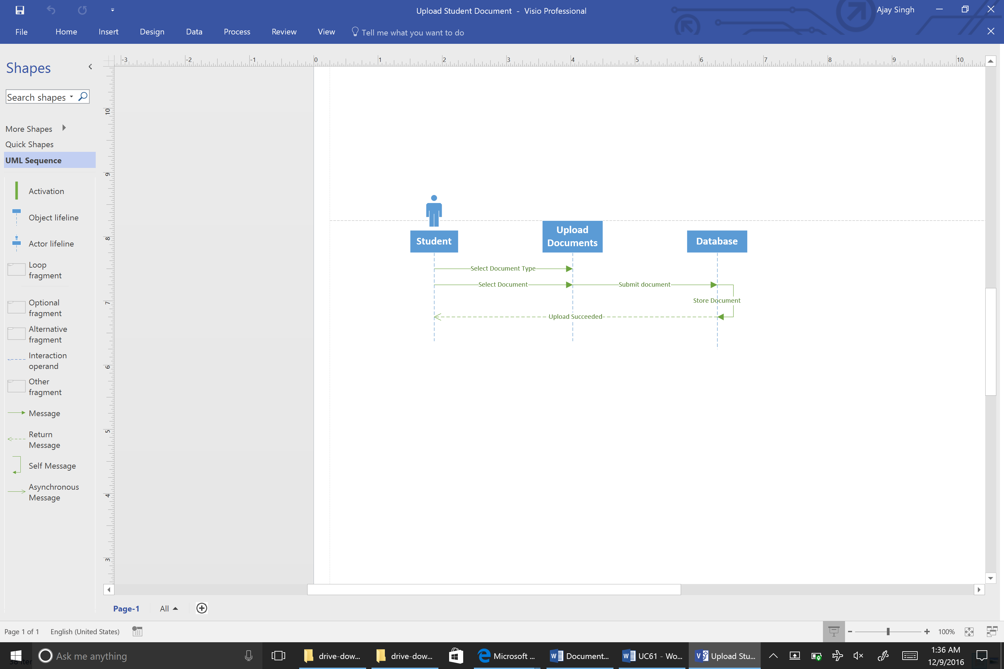

Create Prospective Student

# Use-Case Name

Create Prospective Student

## Brief Description

Prospective Students interested in enrolling in the school of nursing will need a way to find out more information about the school, and need a way to schedule visits with the school in order to get a feel for the program. This describes how a prospective student would create an account.

# Flow of Events

## Basic Flow

## The prospective student will browse to the SONAR system site

* The prospective student will click the No Account link on the login page
* They will then be redirected to another page asking what kind of account they’d like to create, the options will be Prospective Student, Donor, or Alumni. The student will select Prospective Student
* The student will be asked to supply a valid email address, a password, their first name, last name, and phone number.
* The Student will be asked to fill out a captcha box
* The student will hit the Create Account button

## Alternative Flows

### Cancel Create User

## The prospective student will browse to the SONAR system site

* The prospective student will click the No Account link on the login page
* They will then be redirected to another page asking what kind of account they’d like to create, the options will be Prospective Student, Donor, or Alumni. The student will select Prospective Student
* The student will be asked to supply a valid email address, a password, their first name, last name, and phone number.
* The Student will be asked to fill out a captcha box
* The student will hit the Cancel button

# Special Requirements

## Connectivity

To the Internet

# Pre-conditions

## Not Current User

The prospective student cannot currently have an account with the SONAR system.

# Post-conditions

## New Prospective Student Created

A new Prospective Student account will have been created, and will have the full privileges associated with that account.

# Extension Points

## Incomplete Required Fields Finish

If the prospective creating the account has not filled out the required fields (indicated as required by the asterisk next to the field name) and the student clicks the finish button, and error will display asking the student to enter information into the required fields before continuing.

## Incomplete Required Fields Browse

If the student creating the account has not filled out the required fields, and the student tries to browse away from the Create Prospective Student page, they will be prompted with an error asking if they wish to discard the information they have previously entered. If the student click Yes, the student will leave the page, and lose any information they had previously entered. If they click No, the student will stay on the current page until they hit finish or cancel.

Use case 62:

## The prospective student will browse to the SONAR system site

* The prospective student will click the No Account link on the login page
* They will then be redirected to another page asking what kind of account they’d like to create, the options will be Prospective Student, Donor, or Alumni. The student will select Prospective Student
* The student will be asked to supply a valid email address, a password, their first name, last name, and phone number.
* The Student will be asked to fill out a captcha box
* The student will hit the Create Account button

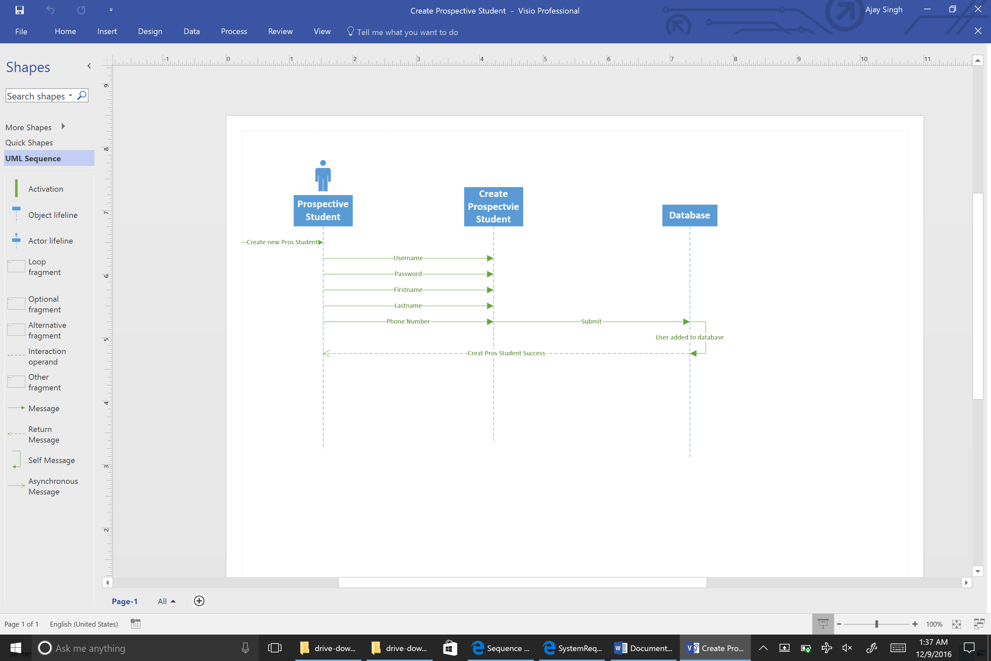

Update Prospective Student

# Use-Case Name

Update Prospective Student

## Brief Description

Prospective Students who have created accounts may need to change their information after the account has been created. The flow of this is described below

# Flow of Events

## Basic Flow

## The prospective student will browse to the SONAR system site

* The prospective student will log in to the SONAR system
* The student will select the Update Information tab
* The Student will change the information in the fields they need to update.
* The student will hit save

## Alternative Flows

### Cancel Update User

## The prospective student will browse to the SONAR system site

* The prospective student will log in to the SONAR system
* The student will select the Update Information tab
* The Student will change the information in the fields they need to update.
* The Prospective Student will hit cancel

# Special Requirements

## Connectivity

Must have internet connection

# Pre-conditions

## User Type

The user must be a Prospective Student

## Logged In

The Prospective Student must be logged in

# Post-conditions

## Updated Prospective Student

The Prospective Student’s information will be updated.

# Extension Points

## Incomplete Required Fields Finish

If the student has cleared out one of the users required fields and attempts to save, the system will display an error asking the student to fill in the required field before continuing.

## Incomplete Required Fields Browse

If the student has updated values and they do not save, then try to browse to another page using the currently open tab, the system will display an error asking the student if they wish to continue away from the page and discard the changes made. If the student hits Yes, the information previously entered will be discarded and the page will change. If the student hit No, the system will remain on the current page and allow the student to continue editing the user, or save the changes to the user and populate these changes in the system.

Use Case 63:

## The prospective student will browse to the SONAR system site

* The prospective student will log in to the SONAR system
* The student will select the Update Information tab
* The Student will change the information in the fields they need to update.
* The student will hit save

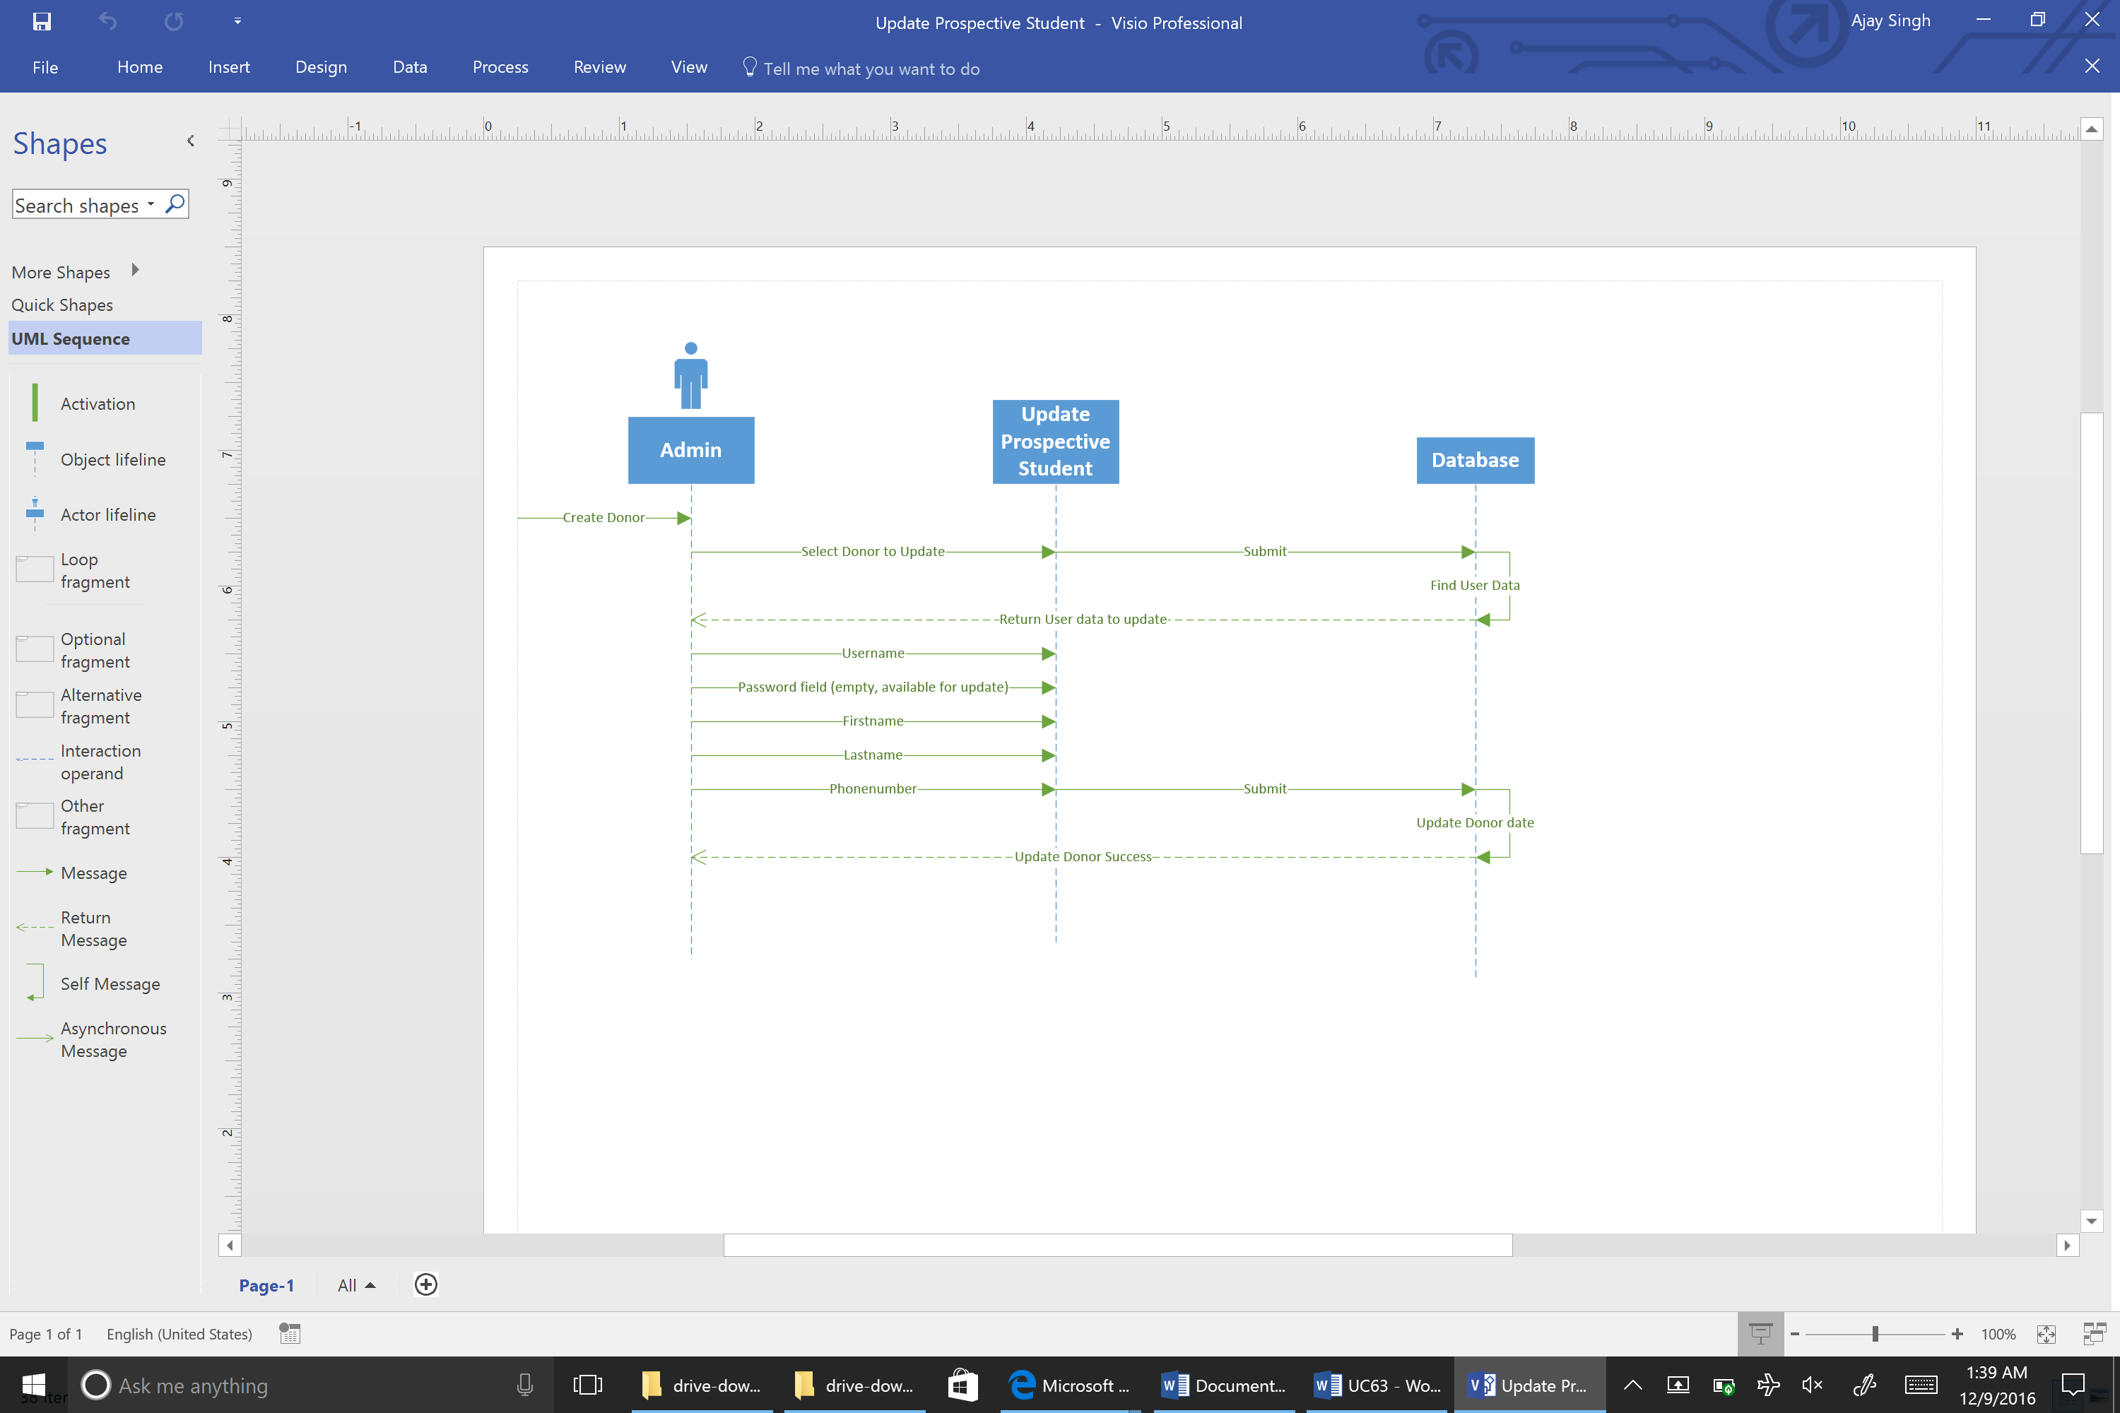

Delete Prospective Student

# Use-Case Name

Delete Prospective Student

## Brief Description

To keep Prospective Student accounts from taking up more space than necessary on the SONAR system, advisors will have the ability to delete them from the system after a certain period of inactivity in a mass delete.

# Flow of Events

## Basic Flow

## The Advisor will browse to the Student Page, where they will run a multi student query for Prospective Students. When the Prospective Student is selected, a delete button will appear to the left of the area that will display the student’s information

* The Prospective Students will be listed in order by date created with the date created listed along with the Prospective Student’s name.
* The advisor will then be able to select all of the accounts they wish to delete
* The advisor will click delete button

## Alternative Flows

### Cancel Delete

## The Advisor will browse from their home page to the Manage Users tab

* Next the Advisor will be presented with a list box on the left side of the screen, which contains all of the users currently in the system. There will be search bar to the right of the list box which allows the admin to search through the list of users, and a button beneath the search bar labeled Create Users
* The advisor enter the first name, last name, email, or employeeID/Student ID they wish to update and hit enter.
* Next the advisor will double click the user in the listbox they wish to edit. This will open up a page that displays the user’s information.
* The advisor will hit Cancel to stop delete.

# Special Requirements

## Connectivity

Must have internet connection

# Pre-conditions

## User Type

The use of the system must be and Advisor

## Logged In

The Advisor must be successfully logged into the system.

# Post-conditions

## ‘Deleted’ Users

The user the advisor deleted will no longer be able to log in. The information regarding that specific user will be maintained for referential purposes only.

# Extension Points

## Deleted Wrong User(s)

If a user is wrongfully deleted, they will still be searchable in the list as the rest of the users. An administrator would have to go through and re-add the Prospective Students that need accounts reinstated.

Use 64:

## The Advisor will browse to the Student Page, where they will run a multi student query for Prospective Students. When the Prospective Student is selected, a delete button will appear to the left of the area that will display the student’s information

* The Prospective Students will be listed in order by date created with the date created listed along with the Prospective Student’s name.
* The advisor will then be able to select all of the accounts they wish to delete
* The advisor will click delete button

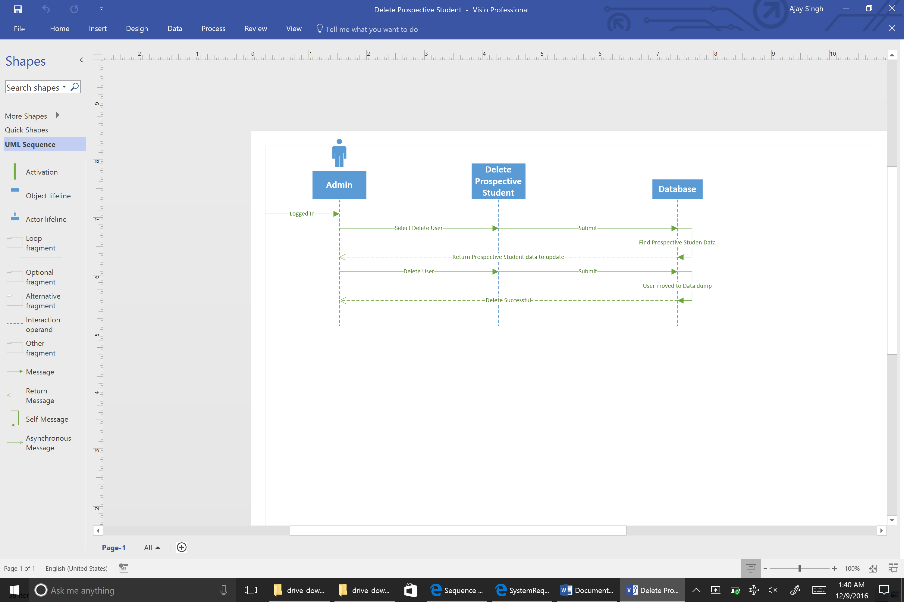

SignUp for Visits

# Use-Case Name

SignUp for Visits

## Brief Description

Prospective Students will need to have the ability to find out more information about the School of Nursing. The account they create will allows students to email advisors from their homepage, or signup for visits. The following describes how students will sign up for visits.

# Flow of Events

## Basic Flow

## The Prospective Student will browse to the Visits tab on their home screen

## The student will be presented with a calendar with days/times marked for available campus visits

## The student will select the time/date they wish to schedule a visit and hit Schedule

* The student will receive a confirmation email letting them know the visit has been scheduled.

## Alternative Flows

### Cancel Visit

## The Prospective Student will browse to the Visits tab on their home screen

## The student will be presented with a calendar with days/times marked for available campus visits

* The Student will see their scheduled visit highlighted on the calendar
* The student will select the visit, and hit Cancel
* The student will receive a confirmation email the visit has been cancelled.

# Special Requirements

## Connectivity

The user must be connected to the internet

# Pre-conditions

## User Type

The use of the system must be a Prospective Student

## Logged In

The Advisor must be successfully logged into the system.

# Post-conditions

## Created Visit

The visit will be created.

# Extension Points

## Forgotten Save

If a user does not save changes before navigating away from the page, their progress will be lost and they will have to start the process over if they wish to enroll in a visit

Create Donor

# Use-Case Name

Create Donor

## Brief Description

Donors interested in enrolling in the school of nursing will need a way to find out more information about the school, and need a way to schedule visits with the school in order to get a feel for the program. This describes how a Donor would create an account.

# Flow of Events

## Basic Flow

## The Donor will browse to the SONAR system site

* The Donor will click the No Account link on the login page
* They will then be redirected to another page asking what kind of account they’d like to create, the options will be Prospective Student, Donor, or Alumni. The student will select Donor
* The student will be asked to supply a valid email address, a password, their first name, last name, and phone number.
* The Student will be asked to fill out a captcha box
* The student will hit the Create Account button

## Alternative Flows

### Cancel Create User

## The Donor will browse to the SONAR system site

* The Donor will click the No Account link on the login page
* They will then be redirected to another page asking what kind of account they’d like to create, the options will be Donor, Donor, or Alumni. The student will select Donor
* The student will be asked to supply a valid email address, a password, their first name, last name, and phone number.
* The Student will be asked to fill out a captcha box
* The student will hit the Cancel button

# Special Requirements

## Connectivity

Must have internet connection

# Pre-conditions

## Not Current User

The Donor cannot currently have an account with the SONAR system.

# Post-conditions

## New Donor Created

A new Donor account will have been created, and will have the full privileges associated with that account.

# Extension Points

## Incomplete Required Fields Finish

If the prospective creating the account has not filled out the required fields (indicated as required by the asterisk next to the field name) and the student clicks the finish button, and error will display asking the student to enter information into the required fields before continuing.

## Incomplete Required Fields Browse

If the student creating the account has not filled out the required fields, and the student tries to browse away from the Create Donor page, they will be prompted with an error asking if they wish to discard the information they have previously entered. If the student click Yes, the student will leave the page, and lose any information they had previously entered. If they click No, the student will stay on the current page until they hit finish or cancel.

Use case 66:

## The Donor will browse to the SONAR system site

* The Donor will click the No Account link on the login page
* They will then be redirected to another page asking what kind of account they’d like to create, the options will be Prospective Student, Donor, or Alumni. The student will select Donor
* The student will be asked to supply a valid email address, a password, their first name, last name, and phone number.
* The Student will be asked to fill out a captcha box
* The student will hit the Create Account button

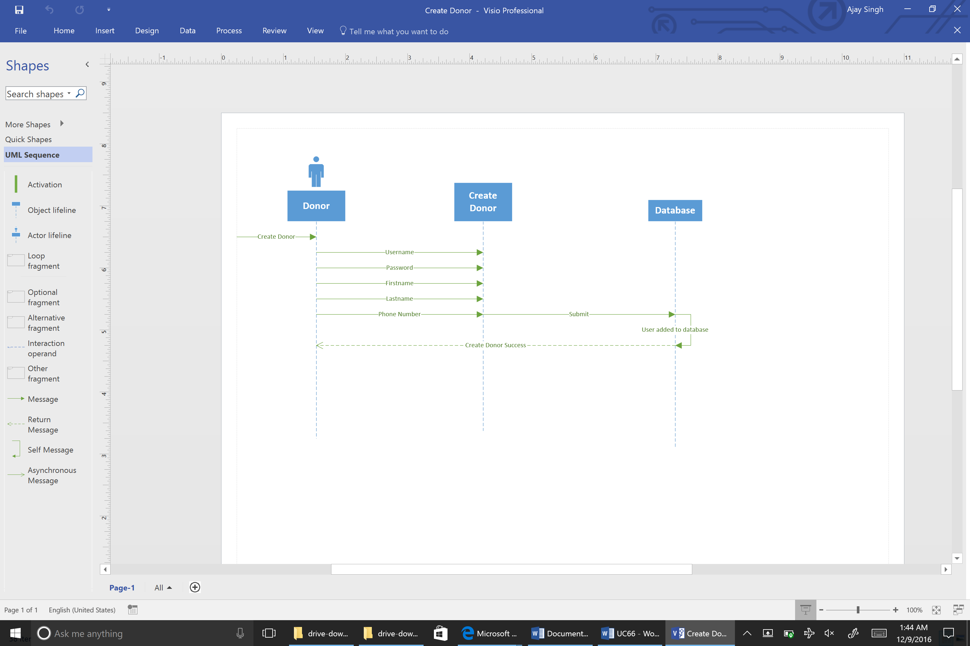

Update Donor

# Use-Case Name

Update Donor

## Brief Description

Donors who have created accounts may need to change their information after the account has been created. The flow of this is described below

# Flow of Events

## Basic Flow

## The Donor will browse to the SONAR system site

* The Donor will log in to the SONAR system
* The student will select the Update Information tab
* The Student will change the information in the fields they need to update.
* The student will hit save

## Alternative Flows

### Cancel Update User

## The Donor will browse to the SONAR system site

* The Donor will log in to the SONAR system
* The student will select the Update Information tab
* The Student will change the information in the fields they need to update.
* The Donor will hit cancel

# Special Requirements

## Connectivity

Must have internet connection

# Pre-conditions

## User Type

The user must be a Donor

## Logged In

The Donor must be logged in

# Post-conditions

## Updated Donor

The Donor’s information will be updated.

# Extension Points

## Incomplete Required Fields Finish

If the student has cleared out one of the users required fields and attempts to save, the system will display an error asking the student to fill in the required field before continuing.

## Incomplete Required Fields Browse

If the student has updated values and they do not save, then try to browse to another page using the currently open tab, the system will display an error asking the student if they wish to continue away from the page and discard the changes made. If the student hits Yes, the information previously entered will be discarded and the page will change. If the student hit No, the system will remain on the current page and allow the student to continue editing the user, or save the changes to the user and populate these changes in the system.

Use case 67:

## The Donor will browse to the SONAR system site

* The Donor will log in to the SONAR system
* The student will select the Update Information tab
* The Student will change the information in the fields they need to update.
* The student will hit save

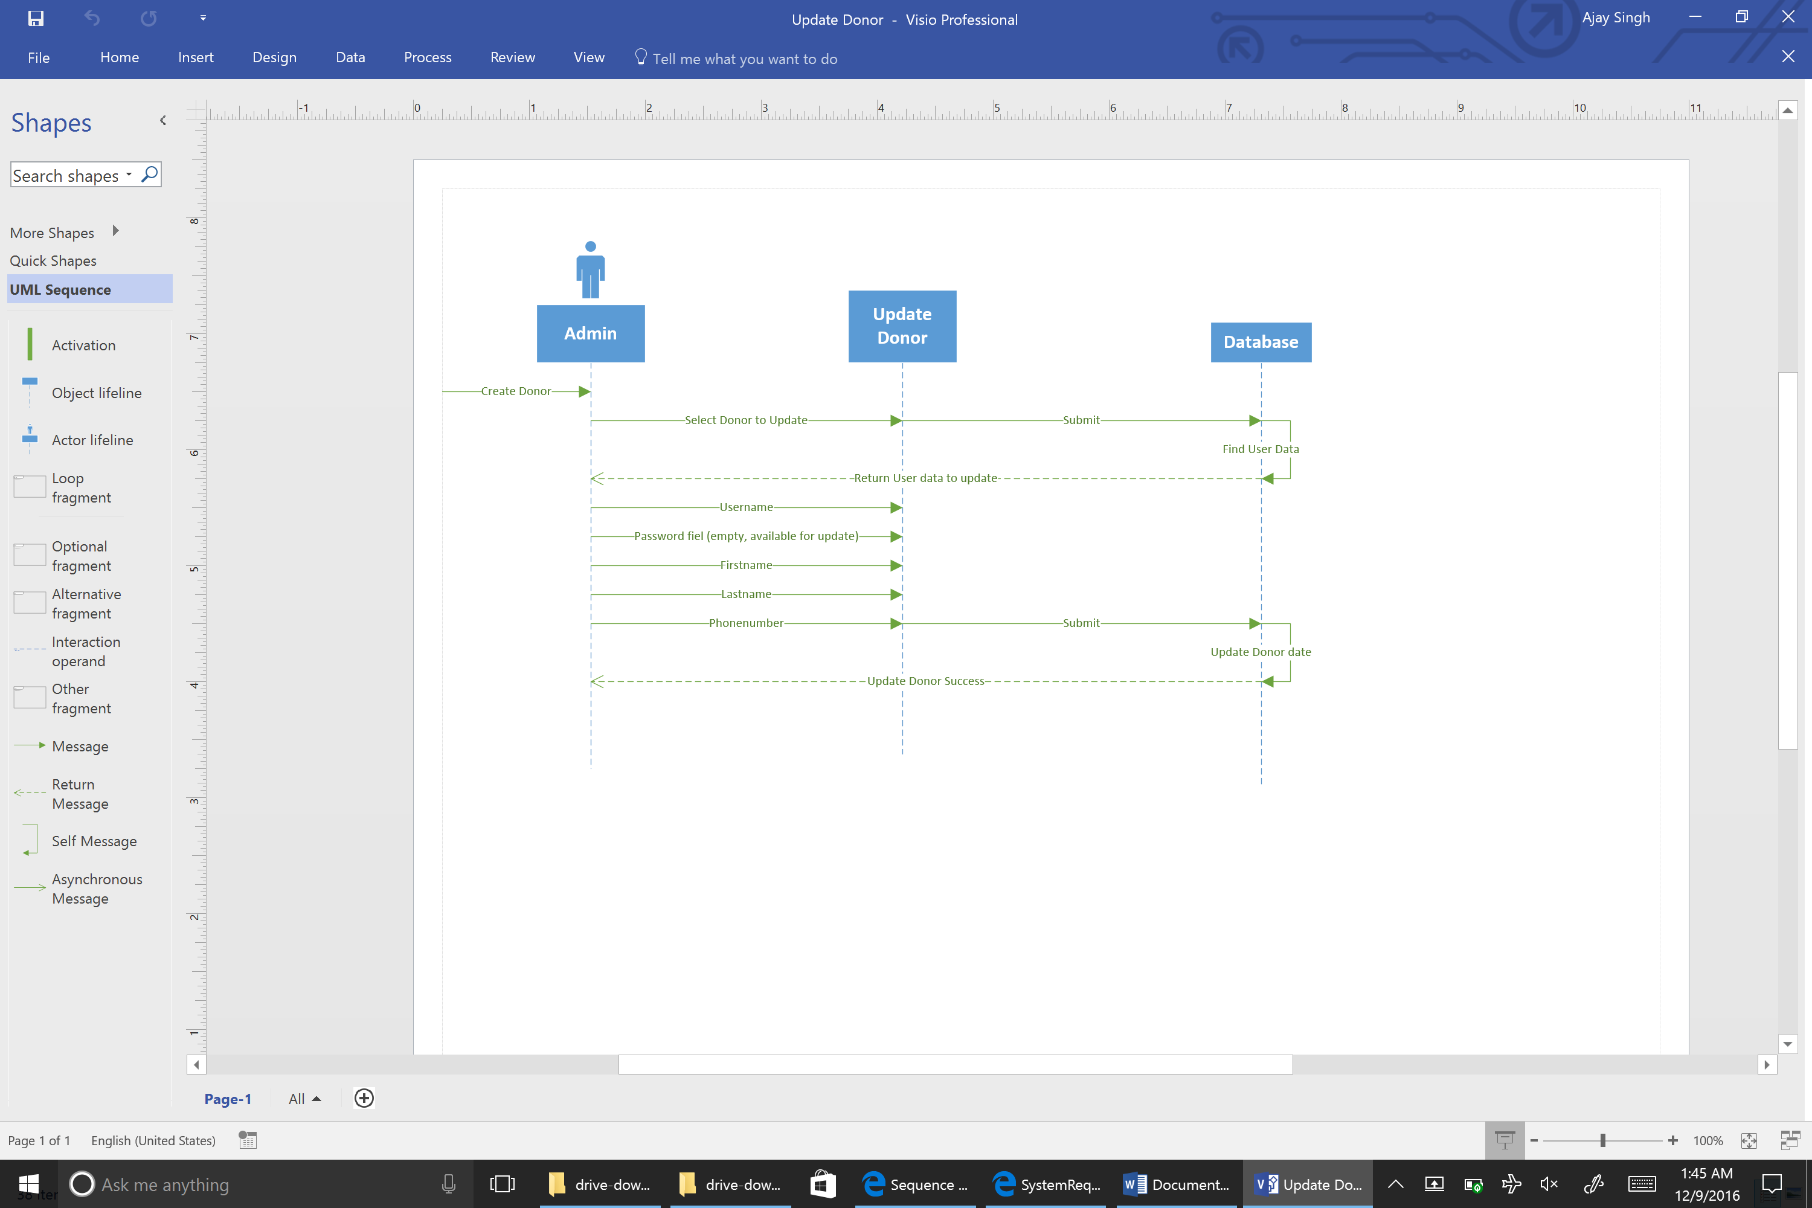

Delete Donor

# Use-Case Name

Delete Donor

## Brief Description

To keep Donor accounts from taking up more space than necessary on the SONAR system, advisors will have the ability to delete them from the system after a certain period of inactivity in a mass delete.

# Flow of Events

## Basic Flow

## The Advisor will browse to the Student Page, where they will run a multi student query for Donors. When the Donor is selected, a delete button will appear to the left of the area that will display the student’s information

* The Donors will be listed in order by date created with the date created listed along with the Donor’s name.
* The advisor will then be able to select all of the accounts they wish to delete
* The advisor will click delete button

## Alternative Flows

### Cancel Delete

## The Advisor will browse from their home page to the Manage Users tab

* Next the Advisor will be presented with a list box on the left side of the screen, which contains all of the users currently in the system. There will be search bar to the right of the list box which allows the admin to search through the list of users, and a button beneath the search bar labeled Create Users
* The advisor enter the first name, last name, email, or employeeID/Student ID they wish to update and hit enter.
* Next the advisor will double click the user in the listbox they wish to edit. This will open up a page that displays the user’s information.
* The advisor will hit Cancel to stop delete.

# Special Requirements

## Connectivity

Must have internet connection

# Pre-conditions

## User Type

The use of the system must be and Advisor

## Logged In

The Advisor must be successfully logged into the system.

# Post-conditions

## ‘Deleted’ Users

The user the advisor deleted will no longer be able to log in. The information regarding that specific user will be maintained for referential purposes only.

# Extension Points

## Deleted Wrong User(s)

If a user is wrongfully deleted, they will still be searchable in the list as the rest of the users. An administrator would have to go through and re-add the Donors that need accounts reinstated.

Use case 68:

## The Advisor will browse to the Student Page, where they will run a multi student query for Donors. When the Donor is selected, a delete button will appear to the left of the area that will display the student’s information

* The Donors will be listed in order by date created with the date created listed along with the Donor’s name.
* The advisor will then be able to select all of the accounts they wish to delete
* The advisor will click delete button

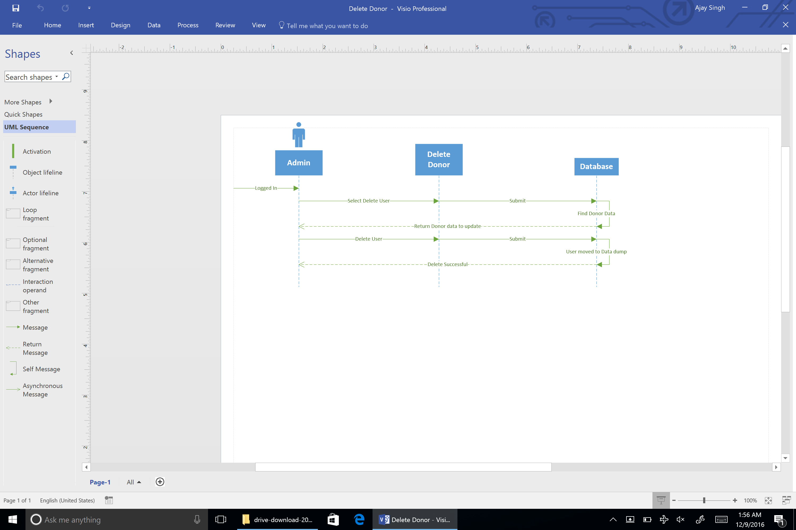

# Track Received Applications

## Brief Description

For use by anyone looking to make donation to the school of nursing. Users will be able to make monetary contribution to the school of nursing.

# Flow of Events

## Basic Flow

User will be able to create an account or log in to an existing one to make a donation to school of nursing with a method of their choosing. They will be directed to the university of Louisville foundation page to complete donation.

## Alternative Flows

### Incomplete information

Page would return errors to notify the user that information entered is incomplete such as the check number, the card number, and/or address.

### Redirect page unavailable

System will show a backup page that will track user info in case the page is unavailable. Information would be used later to contact user to complete the donation process.

# Special Requirements

## System Requirements

* Windows Server 2012
* Access SQL 2016
* Access to university of Louisville foundation page.

## Legal Requirements

System must be compliant with FERPA regulations.

# Pre-conditions

## Access to system

User must be logged in to the system or can create a new account.

## Access to valid payment methods

User must have a valid form of payment method such as a check or major credit card available.

# Post-conditions

## Donation completed

Donation is processed with payment forwarded to University of Louisville Foundation. The system will also return a unique identifier for the donation that will be linked to donors account for tracking purposes.

## Make another donation

System would then allow the user to make another donation if they’d like to the school of nursing or a different school.

# Extension Points

## Invalid input

System would provide an error along with a notification when a valid input isn’t entered or selection isn’t made.

* Invalid format
* Invalid length
* Invalid characters



# Use-Case Name

Security

## Brief Description

We will secure the SONAR system through the following:

* Encrypting backups of the SONAR system information
* Antivirus automatically deployed by University
* Layered firewall approach implemented by the university

# Flow of Events

## Basic Flow

* Place server behind university firewalls on university network, essentially, just plug the box in if it’s a physical box, or create the virtual machine if it is to be a virtual machine.
* University installs antivirus software through auto-deployment
* Ensure all OS software is up to date, as well as virus definitions
* Install SQL Server, encrypt backups using

# Special Requirements

## User Type

User must be an administrator

# Pre-conditions

## Logged onto server

User must be logged directly on to server

# Post-conditions

## Hardened Security

University AV software will now scan the system regularly.

## Firewall Protection

SONAR system will be protected by University Firewalls.

## Encrypted Backups

All backups created by the SONAR system will now be encrypted.

# Extension Points

## System Compromised

Should the system become compromised, the database will still be password protected, that combined with encrypted backups should make actually getting data out of the system very difficult for persons with malicious intent who successfully gain access to the server itself.

Backup

# Use-Case Name

Backup

## Brief Description

In order to prevent data loss, the SONAR system will include a feature that allows the administrator to create backups when necessary, as well as schedule regular partial and full backups when needed. These backups will be stored on the server hosting the SONAR system.

The University also runs automatic backups through the IBM Spectrum Protect product. These backups run on a nightly basis between 10PM and 6AM, and are not stored on the SONAR server, they are stored on IBM servers off-site.

# Flow of Events

## Basic Flow

* Administrator will log in to SONAR system
* Administrator will browse to the Backup/Recovery page from their home screen
* Administrator will then select the Backups tab located on the Backup/Recovery page
* The user will now come to a screen that allows them to select from three options: Differential (partial) Backups, Full Backup, or Automated backups
* The user will select the Differential Backup option.
* There will now be a form displayed that allows the user to select an immediate backup, or schedule one at a later time and date. The user will select immediate backup and hit Continue.
* SONAR will begin the process of backing up the system, and run until completion.

## Alternative Flows

### Differential, Scheduled

* Administrator will log in to SONAR system
* Administrator will browse to the Backup/Recovery page from their home screen
* Administrator will then select the Backups tab located on the Backup/Recovery page
* The user will now come to a screen that allows them to select from three options: Differential (partial) Backups, Full Backup, or Automated backups
* The user will select the Differntial Backup option.
* The user will select a time and date for the backup rather than an immediate backup, then hit Continue.
* SONAR will begin the process of backing up the system, and run until completion.

### Full, Immediate

* Administrator will log in to SONAR system
* Administrator will browse to the Backup/Recovery page from their home screen
* Administrator will then select the Backups tab located on the Backup/Recovery page
* The user will now come to a screen that allows them to select from three options: Differential (partial) Backups, Full Backup, or Automated backups
* The user will select Full Backup option
* Next the user will select the Immediate Backup option that appears and hit Continue
* SONAR will begin the process of backing up the system, and run until completion.

### Full, Scheduled

* Administrator will log in to SONAR system
* Administrator will browse to the Backup/Recovery page from their home screen
* Administrator will then select the Backups tab located on the Backup/Recovery page
* The user will now come to a screen that allows them to select from three options: Differential (partial) Backups, Full Backup, or Automated backups
* The user will select Full Backup, when the full backup form appears, the user will enter a time and date they wish to create a full back up and hit Continue.
* SONAR will begin the process of backing up the system, and run until completion.

### Cancel Manual Backups

* Administrator will log in to SONAR system
* Administrator will browse to the Backup/Recovery page from their home screen
* Administrator will then select the Backups tab located on the Backup/Recovery page
* The user will now come to a screen that allows them to select from three options: Differential (partial) Backups, Full Backup, or Scheduled Backups
* The user will select Scheduled Backups
* When the form appears, users will be able cancel any previously scheduled backups, whether they be partial or full, that were manually created.
* Once the user has selected the backups they wish to cancel, they will hit the Next button
* A message box will appear asking if the user is sure they wish to cancel the scheduled backups, should the user hit OK, the backups selected will be disabled.

# Special Requirements

## User Type

To perform restore operations to the system, the user MUST be an administrator.

# Pre-conditions

## Connectivity

Must be connected to School of Nursing network or connected through virtual Lab.

## Logged In

The Administrator must be successfully logged into the system.

# Post-conditions

## Successful Backup

The user will receive an email when the backup has completed for scheduled backups, or a message box stating the backup was successful for immediate backups.

# Extension Points

## Storage Capacity Reached

The user will receive an email stating the backup failed for scheduled backups, or a message box stating the backup was unsuccessful for immediate backups. This message/email will inform the admin that the max storage capacity for the offsite storage has been reached, and either more storage must be added, or old backups must be deleted.

Recovery

# Use-Case Name

Recovery

## Brief Description

In the event of a system error that results in the removal of needed data, or should some sort of catastrophic failure or natural disaster wipe out the SONAR system, the backup data saved on the NAS (network attached storage device, essentially just a computer used to store data) will need to be retrieved for use. The Administrator of the SONAR system will be able to restore the database to its previous state.

# Flow of Events

## Basic Flow

* Administrator will log in to SONAR system
* Administrator will browse to the Backup/Recovery page from their home screen
* Administrator will then select the Recovery tab located on the Backup/Recovery page
* The administrator will now select the backup they wish to use (these will be named by the time and date they were created). Some backups will be marked differential, meaning they contain only the changes made since the last backup. Others will be full backups, which will contain a backup of ALL data in the database. The admin will select a full back up from which to restore and hit Next.
* Administrators will then be presented with a message box confirming the recovery operation to take place. It will begin when they click OK, or cancel should they choose Cancel.

## Alternative Flows

### Restore a Differential Backup

* Administrator will log in to SONAR system
* Administrator will browse to the Backup/Recovery page from their home screen
* Administrator will then select the Recovery tab located on the Backup/Recovery page
* The administrator will then select the Differential (partial) backup they wish to restore to the SONAR system. Once the administrator has selected the appropriate backup, they will hit Next.
* Administrators will then be presented with a message box confirming the recovery operation to take place. It will begin when they click OK, or cancel should they choose Cancel.

# Special Requirements

## User Type

To perform restore operations to the system, the user MUST be an administrator.

# Pre-conditions

## Connectivity

Must be connected to School of Nursing network or connected through virtual Lab.

## Logged In

The Administrator must be successfully logged into the system.

# Post-conditions

## Successful Restoration

The user will have successfully restored either a full or partial backup to the SONAR system

# Extension Points

## Failed Restore

If the backup attempt fails, a message box suggesting a reboot of the system, then trying to restore the same backup. If the backup fails after a reboot, the user should try another restore point in case the one they attempted to restore from is corrupt.

**Physical Architecture Network Deployment Diagram**

The network deployment diagram shows all users that are connected to the University of Louisville servers. Each user will be able to login with credentials assigned when their profiles are created. The users will be able to access this system from any computer with internet capabilities. They will login through a screen on the University of Nursing’s webpage that will allow each of the users to have access to materials and capabilities based on their user type. After entering their credentials they will directly communicating with the server our system is stored on.

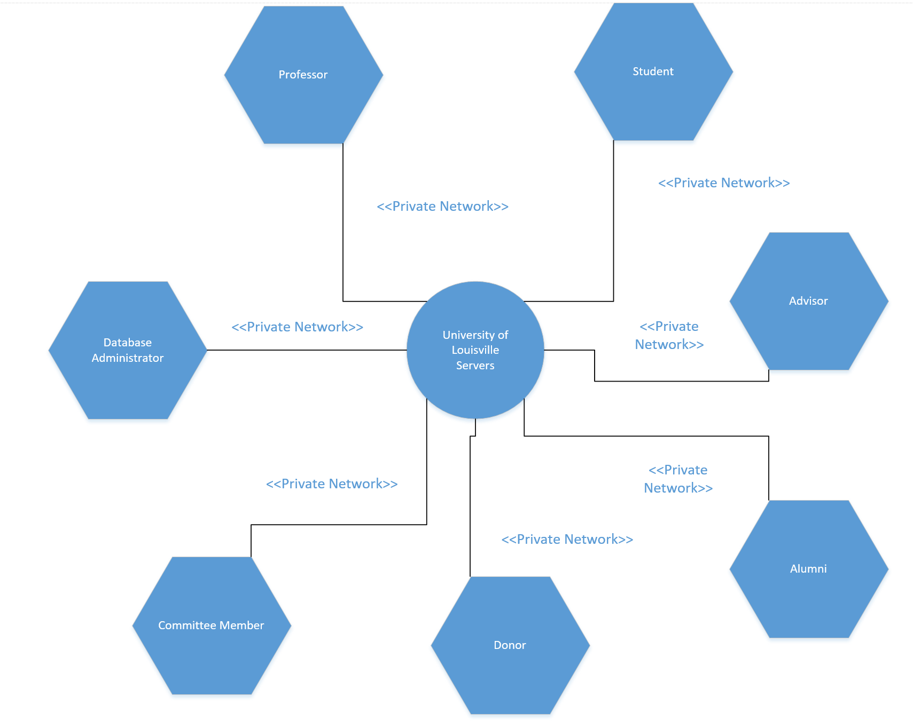

**Design Procedures for Security Concerns and Non-Functional Requirements**

**Security:** Securing the system is necessary so as not to allow malicious third parties access to the sensitive information housed within the SONAR system. Securing the system will contain the following:

* Antivirus: the University IT was not specific in which antivirus software they would deploy to the server, however such enterprise level antivirus will help secure the Microsoft server we’ll be using from most attacks, including any zero day attacks the AV provider is made aware of. University will handle this when the server is setup.
* Firewalls: The server will sit behind University firewalls. This will ensure fewer ports are vulnerable on our server to outside infiltration attempts. University will handle this when the server is setup.
* Operating System updates: As with any system it is critical that we keep the operating system as up to date as possible. Windows provides a way to run updates automatically. We will run these on setup and allow the admin to choose when to install updates going forward. This will have to be done by logging directly on the server, rather than the SONAR system itself.
* We will also encrypt backups made locally on the SONAR system so as not to leave backup data vulnerable to infiltration attempts. We will do this using the SQL 2016 server manager. The backups will be encrypted using AES_256. These encrypted backups will be compressed so as to save room on the SONAR system.

**Backup (University):** Backups run locally are described in the Use Case above. Backups that are run locally on the server will be stored on the server. The university also provides a backup service called IBM Spectrum Protect. This service will run backups on the server as a whole in case the server hosting SONAR were to fail for some reason. These backups are run every night in a window that ranges from 10PM to AM. This is important functionality, as it mitigates data loss in the event of catastrophic server failure.

**Restore (University):** Should the SONAR server fail, the school will need to get in contact with U of L IT in order to restore the server itself. From there, backups that of the SONAR database that were house within University off-site backups can be restored. This two tiered approach allows admins of the system the ability to restore local backups (without involving University IT) which allows the system more agility in returning to a working state should the issue be contained in the database. If the issue is larger, the school will lose less data, as University IT will be able to supply the school with a backup of the system from the previous night.